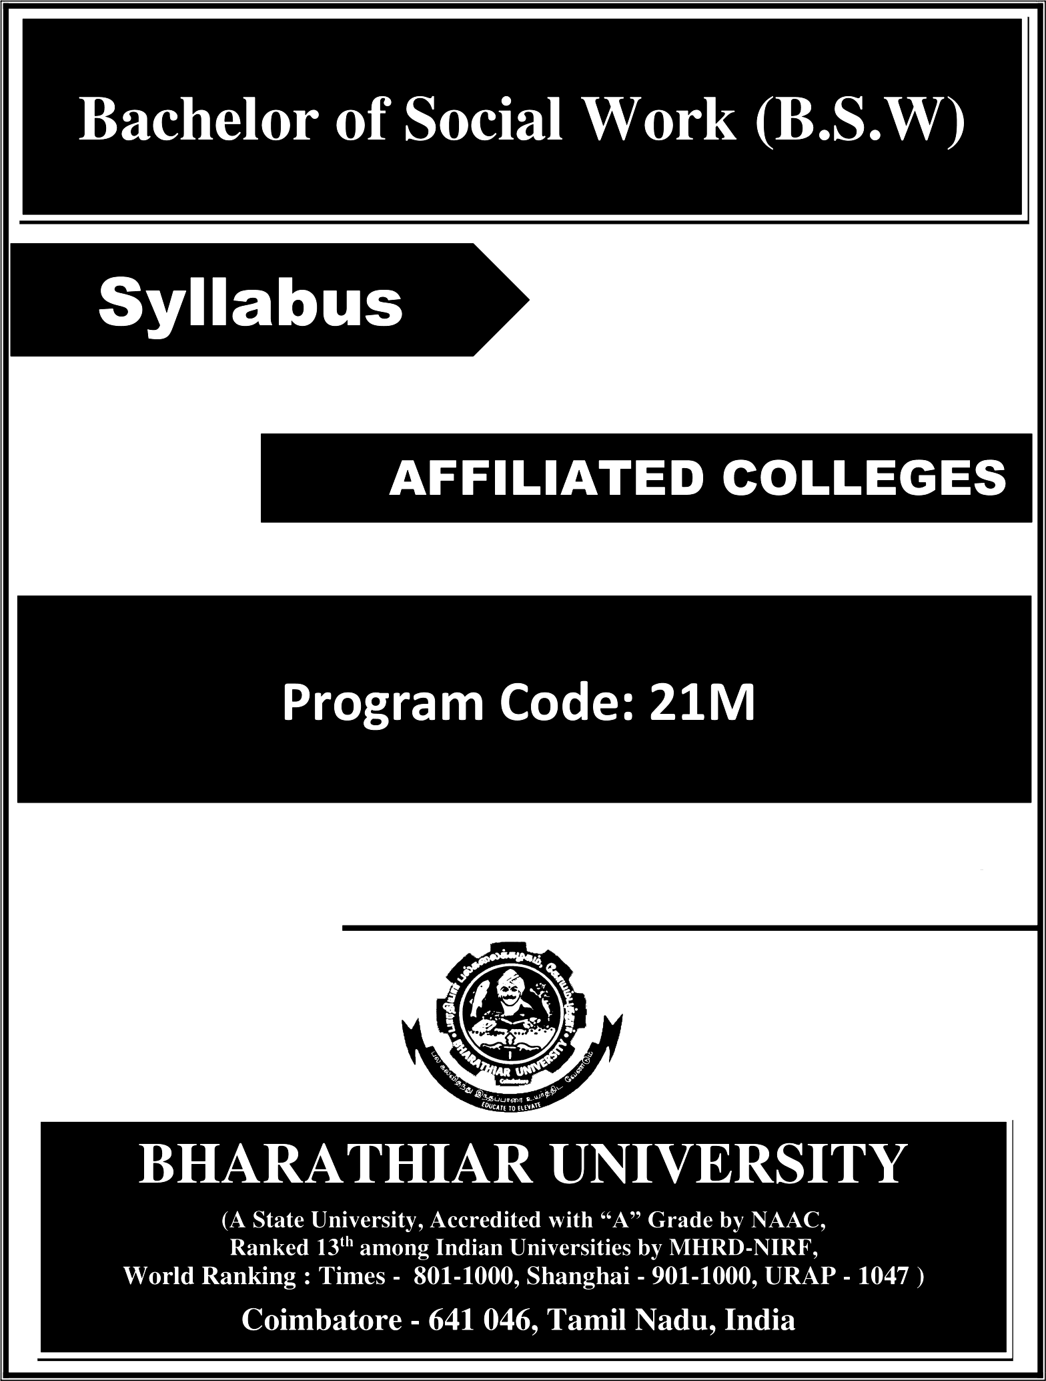

2026—2027 onwards

Programme Educational Objectives PEOs

The B.S.W program describe accomplishments that graduates are expected to attain
within five to seven years after graduation
PEO1 | Students can get an Employment as a social worker in Government and  in private sectors
PEO2 | After the completion of the course student may start an NGO or work as  an entrepreneur
PEO3 | Students can became a social worker in Schools and in hospitals
PEO4 | To introduce the students for advance academic skills needed in the field  of social work.
PEO5 | To help students to develop the skills for conducting many community  programmes.
PEO6 | To equip the students with innovative skills to became a successful  professional person in their organisation.
PEO7 | To enable the students to understand and analyses social problems and  also plan prevention programme
PEO8 | Students can able to write a project proposal
PEO9 | It will personally give them confidence to face challenges in the life and in  the profession
PEO10 | Students may comprehend their knowledge in social work which will  promote them for higher education in social work

Program Specific Outcomes (PSOs)

After the successful completion of -B.S.W program, the students are expected to
PSOl | It will give them knowledge on concept of social work
PSO2 | They can able to understand the methods of social work
PSO3 | It will comprehend their knowledge on roles and skills of a social worker
PSO4 | It will increase their awareness on legislation which is related to social work
PSO5 | Students equip themselves in NGO management
PSO6 | Students will be helped to expand their experience in various fields of social work
PSO7 | It will give them an awareness on different kinds of organisation in society which  working for marginalized groups
PSO8 | Students will able to organise a community programme
PSO9 | Students can analyse a problem and bring an intervention with help of their  research knowledge in social work
PSO10 | This will provide them confidence to march forward in the profession for higher  studies or further investigation

Program Outcomes (POs)

Program Outcomes (POs)
On successful completion of the B.S.W program
PO1 | Students can became a successful social worker
PO2 | Students will get an employment in an NGO
PO3 | Students writing skill and communication skill will improve
PO4 | Students can improve their professional competency
PO5 | It will prepare them to face civil service examination
PO6 | It will facilitate their managerial skill
PO7 | They can became a project coordinator
PO8 | Students develop their research skill
PO9 | Students will improve their fund raising skill
no to | Students will gain insight on many social problems so that they may not be  affected and also involve in eradication process

BHARATHIAR UNIVERSITY: COIMBATORE 641 046
BSW Curriculum
(For the students admitted during the academic year 2026— 27 onwards)

Course  Code | Title of the Course | Credits | Hours |  | Maximum Marks
Course  Code | Title of the Course | Credits | Theory | Practical | CIA | ESE | Total
 | FIRST SEMESTER
1 I T | Language I | 4 | 3 | - | 25 | 75 | 100
12E | English I | 4 | 3 | - | 25 | 75 | 100
l3A | Core I - Introduction to Social Work | 4 | 3 |  | 25 | 75 | 100
l3B | Core II - Man and Society | 4 | 3 | - | 25 | 75 | 100
1AB | Allied Paper I - Indian Social Problems  (Rural and Urban) | 4 | 3 | - | 25 | 75 | 100
1FA | Environmental Studies # | 2 | 3 |  | - | 50 | 50
 | Total | 22 | 18 |  | 125 | 425 | 550
 | SECOND SEMESTER
2lT | Language II | 4 | 3 | - | 25 | 75 | 100
22E | English II | 2 | 3 | - | 25 | 25 | 50 *
 | NAAN MUTHALVAN : Language Proficiency for Employability- Effective English | 2 | 2 | - | 25 | 25 | 50**
 | http://kb.naanmudhalvan.in/Special:Filepath/Cambridge_Course_Details.pdf
23A | Core III - Method of Social Work | 4 | 3 | - | 25 | 75 | 100
23B | Core IV - Human Growth Development | 4 | 3 | - | 25 | 75 | 100
23P | Core V - Documentation and Reporting  (Practical) | 2 | - | 3 | 25 | 25 | 50
2AB | Allied Paper II - Women And  Development | 4 | 3 | - | 25 | 75 | 100
2FB | Value Education Human Rights | 2 | 3 |  | - | 50 | 50
27A | SWATCHH BHARAT | 2 |  |  | 50 |  | 50
 | Total | 26 | 20 | 3 | 225 | 425 | 650
 | THIRD SEMESTER
31T | Language III | 4 | 3 | - | 25 | 75 | 100
32E | English III | 4 | 3 | - | 25 | 75 | 100
33A | Core VI - Human Rights Social Justice  and Social Work | 4 | 3 | - | 25 | 75 | 100
33B | Core VII - Counseling and Guidance | 4 | 3 | - | 25 | 75 | 100
3AC | Allied Paper III - Computer Office  Automation | 4 | 3 | - | 25 | 75 | 100
3ZA | Skilled Based Subject I - Social Work  With Persons With Disability | 3 | 3 | - | 20 | 55 | 75
3FA/B/C/D/E | Basic Tamil @ Advance Tamil # (or) Non Elective: I Yoga for Human excellence #3Women's Rights# Constitution of India # | 2 | 3 |  | - | 50 | 50
 | NAAN MUTHALVAN: Digital Skills for Employability | 2 | 2 |  | 25 | 75 | 100
3HW | Health and wellness # (Self- study Paper) |  |  |  |  |  | 25
Total |  | 27 | 23 |  | 170 | 565 | 750
# Marks will be given by the Department for 3HW – Health &Wellness

FOURTH SEMESTER
41T |  | Language IV | 4 | 3 | - | 25 | 75 | 100
42E |  | English IV | 4 | 3 | - | 25 | 75 | 100
43A |  | Core VIII - Social Work Research and  Statistics | 4 | 3 | - | 25 | 75 | 100
46A |  | Core IX - Field Work( Observation  Visits and Rural Camp) -Practical | 4 |  | 3 | 60 | 40 | 100
4AD |  | Allied Paper IV- Entrepreneurial Development | 2 | 3 |  | 25 | 25 | 50*
 |  | NAAN MUTHALVAN: Digital Skills for Employability – Office Fundamentals | 2 | 2 | - | 25 | 25 | 50**
 |  | http://kb.naanmudhalvan.in/Special:Filepath/Microsoft_Course_Details.xlsx
4ZB |  | Skilled Based Subject II -  Fundamentals | 3 | 3 |  | 20 | 55 | 75
 |  | of Accounting
4FA/B/ E |  | Basic Tamil @ / Advance Tamil #  (or) Non- | 2 | 3 |  | - | 50 | 50
 |  | major Elective: II General Awareness # |  |  |  | -
Total |  |  | 25 | 20 | 3 | 205 | 420 | 625
 |  | FIFTH SEMESTER
53A |  | Core X - Social Welfare Administration | 4 | 3 | - | 25 | 75 | 100
53B |  | Core XI - Disaster Management | 4 | 3 | - | 25 | 75 | 100
56A |  | Core XII - Field Placement –Practical | 4 | - | 3 | 60 | 40 | 100
5EA/B/C |  | Elective I | 4 | 3 | - | 25 | 75 | 100
5ZC |  | Skilled Based Subject III - Welfare of | 3 | 3 | - | 20 | 55 | 75
 |  | Weaker Sections
 |  | NAAN MUTHALVAN: Marketing and Design Tools | 2 | 2 |  | 25 | 75 | 100
Total |  |  | 21 | 14 | 09 | 180 | 395 | 575
 |  | SIXTH SEMESTER
63A |  | Core XIII - Social Legislation | 4 | 3 | - | 25 | 75 | 100
63B |  | Core XIV - Clinical Social Work | 4 | 3 | - | 25 | 75 | 100
66A |  | Core XV - Field Work / Block | 4 | - | 3 | 40 | 60 | 100
 |  | Placement – Practical |  |  |  | 40 | 60
6EA |  | Elective II | 4 | 3 | - | 25 | 75 | 100
6ED | Elective III |  | 4 | 3 | - | 25 | 75 | 100
6ZD | Skill Based Subject IV - NGO |  | 3 | 3 | - | 20 | 55 | 75
 | Management
67A |  | Extension Activities @ | 2 |  |  | - | 50 | 50
 |  | NAAN MUTHALVAN : Employability Readiness- Naan Mudhalvan Course | - | - | - | - | - | -
Total |  |  | 25 | 15 | 3 | 160 | 465 | 625
Grand Total |  |  | 146 | 110 | 12 | 1065 | 2685 | 3775

Includes 25% / 60% continuous internal assessment marks for theory and practical papers respectively @ No University Examinations. Only Continuous Internal Assessment (CIA) # No Continuous Internal Assessment (CIA). Only University Examinations.

* The English II- & Allied Paper IV- Entrepreneurial Development - University semester examination will be conducted for 75 marks (As per existing pattern of Examination) and it will be converted for 25 marks.
** Naan Mudhalvan – skill courses- external 25 marks will be assessed by Industry and internal will be offered by respective course teacher.

List of Elective Papers (Colleges can choose any one of the paper as electives)
Elective I | A | Community Development
Elective I | B | Urban Community Development
Elective I | C | Welfare of the Marginalised
Elective II | A | Human Resource Management
Elective II | B | Labour Welfare
Elective II | C | Industrial Relations
Elective III | A | Social Work with Families and Children
Elective III | B | Counselling Theory and Practice
Elective III | C | Youth Welfare

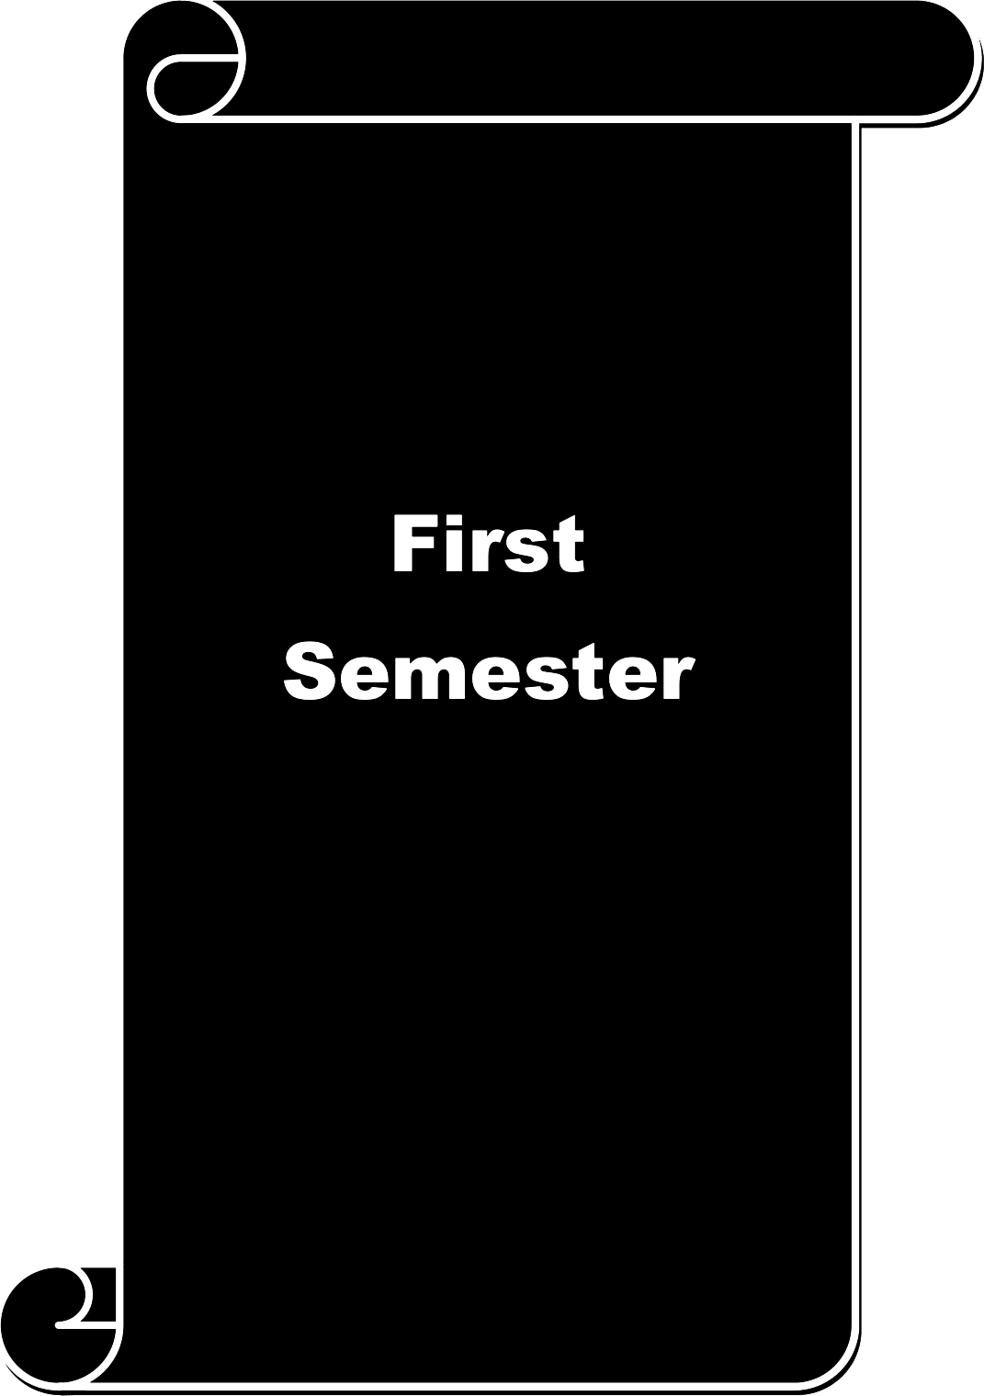

Course code |  |  | 13A | INTRODUCTION TO SOCIALWORK |  | L | T | P |  | C
Core I |  |  |  |  |  | 3 | - |  |  | 4
Pre-requisite |  |  |  | To recognize value in Social Work and its Sy  Methods |  | Syllabus  Version |  | 2026-2027
Course Objectives:
The main objectives of this course are to:

- To know the basic concepts in Social Work
- To understand the professional ethics and values in Social Work
- Gathering curriculum knowledge about scopes in Social Work
Expected Course Outcomes:
On the successful completion of the course, student will be able to:
I |  | To build enable the students to build basic knowledge in social work |  |  |  |  |  |  | K6
2 |  | Students recognize the religious value |  |  |  |  |  |  | K2
3 |  | Students can realize the ethic and values of social work |  |  |  |  |  |  | K2
4 |  | To know the historical growth in social work |  |  |  |  |  |  | Kl
S |  | Students able to understand and learn the systematic and planned way of helping the  People |  |  |  |  |  |  | K4
K1 - Remember; K2 - Understand; K3 - Apply; K4 - Analyze; K5 - Evaluate; K—6 Create
Unit:1 |  |  | BASICS IN SOCIAL WORK |  |  | 15 hours
Basic concepts — social work: meaning, definitions, objectives and functions — Social welfare:
meaning, scope and objectives - social service: meaning, difference between social service and social work - concept of social reform- social action — social security.
Unit:2 |  |  | RELIGIOUS THOUGHTSAND SOCIAL WORK |  |  | 15 hours
Religious thoughts of India — Hinduism- Christianity, Supreme Values of man, Modern Indian social
thinkers: Swami Vivekananda, Gandhiji, Ambedkar and E.V.R
Unit:3 |  |  | BASIC VALUE OF SOCIAL WORK |  |  | 15 |  | hours
Basic values of human life, Philosophy of social work, professional ethics, skills, roles and functions
of social worker
Unit:4 |  |  | HISTORCIAL DEVELOPMENT |  | 14 hours
Historical development - Social work in the West and in India. Voluntary Social work and role of
Non-Governmental social welfare Agencies.
Unit:5 |  |  | METHODS AND FIELD OS SOCIAL WORK |  | 14 hours
Methods and Fields of social work - Casework, Group work, Community Organization, Social
Action, Social Work Research and Social Welfare Administration .
Fields of social work: Labour welfare, Medical and Psychiatric social work, community development, correctional social work, Youth welfare and school social work.
Unit:6 Contemporary Issues 2 hours
Expert lectures, online seminars — webinars
 |  |  | Total Lecture hours |  | 75 hours
Text Book(s)
 | Gangrade, Dimensions Of Social Work,Marwah Publications New Delhi
2 | Paul Choudry Introduction To Social Work, Atma Ram And Sons

3 | ShaikhAzharIgbal Principles and practices of social work Sublime publications,  Jaipur,India
Reference Books
I | Gangrade, K. D , Dimensions Of Social Work, Marwah Publications, New Delhi
2 | Mishra.P.D , Introduction to Social Work,Sage,NewDelhi.
Related Online Contents [MOOC, SWAYAM, NPTEL, Websites etc.]
1 | FERRIS — Introduction to social work. Press book .com
2 | U H CLASS OET - You tube
3 | IGNOUSO — Social Work
Course Designed By: Dr. Sam Lovely Son, Dr. John Wesley

Mapping with Programme Outcomes
COs | PO1 | PO2 | PO3 | PO4 | PO5 | PO6 | PO7 | PO8 | PO9 | PO10
CO1 | M | L | L | S | S | S | M | S | M | S
CO3 | M | L | M | S | M | M | M | S | M | S
CO3 | S | M | M | S | M | S | S | S | M | M
CO4 | M | M | L | L | M | M | M | M | M | M
CO5 | M | M | M | S | S | S | M | S | M | S
*S-Strong; M-Medium; L-Low

Course 13B L T P C
code MAN AND SOCIETY
Core II 3 - - 4
Pre-requisite To Introduce the basic social process of Society, Syllabus 2026-2027
Social Instruction and Pattern of Social Behaviour version

Course Objectives:

The main objectives of this course are to:
- To understand concept and theories and Method of the behavioural.
- To train and interpret objectively the role of social processes and interaction.
- Demonstrate and understanding the human personality and socialization.

Expected Course Outcomes:

On the successful completion of the course, student will be able to:
I To understand the Democratic characteristics of the Indian Society K2
- To Introduce the basis process of Social Institution in the society K6
- To train students to understand and to interpret objectively the role of social process and K3 social institution and interaction in their life.
- To enable students to cope effectively with the socio-cultural and interpersonal process of K3 the constantly change the complex society.

- To investigate the welfare programmes, and to analyses the types and theories of social K5 changes.
K1 - Remember; K2 - Understand; K3 - Apply; K4 - Analyze; K5 - Evaluate; K—6 Create
Unit:1 BASIC INTRODUCTION ON MAN AND SOCIETY 15 hours

Concept of Society. Individual and Society. Basic Elements- Group, Community, Institution and Association- - Complexity of Indian Society Demographic Characteristics of Indian Society. Demographic variables and Malthusian Theory

Socialization: concept, Importance and Functions. Agencies of Socialization. Culture : concept, Characteristic—s Influence on Individuals, Cultural Conflict, Impact of Cultural Chang— Cultural lag
Unit:3 MARRIAGE SYSTEM IN INDIA 15 hours

Indian family system: Marriage - forms, functions, changes in mate choice and ceremonies. Family - forms, Characteristics, functions and contemporary changes. Conflict, break down, adjustments.
Unit:4 CASTE SYSTEM IN INDIA 14 hours

Caste system: Characteristics, Traditional Varna system, theories. Modern Trends of Caste System in India. Social Stratification Definition and Characteristics. Caste and Class. Social Control meaning, Characteristics, Agencies of social control- social sanctions.
Unit:5 TO KNOW THE CONCEPT OF WELFARE STATE 14 hours

Welfare state: Concept, need, characteristics- India as a welfare state- Social Change: Definition, concept, types and theories of social change in India. Gender roles and inequalities.
Unit:6 Contemporary Issues 2 hours
Expert lectures, online seminars — webinars

 |  | Total Lecture hours | 75 hours
Text Book(s)
I | ElliotAnd Merril - Society And Culture, Prentice Halllnc
2 | Ghurye,G.S.Caste - Class And Occupation, Bombay,Popular
3 | Mac-1verAndPage - Society, An Introductory Analysis, London,Macmillan
Reference Books
1 | Prabhu,Radharinath -Hindu Social Organization,Bombay, PopularPrakashan
2 | Natarajan,S, - Century Of Social Reforms,Bombay, AsiaPublishing
Related Online Contents [MOOC, SWAYAM, NPTEL, Websites etc.]
I | Joui‘nals.sagepub.com
2 | Egyankosh.ac.in
3 | A nchal jhoti —The famil y s ysem
Course Designed By: Dr. Sam Lovely Son, Dr. Premamalini

Mapping with Programme Outcomes
COs | PO1 | PO2 | PO3 | PO4 | PO5 | PO6 | PO7 | PO8 | PO9 | PO10
CO1 | M | M | L | M | M | S | S | S | M | S
CO3 | M | M | M | L | M | S | M | M | M | S
CO3 | S | M | M | M | S | S | S | S | M | M
CO4 | S | S | M | M | S | S | S | S | M | M
CO5 | S | S | S | S | S | M | M | S | S | S
*S-Strong; M-Medium; L-Low

Course code |  |  | 12A | INDIAN SOCIAL PROBLEMS  (Rural &Urban) |  | L | T P |  |  | C
Allied |  |  |  |  |  | 3 | - - |  |  | 4
Pre-requisite |  |  |  | To sensitize to emerging social issues and  problem of contemporary India |  | Syllabus  Version |  | 2026-  2027
Course Objectives:
The main objectives of this course are to:

- Brief review of the theoretical perspective involve in viewing social problem.
- Social change and Social control have been a central concern of the Society.
- Describing the Problems involved in the society
Expected Course Outcomes:
On the successful completion of the course, student will be able to:
1 |  | To remember the ethical problem based in India |  |  |  |  |  |  | KI
2 |  | To acquire the understanding of problems challenging in Rural area |  |  |  |  |  |  | K2
3 |  | To acquire the understanding of problems challenging in Urban area |  |  |  |  |  |  | K2
4 |  | To aware students in the social problems arise in the society through the media and  Education |  |  |  |  |  |  | K6
5 |  | Make the students to analyse the differently challenged people problem and to  promoted programmes for the rehabilitation. |  |  |  |  |  |  | K4
K1 - Remember; K2 - Understand; K3 - Apply; K4 - Analyze; K5 - Evaluate; K—6 Create
Unit:1 |  |  | SOCIAL PROBLEM |  |  | 15 hours
Social Problem-Concept-Meaning-Characteristics-General Causes-Effects- Remedial
measures- Social organization-social disorganization -Family disorganization- Individual disorganization-Deviant Behavior-meaning- types.
Unit:2 |  |  | RURAL SOCIAL PROBLEM |  |  | 15 hours
Rural social problems-Concept-Meaning-Illiteracy-Poverty- Unemployment-Untouchability-
Exploitation and Bonded Labour-Caste dominance and Communal riots
Unit:3 |  |  | URBAN SOCIAL PROBLEM |  | 15 hours
Urban social problems-Concept —Meaning- Problems of Socialization and Isolation-Juvenile
delinquency- Child Labour-Prostitution-Alcoholism- Drug addiction —STD and AIDS-Problems of Housing and Slums
Unit:4 |  |  | GENERAL SOCIAL PROBLEM |  | 14 hours
General Social Problems-Vagrancy-Beggary-Corruption-Issues related to consumer Protection-
Environmental Pollution-Dowry and Divorce-Suicide- Crime Terrorism
Unit:5 |  |  | PROBLEMS OF VULNERABLE GROUPS |  | 14 hours
Problems of Vulnerable Groups-Physically handicapped-Mentally handicapped-Problems of
the destitute and Elderly-Role of Social Worker- Voluntary Organizations
Unit:6 |  |  | Contemporary Issues |  | 2 hours
Expert lectures, online seminars — webinars
 |  |  | Total Lecture hours |  | 75 hours
Text Book(s)
1 | Bhattachary - Social Problems in India, Issues and Perspectives, New Delhi: Agency

2 | Anjaria - Indian Rural Problems Bombay: Vira & Compan 1990
3 | Ram Ahuja - Social Problems in India Jaipur: Rowat 1993
Reference Books
1 | Chandra S - Sociology of Deviation in India New Delhi: Allied(1983)
2 | Mamoria C - Social Problems (Indian) Vol I & Vol II Bombay: Allied Publishers 1989
Related Online Contents [MOOC, SWAYAM, NPTEL, Websites etc.]
1 | DCN-on democracy culture and the nation.
2 | Indoverse —India biggest issues and social problems
3 | VIDHIK — Social Problem In India
Course Designed By: Dr. Sam Lovely Son, Dr. John Wesley

Mapping with Programme Outcomes
Cos | PO1 | PO2 | PO3 | PO4 | PO5 | PO6 | PO7 | PO8 | PO9 | PO10
CO1 | M | M | L | L | M | M | M | S | S | M
CO3 | M | M | M | M | M | M | S | S | S | M
CO3 | M | M | M | M | M | M | S | S | S | M
CO4 | M | L | L | M | S | S | S | S | M | M
CO5 | M | M | M | S | S | S | S | S | M | M
*S -Strong; M-Medium; L-Low

Course code |  |  | IFA | ENVIRONMENTAL STUDIES |  | L | T P |  |  | C
Supportive |  |  |  |  |  | 3 | - - |  |  | 2
Pre-requisite |  |  |  | Understanding environment and its related  concepts |  | Syllabus  Version |  | 2026-  2027
Course Objectives:
The main objectives of this course are to:

1. Students will gain knowledge on environmental sciences 2.Students will understand Bio-Geographical
3. It will provide them knowledge on environmental pollution
Expected Course Outcomes:
On the successful completion of the course, student will be able to:
I |  | Students have an idea on Multidisciplinary nature of environmental studies |  |  |  |  |  |  | K2
2 |  | They will understand eco system |  |  |  |  |  |  | K3
3 |  | Students will know about environmental ethics |  |  |  |  |  |  | Kl
4 |  | Students can create an awareness programme on environmental pollution |  |  |  |  |  |  | K6
5 |  | Students can organise a program for environmental conservation |  |  |  |  |  |  | K6
K1 - Remember; K2 - Understand; K3 - Apply; K4 - Analyze; K5 - Evaluate; K6 — Create
Unit:1 |  |  | MULTIDISCIPLINARY NATURE OF  ENVIRONMENTAL STUDIES |  |  | 15 hours
Definition, scope and importance Need for public awareness. Natural resources its types and its
Significance
Unit:2 |  |  | ECOSYSTEM |  |  | l S hours
Concept, Structure, function, producers consumers, decomposers and energy flow in the eco
system Food chain and its types characteristics, structure and its functions
Unit:3 |  |  | BIODIVERSITY AND ITS CONSERVATIONS |  | l5hours
Introduction„ Definition, Bio geographical classification of India Hot spots of biodiversity and
Conservation of biodiversity
Unit:4 |  |  | ENVIRONMENTAL POLLUTION |  | l4hours
Definition, Causes, Effects and Control measures
Unit:5 |  |  | SOCIAL ISSUES AND THE ENVIRONMENT |  | l4hours
Sustainable Development, Environmental Ethics, Climate change Consumerism and Waste
Products
Unit:6 |  |  | Contemporary Issues |  | 2 hours
Expert lectures, online seminars — webinars
 |  |  | Total Lecture hours |  | 75 hours
Text Book(s)
1 | Erach Bharucha Text book of Environmental Studies For Under graduation
2 | R. Rajagopalan Environmental Sciences: Crisis to Cure
Reference Books
I | Mahua Basu and Xavier Savarimuthu (2015) Fundamentals Of Environmental Studies

2 | Noam Chomsky and Robert Pollin Climate Crisis and Global Green The new Deal : The  Political Economy of Saving the Planet
Related Online Contents [MOOC, SWAYAM, NPTEL, Websites etc.]
I | https://b1og.agrivi.com/post/environmental-pollution
2 | https://www.a1lresearchjournal.com/archives/2016/vol2issue3/PartH/2-3-10.pdf
Course Designed By: Dr. Sam Lovely Son Mr. Francis Xavier

Mapping with Programme Outcomes
Cos | PO1 | PO2 | PO3 | PO4 | PO5 | PO6 | PO7 | PO8 | PO9 | PO10
CO1 | M | M | M | M | M | M | M | M | M | M
CO3 | M | M | M | L | M | L | M | M | M | M
CO3 | M | L | L | S | M | S | M | M | L | M
CO4 | M | S | S | S | S | M | M | M | M | M
CO5 | S | S | S | M | M | M | S | M | S | S
*S-Strong; M-Medium; L-Low

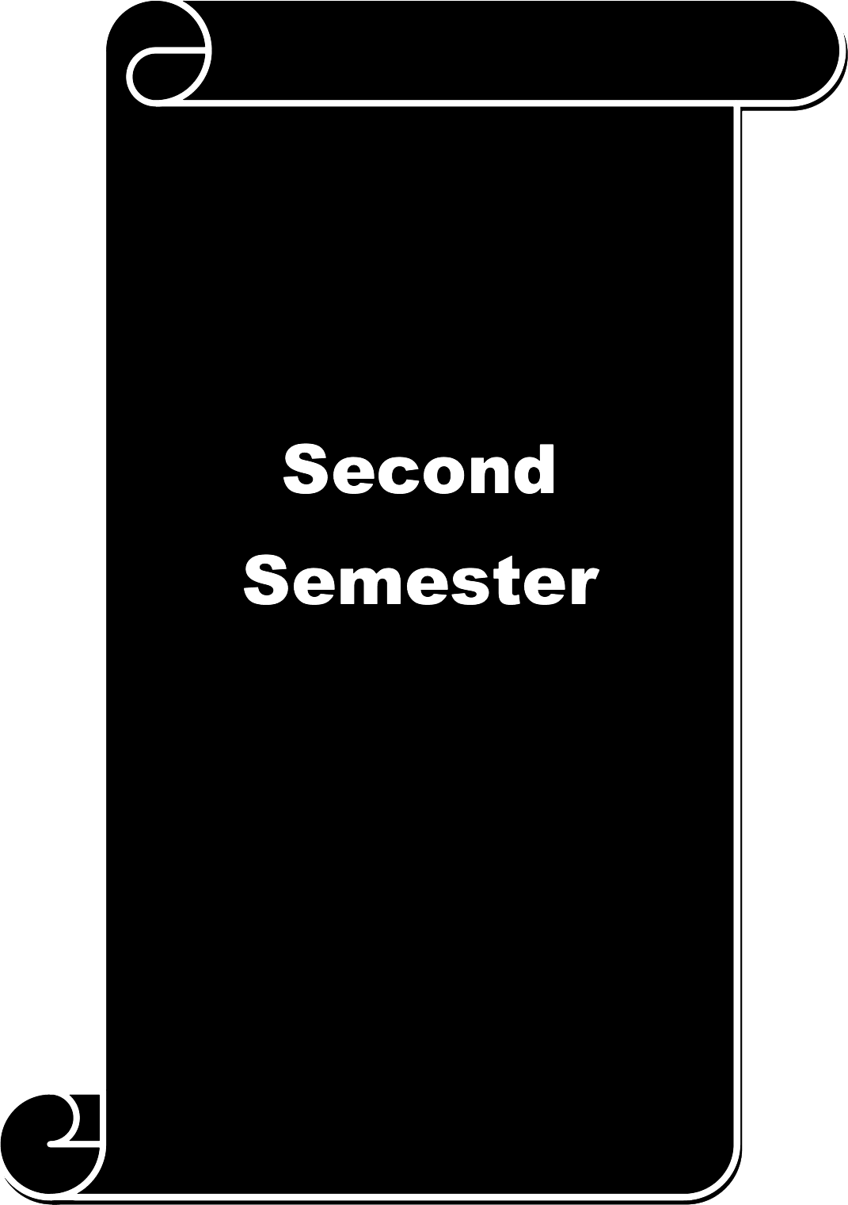

Course code |  |  | 23A | METHODS OF SOCIAL WORK |  | L | T P |  |  | C
Core III |  |  |  |  |  | 3 | - |  |  | 4
Pre-requisite |  |  |  | Understanding the basics of social work and its Sy  objectives |  | Syllabus  Version |  | 2026-2027
Course Objectives:
The main objectives of this course are to:

- To introduce all the methods in social work
- To enable the students to have knowledge on techniques in all the methods of social work
- To develop the skills needed in all the methods of social work
Expected Course Outcomes:
On the successful completion of the course, student will be able to:
I |  | The students learn to appeal to solve the psycho-social problem of a individual |  |  |  |  |  |  | K3
2 |  | To construct students through the interplay of personalities |  |  |  |  |  |  | K6
3 |  | It make students to investigate mobilizing resource and need of a community |  |  |  |  |  |  | K4
4 |  | The Understand the organisation and administrate structure |  |  |  |  |  |  | K2
5 |  | To prevent and evaluate the solution to the mass problem in society |  |  |  |  |  |  | K5
K1 - Remember; K2 - Understand; K3 - Apply; K4 - Analyze; K5 - Evaluate; K6 — Create
Unit:1 |  |  | SOCIAL CASE WORK |  |  | 15 hours
Definition, objectives, scope, principles and process (study, Diagnosis and intervention) - roles of a
case worker.
Unit:2 |  |  | SOCIAL GROUP WORK |  |  | 15 hours
Definition, objectives and scope, types of groups and group processes —Group work process - roles of
a group worker.
Unit:3 |  |  | COMMUNITY ORGANIZATION |  |  | 15 hours
Definition, objectives and scope, principles and processes - roles of a community organizer.
Unit:4 |  |  | INDIRECT METHOD OF SOCIAL WORK |  |  | 14 hours
Social Welfare administration Basic administrative practices —social legislation - Importance for social
work practice.
Unit:5 |  |  | SOCIAL ACTION |  |  | 14 hours
Social action and its importance for social work practice. social work Research — meaning, aims,
Objectives and scope.
Unit:6 |  |  | Contemporary Issues |  | 2 hours
Expert lectures, online seminar—s webinars
 |  |  | Total Lecture hours |  | 75 hours
Text Book(s)
I | M S Gore - social work Education Asia publishing House 1969
2 | Gisala konpka - Social group work — A helping process New Jercy : Prentice Hall
3 | Fred Milson - Skills in Social group work
Reference Books
I | Gangrade K D - Community organization in India Bombay : Popular Prakasahn

2 | Govt. of India, Social - Its role in social welfare New Dehli : Publications  Legislation Division Goal Sl & Jain social
Related Online Contents [MOOC, SWAYAM, NPTEL, Websites etc.]
I | jsswnet.com-I Journals
2 | EDU Sushil-Method of Social Work
Course Designed By: Dr. Sam Lovely Son Dr. Ruth

Mapping with Programme Outcomes
COs | PO1 | PO2 | PO3 | PO4 | PO5 | PO6 | PO7 | PO8 | PO9 | PO10
CO1 | M | M | S | S | S | S | S | M | M | M
CO3 | M | L | L | M | M | M | S | M | M | M
CO3 | M | L | M | L | S | S | S | M | M | S
CO4 | M | L | L | M | M | M | L | M | L | S
CO5 | M | M | M | L | S | S | S | S | M | M
*S-Strong; M-Medium; L-Low

Course code |  |  | 23B | HUMAN GROWTH AND DEVELOPMENT |  | L | T P |  |  | C
Core IV |  |  |  |  |  | 3 | - - |  |  | 4
Pre-requisite |  |  |  | To know the Life Span Development of human Sy |  | Syllabus  Version |  | 2026-  2027
Course Objectives:
The main objectives of this course are to:
1. To understand growth development of the human-Birth to Death
2 Gain knowledge about the behaviour pattern in each stage.
3. To Emirates the hazards in each stages
Expected Course Outcomes:
On the successful completion of the course, student will be able to:
1 |  | Students gets acquired knowledge about the heredity and development |  |  |  |  |  |  | K2
2 |  | For student evaluate of identify during adolescence |  |  |  |  |  |  | K4
3 |  | Students can understand change in growth, strength and overall health during early  adulthood |  |  |  |  |  |  | K2
4 |  | Understand how to resolve related to the body response to challenging life event  during middle age stage |  |  |  |  |  |  | K4
5 |  | To enhance the life hazards of Old age |  |  |  |  |  |  | K5
K1 - Remember; K2 - Understand; K3 - Apply; K4 - Analyze; K5 - Evaluate; K6— Create
Unit:1 |  |  | STAGES AND DEVELOPMENT OF HUMAN |  |  | 15 hours
Meaning of Growth and Development, Developmental tasks, Developmental Stages: Conception,
Pregnancy and Delivery. Infancy : Major adjustments of Infancy Babyhood : Emotional behavior in baby hood- Hazards of Baby hood Early childhood : Emotional and social behavior Late childhood Emotional and social behavior
Unit:2 |  |  | PUBERTY |  |  | 15 hours
Causes and age of puberty- body changes at puberty- effects of puberty changes:
Developmental tasks of Adolescence
Unit:3 |  |  | EARLY AND LATE ADULTHOOD |  | 15 hours
Developmental task of early adult hood-Vocational, marital, social adjustments- late adulthood
adjustments to parenthood
Unit:4 |  |  | MIDDLE AGE |  | 14 hours
Developmental tasks of middle age- social adjustment- adjustment to physical changes
vocational and marital hazards of middle age
Unit:5 |  |  | OLD AGE |  | 14 hours
Characteristics of old ag—e developmental tasks of old age, adjustments to retirement- adjustment
tools of spouse—e Life hazards of old age
Unit:6 |  |  | Contemporary Issues |  | 2 hours
Expert lectures, online seminar—s webinars
 |  |  | Total Lecture hours |  | 75 hours
Text Book(s)
1 | Hurlock E B (1975) Developmental Psychology
2 | Linda L David Off Introduction To Psychology

Reference Books
1 | Kuppuswamy B Child Behaviour And Development
2 | Bhatia H R (1972 ) Abnormal Psychology - Bombay- Oxford IBH  Publications.
Related Online Contents [MOOC, SWAYAM, NPTEL, Websites etc.]
1 | https://www.verywellmind.com/psychosocial-stages-2795743
2 | https:llwww.britannica.com/science/midd1e-are
3 | https://www.who.int/health info/sui‘vey/ageingdefnolder/en/
Course Designed By: Dr. Sam Lovely Son Dr.John Wesley

Mapping with Programme Outcomes
COs | PO1 | PO2 | PO3 | PO4 | PO5 | PO6 | PO7 | PO8 | PO9 | PO10
CO1 | M | L | L | M | M | M | M | S | M | M
CO3 | M | L | L | M | M | M | M | S | M | S
CO3 | L | L | L | M | M | M | S | S | M | S
CO4 | M | M | L | L | M | M | M | M | M | S
CO5 | M | L | M | L | M | M | M | M | M | S
*S-Strong; M-Medium; L-Low

Course code |  |  | 23P | DOCUMENTATION AND REPORTING: PRACTICAL | L | T P |  |  | C
Core V |  |  |  | DOCUMENTATION AND REPORTING: PRACTICAL | - | - 3 |  |  | 2
Pre-requisite |  |  |  | Having knowledge on writing assignments and  experience on doing scrap book | Syllabus  Version |  | 2026-  2027
Course Objectives:
The main objectives of this course are to:
- Helping students to develop interest on research
- Enabling students to have wide knowledge on one particular topic
- It will improve their writing skills
Expected Course Outcomes:
On the successful completion of the course, student will be able to:
I | Students increase their knowledge on the topic they are doing documentation work |  |  |  |  |  |  | K2
2 | Students can update their information by referring various resource |  |  |  |  |  |  | K2
3 | It is an eye opener for doing research work |  |  |  |  |  |  | K4
4 | They will improve their reading and writing skill |  |  |  |  |  |  | K3
5 | Students can thrive themselves in higher studies |  |  |  |  |  |  | K6
K1 - Remember; K2 - Understand; K3 - Apply; K4 - Analyze; K5 - Evaluate; K6— Create
Through this documentation and practical work students will be given one topic in which they
need to collect basic information to understand its concept. In order to get the statistical information they have go through some reviews related. They refer various books, journals, previous dissertation, news bulletin, E-sources for collecting information. For their convenience they can do the documentation in chapterization form. Faculties will guide the student in their successful completion of documentation work. Finally they will submit their documentation report for evaluation.
Text Book(s)
1 |  | Doc Book By Norman Walsh
2 |  | Documentation and Coding By Sheri Poe Bernard
 |  | Reference Books
I |  | Complete Guide For Documentation By Wolters Kluwer Lippincott Williams & Wilkins
2 |  | Technical documentation and process by Jerry C Whitaker and Robert K. Mancini
 |  | Related Online Contents [MOOC, SWAYAM, NPTEL, Websites etc.]
I |  | https://searchsoftwarequa1ity.techtarget.com/definition/documentation
2 |  | https://guides.lib.berkeley.edu/how-to-write-good-documentation
3 |  | https://plan.io/blog/technical-documentation/
Course Designed By: Dr. Sam Lovely Son Mr. Francis Xavier

Mapping with Programme Outcomes
COs | PO1 | PO2 | PO3 | PO4 | PO5 | PO6 | PO7 | PO8 | PO9 | PO10
CO1 | M | M | M | M | L | L | S | S | S | M
CO3 | M | M | S | M | M | M | S | S | M | S
CO3 | M | M | S | M | M | M | S | S | M | S
CO4 | L | M | M | M | L | M | M | S | M | S
CO5 | S | S | S | S | S | S | S | S | S | S
*S-Strong; M-Medium; L-Low

Course code |  | 2AB | WOMEN AND DEVELOPMENT | L | T | P C
Allied |  |  | WOMEN AND DEVELOPMENT | 3 | - | - 4
Pre-requisite |  |  | Basic knowledge on women and their  roles | Syllabus Version |  |  | 2026-  2027
Course Objectives:
The main objectives of this course are to:

- To enable them to understand women and their different roles
- Help them to acquire information on problem of women
- To facilitate their skills to work for the women empowerment
Expected Course Outcomes:
On the successful completion of the course, student will be able to:
1 | Understand women and their roles, status in family and in society |  |  |  |  |  | K2
2 | They can able to analyse the problems of women |  |  |  |  |  | K4
3 | Students will know about various acts related to women |  |  |  |  |  | K3
4 | It will comprehend the information about working women |  |  |  |  |  | K2
5 | They will equip themselves to organise many welfare programmes for women  empowerment |  |  |  |  |  | K6
K1 - Remember; K2 - Understand; K3 - Apply; K4 - Analyze; K5 - Evaluate; K6 — Create
Unit:1 |  | WOMEN AND THEIR ROLES |  |  | 15 hours
Women and development — their roles in family — community and society — status of women —
Values with reference to Indian women.
Unit:2 |  | WOMEN AND FAMILY |  |  | l S hours
Women and family Family structures Women's roles in decision making in the
family.
Unit:3 |  | PROBLEMS OF WOMEN |  |  | 15 hours
Problems of women — child marriage, dowry , female infanticide, and foeticide educational
backwardness, deserted and divorced women , prostitution — trafficking — rape — women andmedia- Empowerment of women
Unit:4 |  | WORKING WOMEN |  |  | 14 hours
Working women — women employment — working women and their problems — women in
Industry — women in agriculture — women and self employment.
Unit:5 |  | WOMEN AND HEALTH |  |  | 14 hours
Women and Health— health service—s Food and Nutrition - Education— Family welfare -
Women and laws.
- Medical Termination of pregnancy Act, 1971.
- Equal remunaration Act,1976.
Central and State Government Welfare programmes for women
Unit:6 |  | Contemporary Issues |  |  | 2 hours
 |  | Expert lectures, online seminars — webinars
 |  | Total Lecture hours |  |  | 75 hours

Text Book(s)
1. | Mazumdar, V (ed) : women in changing societysymbols of
2 | Desai , N and Krishnaraj, M 1987 : women and society in India.Delhi : Ajanta publishers
Reference Books
1 | Augutine , (Ed) : Indian family in transition NewDelhi : Vickas publishing house
2 | Desai , N and Krishnaraj, M 1987 : women and society in India. Delhi : Ajanta publishers
Related Online Contents [MOOC, SWAYAM, NPTEL, Websites etc.]
1 | WOM EN DEV ELOPM ENT —css mentor
2 | Role ot women in society- Muhammad Rehinan
3 | Family sti‘ucture —ma ysa phoenix
Course Designed By: Dr. Sam Lovely Son Dr.Premamalini

Mapping with Programme Outcomes
Cos | PO1 | PO2 | PO3 | PO4 | PO5 | PO6 | PO7 | PO8 | PO9 | PO10
CO1 | L | M | L | M | M | M | S | S | M | M
CO3 | S | M | M | S | S | S | S | S | M | M
CO3 | L | L | M | M | M | L | M | M | M | M
CO4 | L | M | L | M | M | M | S | S | S | S
CO5 | M | S | S | S | S | S | S | S | S | S
*S-Strong; M-Medium; L-Low

Course code |  | 2FB | HUMAN RIGHT'S | L | T | P | C
Value Education |  |  | HUMAN RIGHT'S | 3 | - | - | 2
Pre-requisite |  |  | Basic knowledge about Human values,  Personality Development, National Values, and Human Rights. | Syllabus Version |  | 2026-  2027
Course Objectives:
The main objectives of this course are to:

- To make them to understand that their character is very important in the life time
- To make them to understand that they are responsible citizen for the country.
- Enhancing the students for the development of the country.
Expected Course Outcomes:
On the successful completion of the course, student will be able to:
1 | Learn about the human values, National Values, |  |  |  |  | K1
2 | Understand their personality and they can practice good values in their life. |  |  |  |  | K2
3 | Maintain a good health by following the exercise and practicing in the daily  routine. |  |  |  |  | K3
4 | Get an awareness about the legislature safeguarding the citizens. |  |  |  |  | K4
5 | To guide the needy people in the country and protect them from the harmful  society. |  |  |  |  | K5
K1 - Remember; K2 - Understand; K3 - Apply; K4 - Analyze; K5 - Evaluate; K6— Create
Unit:1 |  | VALUE EDUCATION TOWARDS PERSONAL  DEVELOPMENT. |  |  | 15 hours
Concept of Human Values, Value Education Towards Personal Development Aim of education
and value education; Evolution of value oriented education; Concept of Human values; types of values; Components of value education. Personal Development: Self-analysis and introspection; sensitization towards gender equality, physically challenged, Intellectually challenged. Respect to age, experience, maturity, family members, neighbours, Co-workers. Character Formation Towards Positive Personality: Truthfulness, Constructivity, Sacrifice, Sincerity, Self-Control,
Altruism, Tolerance, Scientific Vision.
Unit:2 |  | VALUE EDUCATION TOWARDS NATIONAL AND  GLOBAL DEVELOPMENT. |  |  | 15 hours
Value Education Towards National and Global Development National and International Values:
Constitutional or national values Democracy, socialism, secularism, equality, justice, liberty, Freedom and fraternity. Social Values — Pity and probity, self-control, universal brotherhood. Professional Values — Knowledge thirst, sincerity in profession, regularity, punctuality and faith. Religious Values — Tolerance, wisdom, character. Aesthetic values — Love and appreciation of literature and fine arts and respect for the same. National Integration and international understanding.

 |  | IMPACT OF GLOBAL DEVELOPMENT ON ETHICS  AND VALUES. | 15 hours
Impact of Global Development on Ethics and Values Conflict of cross-cultural influences, mass
media, cross-border education, materialistic values Professional challenges and compromise. Modern Challenges of Adolescent Emotions and behaviour; Sex and spirituality: Comparison and Competition; positive and negative thoughts. Adolescent : Emotions, arrogance, anger, sexual instability, selfishness, defiance
Unit:4 |  | THERAPEUTIC MEASURES | 14 hours
Therapeutic Measures Control of the mind through
a. Simplified physical exercise
meditation— Objectives, types, effect on body, mind and soul yoga — Objectives, Types, Asanas
d.Activities: (i)Moralisation of Desires (ii)Neutralisation of Anger (iii)Eradication of Worries (iv)Benefits of Blessings
Unit:5 |  | HUMAN RIGHTS | 14 hours
1. Concept of Human Rights — Indian and International Perspectives
a. Evolution of Human Rights b. Definitions under Indian and International documents
2. Broad classification of Human Rights and Relevant Constitutional Provisions.
a. Right to Life, Liberty and Dignity b. Right to Equality c. Right against Exploitation
d. Cultural and Educational Rights e. Economic Rights f. Political Rights g. Social Rights
3. Human Rights of Women and Children
a. Social Practice and Constitutional Safeguards
(i) Female Foeticide and Infanticide (ii) Physical assault and harassment (iii) Domestic violence
(iv) Conditions of Working Women
4. Institutions for Implementation
a. Human Rights Commission b. Judiciary
5. Violations and Redressel
a. Violation by State b. Violation by Individuals c. Nuclear Weapons and terrorism
d. Safeguards.
Unit:6 |  | Contemporary Issues | 2 hours
Expert lectures, online seminar—s webinars
 |  | Total Lecture hours | -- hours
Text Book(s)
I | James W.Nickel Making Sense Of Human Rights
2 | Universal Declaration Of Human Rights Kindle Edition
 | Reference Books
I | Brain Tierney The Ideas Of Natural Rights
2 | James Griffin On Human Rights

Related Online Contents [MOOC, SWAYAM, NPTEL, Websites etc.]
I | https://www.un.oi‘g/en/sections/issues-depth/human-i ights/
2 | https://www.un.org/en/universal-declaration-human-rights/
Course Designed By: Dr. Sam Lovely Son Mr. Francis Xavier

Mapping with Programme Outcomes
COs | PO1 | PO2 | PO3 | PO4 | PO5 | PO6 | PO7 | PO8 | PO9 | PO10
CO1 | M | M | M | M | M | S | M | M | S | M
CO3 | M | L | M | M | L | S | L | M | S | M
CO3 | M | M | M | M | L | M | S | M | M | S
CO4 | M | M | S | L | M | M | S | M | L | S
COS | M | S | S | S | S | M | S | S | M | M
*S-Strong; M-Medium; L-Low

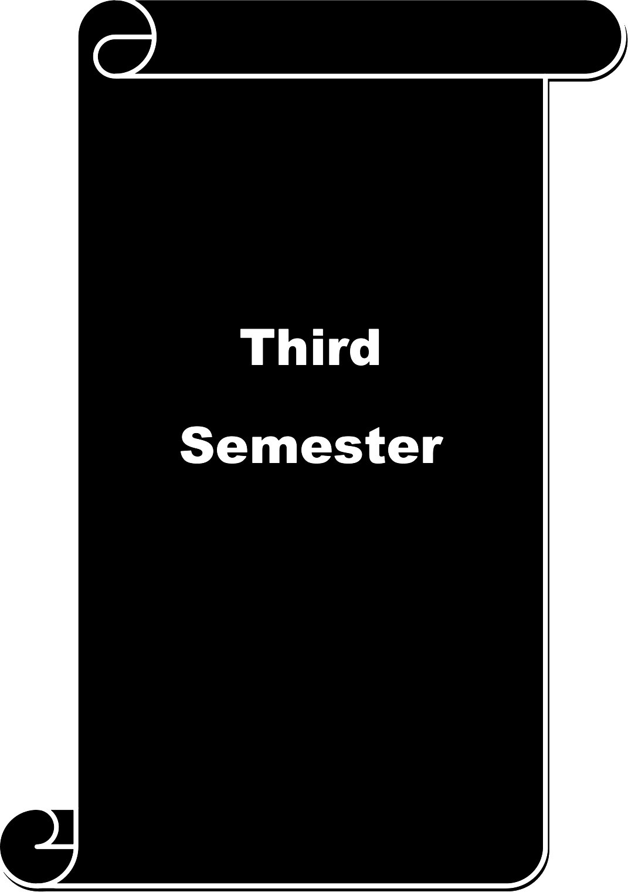

Course code |  |  | 33A |  | HUMAN RIGHTS SOCIAL JUSTICE AND  SOCIAL WORK |  | L | T |  |  | P | C
Core VI |  |  |  |  |  |  | 3 | . |  |  | - | 4
Pre-requisite |  |  |  |  | Understanding concept of right's and Sy  fundamentals rights of constitution |  | syllabus  Version |  | 2026-  2027
Course Objectives:
The main objectives of this course are to:

- Social work students should know the concept of human rights
- Student must equip them on the knowledge of human rights for vulnerable groups
- It help them in understanding the role of social work in human rights
Expected Course Outcomes:
On the successful completion of the course, student will be able to:
1 |  | Increase their knowledge on human rights |  |  |  |  |  |  |  | K2
2 |  | They can play the role of advocacy for the victims in the society |  |  |  |  |  |  |  | K5
3 |  | They will involve themselves in women empowerment activities |  |  |  |  |  |  |  | K3
4 |  | It will equip their skills to work for social justice |  |  |  |  |  |  |  | K3
5 |  | They can start an NGO through which constantly they work for the rights of many  vulnerable groups |  |  |  |  |  |  |  | K6
K1 - Remember; K2 - Understand; K3 - Apply; K4 - Analyze; I'iS - Evaluate; K—6 Create
Unit:1 |  |  | HUMAN RIGHTS |  |  |  | 15 hours
Human rights —Meaning, concept - classification of rights- Moral rights — Legal rights- Civil
rights- political rights- Human rights and Issues of social justice..
Unit:2 |  |  | UN DECLARATION OF HUMAN RIGHTS |  |  |  | 15 hours
. Human rights concern- The UN Declaration of Human rights- Fundamental rights and Duties
under the Indian Constitution- Directive principles of State Policy (DPSP).
Unit:3 |  |  | HUMAN RIGHTS FOR VULENERABLE GROUPS |  |  | 15 hours
Human rights of Emerging Sectors- Children's rights- Refugees-Indigenous people- Contemporary
issues in Human rights — Female infanticide, child labour, bonded labour. Dalit and Human rights.
Unit:4 |  |  | WOMEN'S RIGHTS |  |  | 14 hours
Women rights — Problems of women- child marriage, rape, torture, dowry, wage disparities in
agricultural and Industrial sectors, gender bias- Empowerment of women. Role of Government and Non-governmental organization in solving women problems.
Unit:5 |  |  |  | ROLE OF SOCIAL WORKER IN HUMAN RIGHTS |  |  | 14 |  |  |  | hours
Role of social work (Voluntary organization) in relation to Human rights. National Human rights
Commission, State human rights commission, Human rights court-Public Interest Litigation (PIL), Legal Aid, Lok Adalats, Role of advocacy, Role of social action.
Unit:6 |  |  |  | Contemporary Issues |  | 2 hours
 |  |  |  | Expert lectures, online seminar—s webinars
 |  |  |  | Total Lecture hours |  | 75 hours
Text Book(s)
1 | Biswal Tafan 2003 Social work and Human rights: New Delhi: Rawat
2 | Hobhouse L.T 1922 Elements of social justice, London: Allen and Unwin
3 | Jagannadhan .V. 1978 Administration and social Change, New Delhi. Uppal.

Reference Books
1 | Malhotra . M. (ed) 1992) Anthropology of development,  Mittal publications, New Delhi,
2 | Richard B Brandt (Ed) 1962 Social justice,  Prentice - hall, Inc, N 1 1962
Related Online Contents [MOOC, SWAYAM, NPTEL, Websites etc.]
1 | https:llwww.un.oi‘g/en/sections/issues-depth/human-rights/
2 | https:llwww.dot.Nov/agencies/ilab/our-work/woikers-riehts
3 | http:llwww.womenlawsindia.com/1egal-awai‘eness/women-iights-in-india/
Course Designed By: Dr. Sam Lovely Son Dr. Sasikalamary

Mapping with Programme Outcomes
Cos | PO1 | PO2 | PO3 | PO4 | PO5 | PO6 | PO7 | PO8 | PO9 | PO10
CO1 | M | M | M | S | S | S | M | M | M | S
CO3 | S | S | M | S | S | S | M | M | M | S
CO3 | M | L | L | M | M | M | M | S | M | S
CO4 | M | M | M | M | S | S | S | M | M | M
CO5 | S | S | S | S | S | S | S | M | M | S
*S-Strong; M-Medium; L-Low

Course code |  | 33B | COUNSELLING AND GUIDANCE |  | L | T | P | C
Core VII |  |  |  |  | 3 | - | - | 4
Pre-requisite |  |  | Essential knowledge on Human Growth and Development  Basic knowledge on the Indian Sociology |  | Syllabus Version |  | 2026-  2027
Course Objectives:
- To impart basic understanding on the Counseling and its scope
- To clarify the doubts between various related terms such as, guidance, direction, advice, assistance and psychotherapy.
- To give an out sketch on the common techniques at use in Counselling
- To help the students know the functions and skills of Counsellor essential to serve with different groups
Expected Course Outcomes:
1 | Students can remember that relationship is the key of Social Work. |  |  |  |  |  | K1
2 | Students shall be acquainted with an understanding to differentiate Counselling with  related terms. |  |  |  |  |  | K2
3 | Students can be influenced for voluntary behavioral change and self-realisation. |  |  |  |  |  | K3
4 | The course deepens the understanding on conditions facilitating voluntary  behavioural change and reasons to promote face- to —face professional relations. |  |  |  |  |  | K4
5 | Case histories discussed and role-plays sessions conducted in the class can be a tool  of self-evaluation to discover their understanding on the subject. |  |  |  |  |  | K5
6 | The course shall inspire young minds to become efficient and effective Counsellors  and increase learning platforms where, employability is not constrained. |  |  |  |  |  | K6
K1 - Remember; K2 - Understand; K3 - Apply; K4 - Analyze; K5 - Evaluate; K6 — Create
Unit:1 |  | CONCEPT OF COUNSELLING |  |  | 15 hours
Meaning and definition of the term counselling Goals and objectives of counseling scope of
counselling.
Unit:2 |  | DIFFERENCES WITH RELATED TERMS |  |  | 15 hours
Counselling and Guidance — Counselling and Psychotherapy Counselling and advice — Counselling
and Direction— Counselling and assistanc—e Counselling as profession.
Unit:3 |  | COMMON TECHNIQUES FOR COUNSELLING |  | 15 hours
Psychoanalytical model and behaviour modification and counselling.
Unit:4 |  | INFLUENTIAL FACTORS OF COUNSELLING |  | 14 hours
Factors influencing Counselling relationship; namely, social, emotional, religion, sex, age, etc — Basic
principles and processes of Counselling.
Unit:5 |  | BASIC REQUIREMENTS FOR COUNSELLING |  | 14 hours
Counselling with different Groups- skills , roles & Functions of the counsellor

Unit:6 |  | Contemporary Issues | 2 hours
 |  | Expert lectures, online seminar—s webinars
 |  | Total Lecture hours | 75 hours
Text Book(s)
1 | Human Growth & Development— Elizabeth Hurlock
2 | Fundamentals of Counselling - Shertzon and Stone
3 | Introduction to Counselling (New) - Tobber E.L
Reference Books
Counselling Psychology - Narayana Rao
2. Textbook of Psychiatry — Vol. 1 & 2
Related Online Contents [MOOC, SWAYAM, NPTEL, Websites etc.]
1 https://medium.com/%popularrightnow/difference-between-counselling-and-guidance-a9d7f4tdbd3d
2https://en.wikipedia.org/wiki/Psychoanalytic_theory
3https://www.yourcounseIIingservice.co.uk/areas-ot-counselling/
Course Designed By: Dr. Sam Lovely Son Mr. Francis Xavier

Mapping with Programme Outcomes
Cos | PO1 | PO2 | PO3 | PO4 | PO5 | PO6 | PO7 | PO8 | PO9 | PO10
CO1 | L | L | M | M | M | M | M | M | M | S
CO3 | M | M | M | M | M | S | S | S | M | S
CO3 | S | M | M | S | S | S | S | S | M | S
CO4 | S | M | S | S | S | M | S | S | M | M
COS | M | M | S | S | S | S | S | S | M | M
*S-Strong; M-Medium; L-Low

Course code |  | 3AC | COMPUTER OFFICE AUTOMATION | L |  |  | T | P | C
Allied |  |  | COMPUTER OFFICE AUTOMATION | 3 |  |  | - | - | 4
Pre-requisite |  |  | Basic knowledge on computer | Syllabus  Version |  |  |  | 2026-  2027
Course Objectives:
The main objectives of this course are to:

- Students will get basic computer knowledge
- Students know the usage of internet
- Students will able to use computer for analysis of data
Expected Course Outcomes:
On the successful completion of the course, student will be able to:
1 | Students can use computer to store information their profession |  |  |  |  |  |  | K2
2 | With the help of computer knowledge they can do their work effectively and  smartly |  |  |  |  |  |  | K2
3 | They can work as data analyser in an NGO |  |  |  |  |  |  | K4
4 | Student will be helped to create innovative and interesting programmes in their  profession with the help of computer knowledge |  |  |  |  |  |  | K6
5 | Students will increase their research skill with the help of computer |  |  |  |  |  |  | K3
Unit:1 |  | APPLICATION OF COMPUTER IN SOCIAL WORK  PROFESSION |  |  |  | l S hours
Introduction to compute—r definition, History of computer, generations, types of computers. Need
and importance of computers in Social Work Profession. Software—e system software, application software, operating software and programming languages.
Unit:2 |  | MS WORD |  |  |  | 15 hours
MS Word — Features, Creating, Saving and Opening Documents in Word, Key board Shortcuts,
Editing, Previewing, Printing, & Formatting a Document. Converting a word document into various formats like - Text, Rich Text format, Word perfect, PDF. Introduction to MS Access. MS Excel - Worksheet basics, creating worksheet, saving & quitting worksheet, Keyboard shortcuts. Formulae & cell referencing, Auto sum, coping formulae, formatting of worksheet, Previewing & Printing worksheet, Graphs and charts, Database.
Unit:3 |  | MS POWER POINT |  |  | 15 hours
MS Power Point creating a blank presentation, save and edit, auto layout, insert a new slide,
applying design template, changing slide layout, slide show and editing custom slide. Adding notes, insert Video and Audio, Adding clip art, Backgrounds, Slide master Header and footer, Slide numbers Date and time. Basic applications and use of Corel draw and Photoshop for Social Work Profession.
Unit:4 |  | SIGNIFICANCE OF INTERNET |  |  | 14 hours
Internet IP address, Web Browsers, Internet Services Providers, Internet Security, Web Search
Engines, and Internet Services. Creating Email account, Anatomy of e-mail, e-mail address, finding e-mail address, adding signature, attaching files, opening attachments, managing e-mail account. Introduction of e-books and e-journals, advantages of e-books and e-journals, list of

constructive-journals and e-books, ways and means to subscribe and publish
Unit:5 |  | STATISTICS PACKAGE FOR SOCIAL SCIENCES | 14 hours
SPSS history and evolutions-creating editing, coding, variables. Preparation of Coding Sheets.
Analysis mean, media & mode. Analysis of chi-square & correlations. Types of tables used in social research reports.
Unit:6 |  | Contemporary Issues | 2 hours
 |  | Expert lectures, online seminar—s webinars
 |  | Total Lecture hours | 75 hours
Text Book(s)
1 | Professional Office Procedure by Susan H Cooperman, Prentice Hall
2 | Information Technology: Principles, Practices and Opportunities by James A Senn, Prentice  Hall
Ref | erence Books
1 | Microsoft office reference guide by Tom Bunzel
2 | The SPSS book: A student guide to the Statistical Package for the Social Sciences by Mathew  Zagumny
Rela | ted Online Contents [MOOC, SWAYAM, NPTEL, Websites etc.]
1 | https://www.researchgate.net/publication/328869435 microsoft word learning
2 | https://www.acsedu.com/learning/studying-on-the-internet.aspx
4 | https://en.wikipedia.org/wiki/Data mining
Course Designed By: Dr. Sam Lovely Son Mr. Francis Xavier

Mapping with Programme Outcomes
Cos | PO1 | PO2 | PO3 | PO4 | PO5 | PO6 | PO7 | PO8 | PO9 | PO10
CO1 | M | M | L | M | M | L | S | S | S | M
CO3 | S | M | M | S | S | M | S | S | S | M
CO3 | M | M | S | S | S | M | S | M | M | M
CO4 | S | S | M | S | S | S | S | S | M | S
CO5 | M | M | M | S | S | M | M | S | M | S
S-Strong; M-Medium; L-Low

Course code |  | 3ZA | Social Work with Persons with Disabilities |  | L | T | P | C
Skill based subject |  |  |  |  | 3 | - | - | 3
Pre-requisite |  |  | Basic knowledge on the types of Disabilities, its  Prevention and Rehabilitation |  | Syllabus  Version |  | 2026-  2027
Course Objectives:
The main objectives of this course are to:
- To be exposed to the various types of disabilities and their causal factors, prevention, promotion and rehabilitation measures needed by each disability group at different life cycle stages and rehabilitation settings.
- To become aware of society's perception and attitude towards disabled persons.
- To understand issues and challenges faced by disabled
Expected Course Outcomes:
On the successful completion of the course, student will be able to:
1 | Enable students to develop a positive approach towards people with disabilities. |  |  |  |  |  | K1
2 | Students would have gained knowledge and understanding about disability history,  rights, policies, and contemporary issues. |  |  |  |  |  | K2
3 | Students will demonstrate improved skills in working with people with disabilities,  and increased ability to understand individual and family concerns. |  |  |  |  |  | K3
4 | Students will have a broader awareness of the applicability of disability studies  knowledge to a wide range of prolessions, and increased understanding of specilic careers related to working with people with disabilities. |  |  |  |  |  | K4
K1 - Remember; K2 - Understand; K3 - Analyse; K4 — Applicability
Unit:1 |  | Introduction to the Concept of Disability |  |  | 15 hours
Definition / Meaning of impairment, disability, handicap, exceptional child and differently abled,
Classification of Disabilities, advantages, disadvantages, Misconceptions and attitudes towards, the disabled.—Labeling —Changing concept of disability
Unit:2 |  | Sensory Impairments |  |  | 15 hours
Definition, Identification, Classification, Characteristics of Visual Impairment, Causes and Prevention
of Visual Impairment. Definitions, Identification, Classification, Characteristics of hearing impairment, Causes and Prevention of Hearing Impairment.
Unit:3 |  | Developmental Disabilities |  | 15 hours
Definitions, Misconceptions, Identification and Characteristics, Causes, and Classification of Mental
Retardation. Definitions, Misconceptions, Causes, Identification and Characteristics of Autism and ADHD.

Unit:4 |  | Locomotors Disabilities | 14 hours
Definitions, causes, classification of Physical Disabilities. Misconceptions, Identification and
Characteristics of Physical Disabilities
 |  | Rehabilitation of Persons with Disabilities Legal | 14 hours
PWD Act, Rehabilitation Council of India (RCI) Role of government (concessions, schemes) NGO,
INGO, and Social Workers for persons with disability.
Unit:6 |  | Contemporary Issues |  | 2 hours
 |  | Expert lectures, online seminars — webinars
 |  | Total Lecture hours | 75 hours
Text Book(s)
1 | M.N.G Mani & M.B. Jaiganesh, 2010. UDIS Forum, Coimbatore
2 | Moore, (2005) Researching disability issues, Open University, London
Reference Books
1. Albrecht G.L, Katherine D Seelman &amp; Michael Bury, (2001) Hand Book of disability Studies, Sage, London

3 Grant (2005) Learning disability: A lifecycle approach to valuing people, Open University Press, London
Related Online Contents
- http://www.includelebanon.org/pdf/types.pdf
- http://hesperian.org/wp-content/uploads/pdf/en dvc 2tJ09/en dvc 2tJ09 03.pdf 3.http://www.einarhelander.com/PD-Chapter-2.pdf
Course Designed By Dr. Sam Lovely Son Dr. John Wesley

Mapping with Programme Outcomes
COs | PO1 | PO2 | PO3 | PO4 | PO5 | PO6 | PO7 | PO8 | PO9 | PO10
CO1 | M | M | L | M | M | L | S | S | M | M
CO3 | S | M | M | S | S | M | S | S | M | M
CO3 | M | M | S | S | S | M | S | M | M | M
CO4 | S | S | M | S | S | S | S | S | S | M
COS | M | M | M | S | S | M | M | S | S | S
S-Strong; M-Medium; L-Low


Course code |  | 3FD | WOMEN'S RIGHTS | L T |  |  | P c
Non-Major Elective -I |  |  | WOMEN'S RIGHTS
Pre-requisite |  |  | Basic knowledge on Women's Right and related legislation | Syllabus Version |  |  | 2026-  2027
Course Objectives:
The main objectives of this course are to:

- To introduce Women's Rights in Constitution of India and Empowerment of Women
- To introduce legal systems and procedures of Women welfare in India.
Expected Course Outcomes:
On the successful completion of the course, student will be able to:
1 | It supposes understanding processes in different Women related legislation. |  |  |  |  |  | K3
2 | Help students to understand the legal systems and procedures of Women  welfare in India. |  |  |  |  |  | K4
3 | Gain insight into the problems faced by women and remedial measures through  legislation. |  |  |  |  |  | K3
4 | Understand Women Laws, remedies and free legal aid. |  |  |  |  |  | K3
5 | Gain insight to the working conditions of Women in the society with reference  to the constitutional rights. |  |  |  |  |  | K3
KI - Remember; K2 - Understand; K3 - Apply; K4 - Analyze; K5 - Evaluate; K6 — Create
Unit:1 |  | Laws, Legal Systems and Change |  |  |  | 15 hours
Definition - Constitutional law, CEDAW and International Human Rights Laws and Norms
Laws and Social Context — Constitutional and Legal Framework.
Unit:2 |  | Politics of land and gender in India |  |  |  | l S hours
Introduction— Faces of Poverty— Land as Productive Resource—s Locating Identitie—s
Women's Claims to Land — Right to Property - Case Studies.
Unit:3 |  | Women's Rights: Access to Justice |  |  | 15 hours
Introduction — Criminal Law — Crime Against Women — Domestic Violence — Dowry Related
Harassment and Dowry Deaths — Molestation — Sexual Abuse and Rape — Loopholes in Practice Law Enforcement Agency.
Unit:4 |  | Women's Rights and Legislation |  |  | 14 hours
Violence Against Women — Domestic Violence - The Protection of Women from Domestic
Violence Act, 2005 - The Marriage Validation Act, 1982 - The Hindu Widow Re-marriage Act, 1856 - The Dowry Prohibition Act, 1961
Unit:5 |  | Special Women Welfare Laws |  |  | 14 hours
Sexual Harassment at Work Places — Rape and Indecent Representation — The In decedent
Representation (Prohibition) Act, 1986 - Immoral Trafficking The Immoral Traffic (Prevention) Act, 1956 - Acts Enacted for Women Development and Empowerment - Role of Rape Crisis Centers.

Unit:6 |  | Contemporary Issues | 2 hours
 |  | Expert lectures, online seminar—s webinars
 |  | Total Lecture hours | 75 hours
Text Book(s)
I | Nitya Rao “Good Women do not Inherit Land” Social Science Press and Orient  Blackswan 2008
2 | P.D.Kaushik “Women Rights” Bookwell Publication 2007
3 | Aruna Goal “Violence Protective Measures for Women Development and  Empowerment” Deep and Deep Publications Pvt 2004
Refe | rence Books
1 | Preeti Mishra “Domestic Violence Against Women” Deep and Deep Publications Pvt 2007
2 | Monica Chawla “Gender Justice” Deep and Deep Publications Pvt Ltd.2006
Rela | ted Online Contents [MOOC, SWAYAM, NPTEL, Websites etc.]
1 | http://www.womenwarpeace.ore/issues/violance/GBVnairobi/finale
2 | http://legislative.gov.in/constitution-of-india
 | Course Designed By Dr. Sam Lovely Son Dr. Sasikalamary

Mapping with Programme Outcomes
Cos | PO1 | PO2 | PO3 | PO4 | PO5 | PO6 | PO7 | PO8 | PO9 | PO10
CO1 | M | S | S | S | M | M | L | M | M | M
CO3 | S | S | S | S | M | M | M | M | M | M
CO3 | M | S | S | S | S | S | S | S | M | M
CO4 | S | S | S | S | M | M | S | M | L | L
CO5 | S | S | S | S | M | M | M | M | L | M
*S-Strong; M-Medium; L-Low

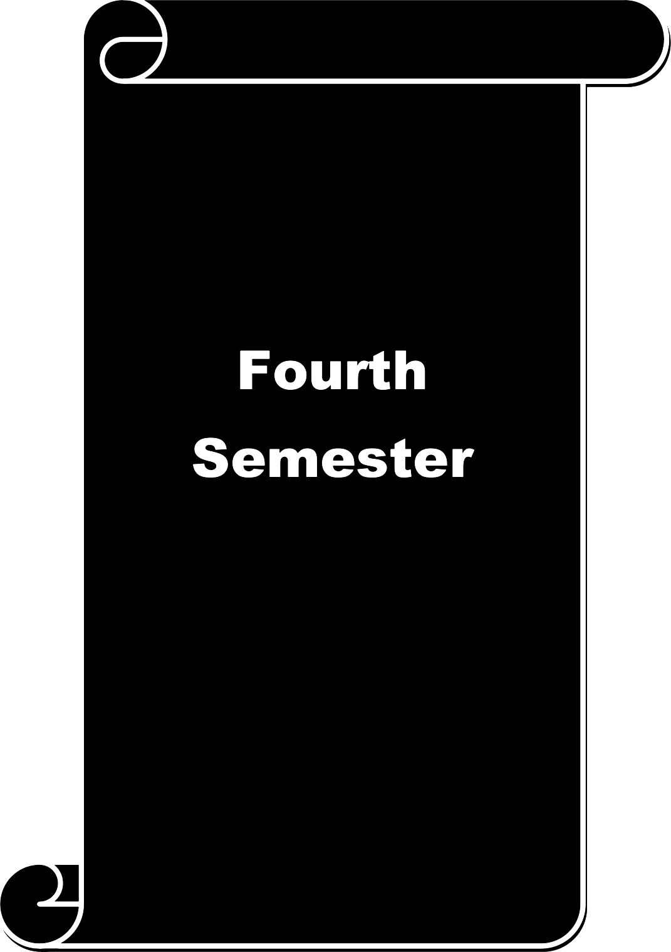

Course  code |  | 43A | SOCIAL WORK RESEARCH AND SOCIAL STATISTICS |  | L | T | P | C
Core VIII |  |  |  |  | 3 | - | - | 4
Pre-requisite |  |  | Methodological aspects of Research, and Elementary  Statistics and its Application to Social Work Research |  | Syllabus  Version |  | 2026-  2027
Course Objectives:
The main objectives of this course are to:
- To gain understanding of nature and relevance of social science research and its application in the study of social phenomena
- To learn steps and process of formulation of research design and carry out the same
- To learn about the process of conducting a review of literature
Expected Course Outcomes:
On the successful completion of the course, student will be able to:
1 | Able to demonstrate ability to be able to conduct research, and to do this with an  understanding of the application of different methods and tools |  |  |  |  |  | KI
2 | Interpret 9riantiiative rind qualitative information. |  |  |  |  |  | K2
3 | Intcgr‹itc one’s own ir1c‹is with those of others to address an issue |  |  |  |  |  | K3
4 | Create a questionnaire using clear and interesting questions, presenting them in a  well-organized manner |  |  |  |  |  | K4
5 | Able to develop skills of data collection, organization, presentation, analysis and  report Writing |  |  |  |  |  | K5
K1 - Understanding; K2 — Interpretation; K3 - Analyse; K.4 — Creativity ; K5— Applicability
Unit:1 |  | INTRODUCTION TO RESEARCH & BASIC CONCEPTS |  |  | 15 hours
Social work research: meaning, objectives, functions, types and limitations identification of the area
for research: selection and formulation of problems —formulation of assumptions — hypothesis: meaning, characteristics of a good hypothesis, sources and types of hypothesis — review of literature.
Unit:2 |  | RESEARCH DESIGN |  |  | 15 hours
Research design: definition and importance of research design — types of research design: qualitative,
quantitative, exploratory, diagnostic and experimental—l steps involved in conducting a research
Unit:3 |  | SOCIAL SURVEY & CASE STUDY: |  | 15 hours
Social survey: definition, objectives and scope — case study — historical study — comparative study —
participatory research: nature and significance.
Unit:4 |  | RESEARCH TOOLS, DATA ANALYSIS & RESEARCH  REPORTS |  | 14 hours
Sources and types of data: primary data: observation — interview schedule — questionnaire — pre-test
and pilot study — sociometry — secondary data: personal documents, public documents — classification of data and analysi—s research repor—t format and types.

 |  | SAMPLING FRAMEWORK & BASIC STATISTICS |  | 14 hours
Sampling and level of measurement: definition and types of universe — sampling designs: probability
sampling: simple random, systematic, stratified, cluster, proportionate and disproportionate sampling
— Non-probability sampling methods: purposive, judgment, quota snowball sampling — Average: arithmetic mean, Median, Mode Dispersion: mean deviation, standard deviation use of computer for statistical analysis.
Unit:6 |  |  | Contemporary Issues | 2 hours
 |  |  | Expert lectures, online seminars — webinars
 |  |  | Total Lecture hours | 75 hours
Text Book(s)
1 | Paneer selvam R, 2008. Research Methodology, Prentice Hall of India, New Delhi
2 | Allen Rubin and Earl R. Babbie, 2010 Research Methods for Social Work, Cengage
Related Online Contents
http://www.ignou.ac.in/upload/Bswe-003%20Block-4-UNIT-16-smal1%20size.pdf
http://ijmer.in/pdf/volume1-issue3-2012/201-212.pdf http://www.uk.sagepub.com/kumar4e/Kumar Chapter 2.pdf Course Designed By: Dr. Sam Lovely Son Dr.K.Premamalini

Mapping with Programme Outcomes
Cos | PO1 | PO2 | PO3 | PO4 | PO5 | PO6 | PO7 | PO8 | PO9 | PO10
CO1 | M | M | L | M | M | L | S | S | S | M
CO3 | S | M | M | S | S | M | S | S | S | M
CO3 | M | M | S | S | S | M | S | M | M | M
CO4 | S | S | M | S | S | S | S | S | M | S
CO5 | M | M | M | S | S | M | M | S | S | S
S-Strong; M-Medium; L-Low

Course  code |  | 46A | FIELD WORK ( OBSERVATION VISIT & RURAL CAMP) | L | T | P | C
Core IX |  |  | FIELD WORK ( OBSERVATION VISIT & RURAL CAMP) | - | - | 3 | 4
Pre-requisite |  |  | Basic understanding about NGO's and its nature | Syllabus Version |  | 2026-  2027
Course Objectives:
The main objectives of this course are to:

- Students will gain a knowledge on scope of social work in industry, hospital and in NGO
- It will impart them about the visions ,functions and responsibilities of various social organisation in relation to social work
- Students will understand the role of social worker in an organisation which serves the needy people in the society
Expected Course Outcomes:
On the successful completion of the course, student will be able to:
1 | Students will know the significance of social work |  |  |  |  | K1
2 | Students will able to understand the application of social work methods in the  organisations where they visit in person |  |  |  |  | K2
3 | It may equip them on the various functions of different organisations in  association with social work principles |  |  |  |  | K3
4 | Students will be motivated to became a social worker |  |  |  |  | K4
5 | It will throw light on their professional challenges in order to develop essential  skills |  |  |  |  | K5
K1 - Remember; K2 - Understand; K3 - Apply; K4 - Analyze; K5 - Evaluate; K6 — Create
In the fourth semester social work students will be given an opportunity to visit different
Industries, hospitals, and NGO's in order to orient about its nature vision, functions. Through this orientation visit students will have a knowledge on different organisations in and around Coimbatore. Students will be able to relate the need and importance of social work profession in the organisations which are mainly concern for the needy people in our society It will widen their awareness on scope of social work in different settings.
Students will also improve their writing skills by preparing reports for every visit they do in their field work. This will increase their confidence level when they prepare themselves and present itin the VIVA VOCE examination.
 |  | Total Lecture hours |  | -- hours

Text Book(s)
I | Sanjoy Roy (2012) Field work in social work
2 | Bishnu Mohan Dash, Sanjoy Roy (2019) Fieldwork Training in Social Work
Reference Books
I | Regna Scheyvens, Donovan Storey (2014) Development Field Work —A Practical Guide
2 | Jack Sanger (1996) TheCompleat Observer?
Related Online Contents [MOOC, SWAYAM, NPTEL, Websites etc.]
I | https://www.jstor.org/stable/23693658
2 | https://pdfs.semanticscho1ar.org/fdf2/b7c66l5442d645d54ld If95c773f5b51 cf3b.pdf
Course Designed By: Dr. Sam Lovely Son Dr.Sasikalamary

Mapping with Programme Outcomes
COs | PO1 | PO2 | PO3 | PO4 | PO5 | PO6 | PO7 | PO8 | PO9 | PO10
CO1 | M | M | S | M | M | S | S | S | M | S
CO3 | M | M | S | M | M | S | S | M | M | S
CO3 | S | M | M | L | M | M | M | L | M | M
CO4 | S | M | M | M | L | M | M | M | M | M
CO5 | S | M | M | M | M | S | M | M | M | M
*S-Strong; M-Medium; L-Low

Course code |  | 4AD | ENTERPRENEURIAL DEVELOPMENT |  | L | T P |  |  | C
Allied IV |  |  |  |  | 3 | - - |  |  | 4
Pre-requisite |  |  | Basic knowledge about Entrepreneurship |  | Syllabus  Version |  | 2026-  2027
Course Objectives:
The main objectives of this course are to:

- To familiarize the students with the concept and overview of entrepreneurship.
- To impart knowledge on the basics of entrepreneurial skills
Expected Course Outcomes:
On the successful completion of the course, student will be able to:
1 | Students will be able to gain knowledge and skills needed to run a business  successfully. |  |  |  |  |  |  | K6
2 | Students gain knowledge about industry structure. |  |  |  |  |  |  | K2
3 | Students will be able to know different kinds of Entrepreneurs. |  |  |  |  |  |  | K4
4 | Gain knowledge about Institutional Support System for entrepreneurial development |  |  |  |  |  |  | K4
5 | The course presents the various aspects of entrepreneurship. |  |  |  |  |  |  | K4
K1 - Remember; K2 - Understand; K3 - Apply; K4 - Analyse; I'iS - Evaluate; K—6 Create
Unit:1 |  | INTRODUCTION TO ENTREPRENEURSHIP |  |  | 15 hours
Entrepreneurship-Concept and Definition-Characteristics, functions and types of
entrepreneurs-Need for training and development-EDP-Phases of EDP-Development of women Entrepreneurs and rural Entrepreneurs.
Unit:2 |  | INSTITUTIONS SUPPORTING ENTREPRENEURS |  |  | 15 hours
Institutional finance to entrepreneurs —SFCs-SIDCs-SPCOT-commercial Banks-UTI-Small
Industries Development Bank.
Unit:3 |  | SPECIAL AGENCIESFOR ENTREPRENEURS |  | 15 hours
Special Agencies for entrepreneurs-DICs-SIDO-NSIC-SISIs-Indian Investment Centre-Khadhi
and Village Industries Commission.
Unit:4 |  | SOCIAL ENTREPRENEURSHIP |  | 14 hours
Social Entrepreneurship: Concept, Definition and the need of social Entrepreneurship-Similarities
and Differences between social Entrepreneurship and business Entrepreneurship. Central and state government Assistance to Women Entrepreneurs, person with disabilities and SC/ST Entrepreneurs.
Unit:5 |  | PROJECTS |  | 14 hours
Industrial Sickness-causes and consequences of Industrial sickness, corrective measures-
Government policies for small scale enterprises. Project identification -meaning and classification of project-project formulation —concept, significance and elements of project formulation — Evaluation and project report.

Unit:6 |  | Contemporary Issues | 2 hours
 |  | Expert lectures, online seminar—s webinars
 |  | Total Lecture hours | 75 hours
Text Book(s)
1 | Srinivasan. N.P. Entrepreneurial Development New Delhi: S.Chand.
2 | Khanka. S.S., “Entrepreneurial Development” S.Chand & Co. Ltd.,Ram Nagar, New Delhi,
3 | Donald F Kuratko, “ Entrepreneurship — Theory, Process and Practice”, 9th Edition, Cengage  Learning
Refe | rence Books
1 | Paramjeet Kaur Women entrepreneurs, New Delhi: Blaze.
2 | Saravanavel .P Entrepreneurial Development, Chennai: Esspee kay
Rela | ted Online Contents [MOOC, SWAYAM, NPTEL, Websites etc.]
1 | http://www.crectirupati.com/sites/default/fi1es/lecture notes/Entrepreneurship%20Developme  nt%20Notes.pdf
2 | https://www.researchgate.net/publication/276277153 A Literature Review on Entrepreneur  ial Development and its antecedents
Course Designed By: Dr. Sam Lovely Son Dr. Sasikalamary

Mapping with Programme Outcomes
Cos | PO1 | PO2 | PO3 | PO4 | PO5 | PO6 | PO7 | PO8 | PO9 | PO10
CO1 | M | S | S | S | M | M | L | M | M | M
CO3 | S | S | S | S | M | M | M | M | M | M
CO3 | M | S | S | S | S | S | S | S | M | M
CO4 | S | S | S | S | M | M | S | M | L | M
COS | S | S | S | S | M | M | M | M | L | S
*S-Strong; M-Medium; L-Low

Course code |  |  | 4ZB | FUNDAMENTALS OF ACCOUNTING | L |  | T | P | C
Skilled Based Subject-2 |  |  |  | FUNDAMENTALS OF ACCOUNTING | 3 |  | - | - | 3
Pre-requisite |  |  |  | Basic knowledge on math and Accounts Sy | syllabus  Version |  |  | 2026-  2027
Course Objectives:
The main objectives of this course are to:

- Students get basic knowledge on accounts
- Students will know final accounts and balance sheet
- Students will able to maintain accounts for non-profit organization
Expected Course Outcomes:
On the successful completion of the course, student will be able to:
I |  | Because of basic knowledge on accounts they can manage accounts |  |  |  |  |  | K2
2 |  | Students handle accounts for non-profit organisation |  |  |  |  |  | K4
3 |  | Students can able to manage financial matters in an organisation |  |  |  |  |  | K3
4 |  | Students can work as project manager |  |  |  |  |  | K3
5 |  | Students will able to frame budget for new project |  |  |  |  |  | K6
KI - Remember; K2 - Understand; K3 - Apply; K4 - Analyze; K5 - Evaluate; K6 — Create
Unit:1 |  |  | BOOK KEEPING |  |  | 15 hours
Book keeping: Definition, objectives, systems; Book of Accounts: Day book, Ledger Accounts;
Recording of Transactions: kinds of accounts; Rules for debit and credit.
Unit:2 |  |  | TRIAL BALANCE |  |  | 15 hours
Trial Balance: meaning, objectives, scope, preparation, error and rectification ;Performa Invoice;
Stock Register..
Unit:3 |  |  | FINAL ACCOUNTS AND BALANCE SHEET |  | 15 hours
Final Accounts and Balance Sheet: Definition, objectives and preparation of trading accounts;
Profit and Loss Account and Balance Sheet.
Unit:4 |  |  | ACCOUNTING FOR NON- PROFIT ORGANISATION |  | 14 hours
Accounting for Non-Profit Organisation: Receipts and Payments Account, Income and
Expenditure Account; Balance Sheet; Maintenance of Project Account.
Unit:5 |  |  | ACCOUNTING INFORMATION SYSTEM |  | 14 hours
Accounting Information System: meaning and importance, end users; Financial Statements:
limitations, rearrangement and modification, Accounting vs. Reporting formats; Preparation of Reports: Statement of Accounts, Statement of Inventory, Cash Flow Summaries.
Unit:6 Contemporary Issues 2 hours
 |  |  | Expert lectures, online seminar—s webinars
Text Book(s)
1 | Krishnaswamy, O.R. 1980. Cooperative Account Keeping. New Delhi: Oxford and IBH  Publishing Co.
2 | Maheswari, S.N. 1993. Financial Accounting New Delhi: Vikas Publishing House.
Ref | erence Books
1 | Grewaal, T.S. Introduction to Accountanc y. New Delhi: S. Chand & Sons.
2 | Gupta, R.L. Advance Accounting. Vol. I. New Delhi: S. Chand & Sons.

Related Online Contents [MOOC, SWAYAM, NPTEL, Websites etc.]
I | https://www.accountingtoo1s.com/artic1es/basics-of-accounting.html
2 | https://www.accountingcoach.com/ba1ance-sheet/exp1anation
3 | https://www.investopedia.com/articles/professionaleducation/11/accounting-information-  systems.asp
Course Designed By: Dr. Sam Lovely Son

Mapping with Programme Outcomes
Cos | PO1 | PO2 | PO3 | PO4 | PO5 | PO6 | PO7 | PO8 | PO9 | PO10
CO1 | M | M | M | L | L | L | L | M | M | M
CO3 | L | L | L | M | M | M | M | S | S | M
CO3 | L | L | M | L | L | L | M | S | S | M
CO4 | M | S | S | S | S | S | S | S | S | S
CO5 | S | S | S | M | M | M | S | S | S | S
*S-Strong; M-Medium; L-Low

Course code |  |  | 4FE | GENERAL AWARENESS | L |  |  | T | P | C
Non-major Elective II |  |  |  | GENERAL AWARENESS | 3 |  |  | - | - | 2
Pre-requisite |  |  |  | Basic understanding on general knowledge  and having reading skill | Syllabus  Version |  |  |  | 2026-  2027
Course Objectives:
The main objectives of this course are to:
1.Students improve their general knowledge
- Students can increase their aptitude and reasoning skill
- It will enlarge their knowledge on current affairs
Expected Course Outcomes:
On the successful completion of the course, student will be able to:
I |  | Students will be helped in preparing UPSC, SSC, TNPSC exams |  |  |  |  |  |  | K3
2 |  | Students can raise their confidence to write RRB and other banking exams |  |  |  |  |  |  | K2
3 |  | Students can able to participate in the entrance exams for higher education |  |  |  |  |  |  | K3
4 |  | Students can comprehend their knowledge level to attend campus interview |  |  |  |  |  |  | K4
5 |  | Students can able to participate in group discussions |  |  |  |  |  |  | K6
K1 - Remember; K2 - Understand; K3 - Apply; K4 - Analyze; K5 - Evaluate; K6— Create
Unit:1 |  |  | APTITUDE KNOWLEDGE |  |  |  | 15 hours
Verbal Aptitude and. Numerical Aptitude.
Unit:2 |  |  | REASONING KNOWLEDGE |  |  |  | 15 hours
Abstract Reasoning and. Tamil and Other Literature
Unit:3 |  |  | GENERAL SCIENCE |  |  | 15 hours
General Science and Technology and Education Computer
Unit:4 |  |  | KNOWLEDGE ON SOCIAL SCIENCES |  |  | 14 hours
Economics and Commerce and Social Studies
Unit:5 |  |  | CURRENT AFFAIRS |  |  | 14 hours
Sports and .Current Affairs
Unit:6 |  |  | Contemporary Issues |  |  | 2 hours
Expert lectures, online seminars — webinars
 |  |  | Total Lecture hours |  |  | 75 hours
Text Book(s)
1 | General Knowledge 2019 By Manohar Pandey
2 | Lucent's General Knowledge BY R.P Suman, Renu Sinah, Vinay Karna, Sanjeev Kumar,  Manvendra Mukul
Refe | rence Books
I | A modern approach to verbal and non-verbal reasoning By R.S Aggarval
2 | Malayala Manaroma Englisk Year Book 2020
Rela | ted Online Contents [MOOC, SWAYAM, NPTEL, Websites etc.]
I | https://www.careerpower.in/gk-general-knowledge.htm1
2 | https://www.learncbse.in/general-knowledge/
Course Designed By: Dr. Sam Lovely Son, Dr.Sasikalamary

Mapping with Programme Outcomes
COs | PO1 | PO2 | PO3 | PO4 | PO5 | PO6 | PO7 | PO8 | PO9 | PO10
CO1 | M | M | M | M | M | M | M | M | M | M
CO3 | M | M | M | S | M | S | M | M | M | M
CO3 | M | L | L | S | M | S | M | M | L | M
CO4 | M | L | L | M | L | M | M | M | M | M
CO5 | M | M | M | M | M | M | S | M | S | S
*S-Strong; M-Medium; L-Low

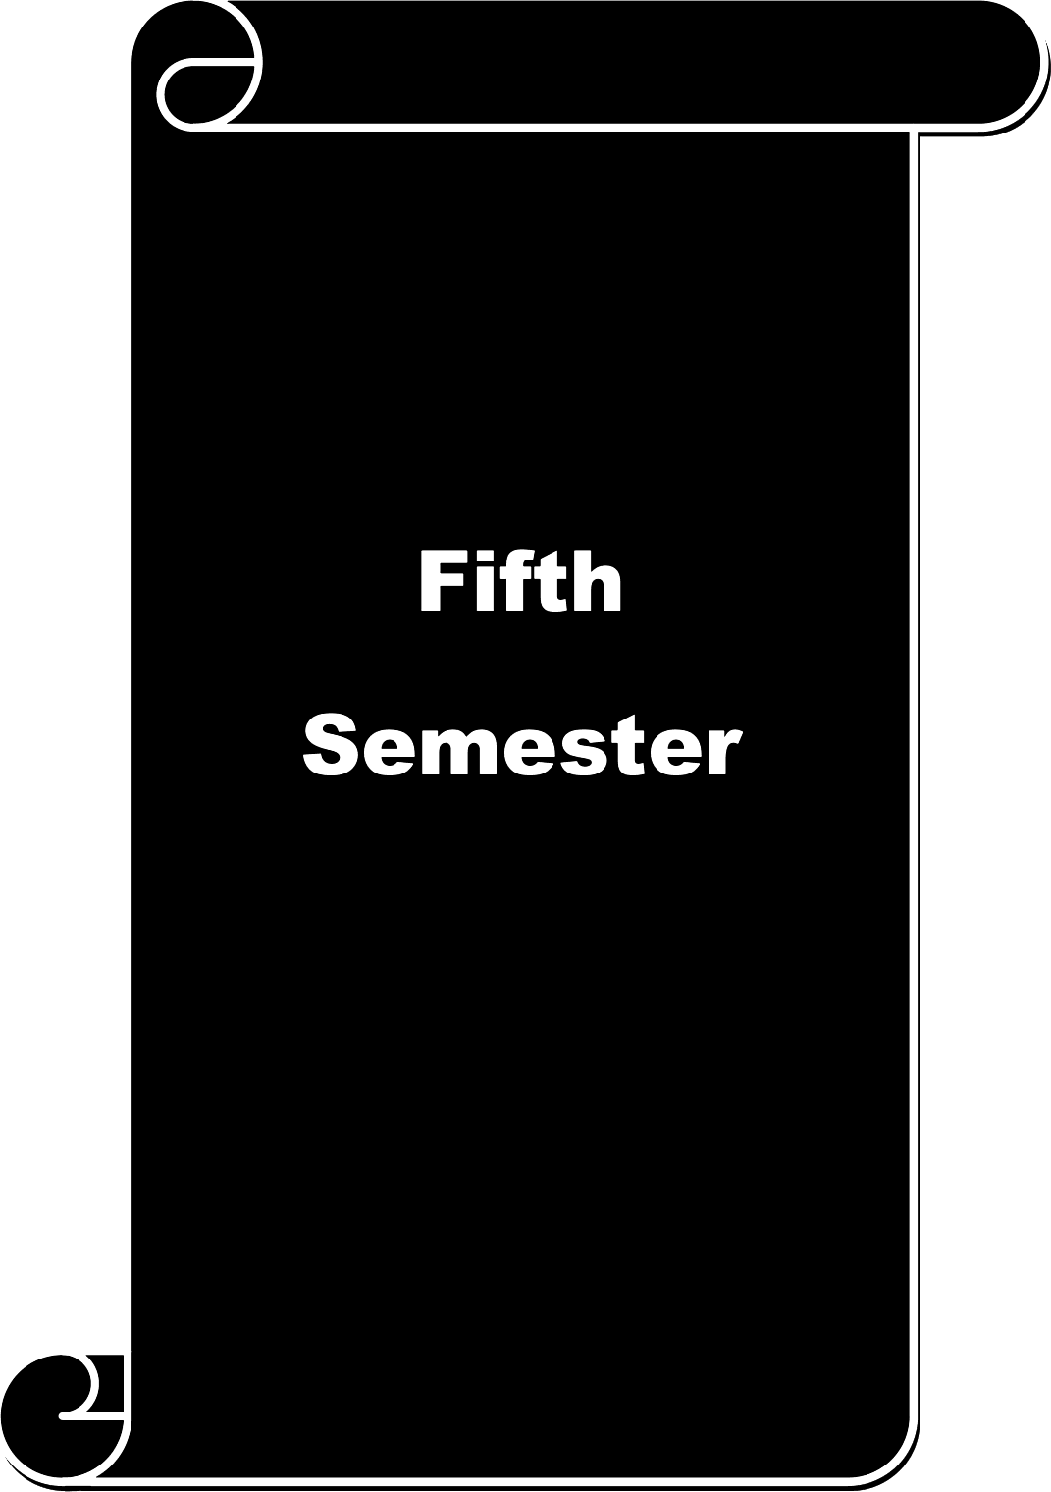

Course  code |  | 53A | SOCIAL WELFARE ADMINISTRATION |  | L | T | P | C
Core X |  |  |  |  | 3 | - | - | 4
Pre-requisite |  |  | Application of Social Welfare Administration method |  | Syllabus  Version |  | 2026-  2027
Course Objectives:
The main objectives of this course are to:
- Acquire basic knowledge in Social Welfare Administration.
- Develop an understanding of Social Welfare Administration and its approaches.
- Remember and evaluate the Social Welfare schemes and programmes.
Expected Course Outcomes:
On the successful completion of the course, student will be able to:
1 | Students get acquainted with concept and scope of Social welfare Administration. |  |  |  |  |  | K2
2 | Students to establish the qualities and skills of Social welfare Administration. |  |  |  |  |  | K3
3 | To facilitate the students about the personnel policies essential to promote  manpower. |  |  |  |  |  | K4
4 | The role and the responsibilities of Volunteer agencies are identified by the students |  |  |  |  |  | K3
5 | The students observes the Government contributions towards the social welfare. |  |  |  |  |  | K1  &K5
K1 - Remember; K2 - Understand; K3 - Apply; K4 - Analyze; K5 - Evaluate; K6 — Create
Unit:1 |  | CONCEPT AND SCOPE OF SOCIAL WELFARE  ADMINISTRATION |  |  | 15 hours
Social welfare administration—n Concept —Definition objectives, principles and scope of social
welfare administration.
Unit:2 |  | APPROACHES OF SOCIAL WELFARE  ADMINISTRATION |  |  | 15 hours
Administration proces—s planning, organizing, staffing, direction, Coordination, reporting, budgeting,
decision making. Leadership and communication.
Unit:3 |  | IMPORTANCE AND MAINTENANCE OF PERSONNELS |  | 15 hours
Personnel administration concept —definition —Staff selection orientation- placemen—t staff morale
— supervision — evaluation — public relations — fund raising.
Unit:4 |  | VOLUNTARY SOCIAL WLEFARE ORGANISATIONS |  | 14 hours
Voluntary social welfare organizations: Structur—e functions and problems of voluntary
Organizations in Indi—a Role of voluntary organizations in planned social change— Functioning of Boards and Committees.
Unit:5 |  | SOCIAL WELFARE ORGANISATIONS |  | 14 hours
Central Social Welfare Board and state social welfare advisory board, Departments of social welfare
at the center and state level—s Programmes, Activities, functions, Aiding process.
Unit:6 |  | Contemporary Issues |  | 2 hours
Expert lectures, online seminars — webinars
Total Lecture hours |  |  |  | 75 hours

Text Book(s)
1 | Batattacharia sanjay Social work administration and development, New Delhi, Rawat.
2 | Choudry .D. Paul Voluntary social welfare in India, New Delhi, sterling.
3 | ChoudryD.Paul; Social Welfare Administration, Lucknow, At maram and sons
Reference Books
1 | Rameshwari Devi Social Welfare Administration, Jaipur, Mangal deep publication  publication, Jaipur
2 | Sachdeva D.R Social Welfare Administration in India, Allahadad, kitab Mahal
Related Online Contents [MOOC, SWAYAM, NPTEL, Websites etc.]
1 | www.cswb. Gov.in
2 | https://www.quora.com/What-are-social-welfare-organizations
3 | https://journals.sagepub.com/doi/abs/10.1177/003231876001200102?journalCode=pnzb
Course Designed By: Dr. Sam Lovely Son, Dr.Sasikalamary

Mapping with Programme Outcomes
Cos | PO1 | PO2 | PO3 | PO4 | PO5 | PO6 | PO7 | PO8 | PO9 | PO10
CO1 | M | S | S | S | M | M | L | M | M | M
CO3 | S | S | S | S | M | M | M | M | M | M
CO3 | M | S | S | S | S | S | S | S | M | M
CO4 | S | S | S | S | M | M | S | M | L | S
COS | S | S | S | S | M | M | M | M | L | S
*S-Strong; M-Medium; L-Low

Course  code |  | 53B | DISASTER MANAGEMENT | L |  |  | T | P | C
Core XI |  |  | DISASTER MANAGEMENT | 3 |  |  | - | - | 4
Pre-requisite |  |  | Basic Knowledge on Disasters and types of  Disasters. | Syllabus  Version |  |  |  | 2026-  2027
Course Objectives:
The main objectives of this course are to:
- To provide students an exposure to disasters, types, and impact of disaster
- To understand the relationship between vulnerability, disasters, prevention and risk reduction
- To gain general understanding of Disaster Management and approaches
- To build skills to respond to disasters
Expected Course Outcomes:
On the successful completion of the course, student will be able to:
1 | Able to integrate knowledge and to analyze the disasters |  |  |  |  |  |  | K2
2 | Capacity to describe, analyse and evaluate the social, environmental, cultural,  economic, political and organizational aspects influencing vulnerabilities and capacities to face disasters. |  |  |  |  |  |  | K4
3 | Capacity to obtain, analyzes, and communicates information on risks, relief needs  and lessons learned from earlier disasters in order to formulate strategies for mitigation. |  |  |  |  |  |  | K5
4 | Able to manage disasters |  |  |  |  |  |  | K3
5 | Capacity to publish documentation, research papers on disasters |  |  |  |  |  |  | K6
K1 - Remember; K2 - Understand; K3 - Apply; K4 - Analyze; I'iS - Evaluate; K—6 Create
Unit:1 |  | CONCEPT OF DISATER |  |  |  | 15 hours
Disaster-meaning, concept, Definition, Types, Characteristics of disaster and consequences of
disaster.
Unit:2 |  | TYPES OF DISASTER |  |  |  | 15 hours
- Natural Disaster- floods, earthquake, draught, volcanoes, forest fires, coastal hazards,
and landslides.
- Manmade Disaster-Chemical and Industrial Accidents, Accidental explosions, Bomb blast, nuclear disasters, Pollutions.
Unit:3 |  | FACTORS INFLUENCING DISASTER |  |  | 15 hours
Factors influencing Natural and Manmade disaster-political, economic, social, cultural,
Ideological, Ecological, institutional, scientific and technological. Disasters and Development- causes and consequences.
Unit:4 |  | DISASTER MANAGEMENT |  |  | 14 hours
Disaster Management-Control plan, emergency preparedness. Disaster management cycle-Post
disaster review, results of exercises, prevention, mitigation, preparedness. Intervention of State in Disaster.
Unit:5 |  | ROLE OF SOCIAL WORKERS |  |  | 14 hours
Role of Voluntary organization in Disaster Management, Social Work intervention in Disaster-
resource mobilization, working with other professionals.

Unit:6 |  | Contemporary Issues 2 hours
 |  | Expert lectures, online seminar—s webinars
Text Book(s)
1 | Damon, P. Copola, - Introduction to International Disaster Management
2 | Murthy D.B.N. - Disaster Management, Deep and Deep Publication PVT. Ltd. New Delhi
Reference Books
1 | Indu Prakash - Disaster Management Rashtra Prahari Prakashan, Sahibad, Gaziabad.
2 | Narayan B. - Disaster Management A.P.H. Publishing Corporation, New Delhi.
Related Online Contents [MOOC, SWAYAM, NPTEL, Websites etc.]
1 | https://ndma.gov.in/
2 | https://www.sciencedirect.com/science/article/pii/S1976131719305109
4 | https://www.physio-pedia.com/Disaster Management
Course Designed By: Dr. Sam Lovely Son, Dr.Premamalini

Mapping with Programme Outcomes
Cos | PO1 | PO2 | PO3 | PO4 | PO5 | PO6 | PO7 | PO8 | PO9 | PO10
CO1 | S | M | M | S | S | S | S | S | M | M
CO3 | M | M | M | S | M | M | M | M | M | S
CO3 | S | M | M | S | S | S | S | S | M | S
CO4 | S | M | S | S | S | S | S | S | M | M
CO5 | S | S | S | S | S | S | S | S | M | S
*S-Strong; M-Medium; L-Low

Course  code |  |  | 53P | FIELD WORK PLACEMENT | L | T | P | C
Core XII |  |  |  | FIELD WORK PLACEMENT | - | - | 3 | 4
Pre-requisite |  |  |  | Basic knowledge on role and responsibilities of  social worker | Syllabus  Version |  | 2026-  2027
Course Objectives:
The main objectives of this course are to:

- Students will understand the methods of social work and its application in their field work organization
- They will be given an exposure to observe and work in the organisation effectively
- Students will equip themselves to organize a program with the support of the organization
Expected Course Outcomes:
On the successful completion of the course, student will be able to:
I |  | Students will be able understand the nature of the organisation where they are  place for field work |  |  |  |  | KI
2 |  | Students can assist their supervisor in the organisation |  |  |  |  | K2
3 |  | Students will be able to organise a programme by applying their knowledge on  methods of social work |  |  |  |  | K3
4 |  | Students equip their professional skills and techniques through their practical  exposure |  |  |  |  | K4
5 |  | It will give them confidence to work as social worker in an organisation |  |  |  |  | K5
K1 - Remember; K2 - Understand; K3 - Apply; K4 - Analyze; K5 - Evaluate; K6 — Create
During fifth semester social work students will be placed in a Non- Governmental Organisation for
two consecutive days in a week in order to acquaint with the objective, administrative functions and its programmes. Through this concurrent field visit students will be given a chance to observe the activity of the organisation. And also they can involve themselves in every event. Students can organise a community awareness programme based on their knowledge on social work. It will increase their professional skills. They will have rich experience and exposure in social work and its significance in an NGO
Through this maximum of 25 days of field visit in an organisation students gain knowledge on writing, and communication skills, they will also strengthen their organising skills.
Text Book(s)
1 | Social work Method by Ravi Arya
2 | Understanding Social Work by John Pierson
Refe | rence Books
I | Theory and Practice of Social Work by M.K. Singh
2 | Social skill guide book by Chris MacLeod
1 | https://govinfo.library.unt.edu/negp/reports/orguide.pdf
2 | https://comm-org.wise.edu/papers97/beckwith.htm
4 | https://www.iwgia.org/images/publications/tJ647 COT manual.pdf
Course Designed By: Dr. Sam Lovely Son, Mr. Francis Xavier

Mapping with Programme Outcomes
COs | PO1 | PO2 | PO3 | PO4 | PO5 | PO6 | PO7 | PO8 | PO9 | PO10
CO1 | M | L | S | L | M | M | M | M | M | M
CO3 | M | M | S | L | M | M | M | M | M | M
CO3 | M | M | M | L | M | S | M | M | S | L
CO4 | M | M | M | M | L | S | M | M | S | M
CO5 | S | M | M | M | M | S | S | M | M | M
*S-Strong; M-Medium; L-Low

Course  code |  | 5EA | COMMUNITY DEVELOPMENT |  | L | T P |  |  | C
Elective I |  |  |  |  | 3 | - - |  |  | 4
Pre-requisite |  |  | Basic understanding on community its characteristics, Sy  types and its problems |  | syllabus Version |  | 2026-  2027
Course Objectives:
The main objectives of this course are to:
- Students understand concept of community development
- Students will enrich their knowledge on local self-government and its function
- Students will gain knowledge on urban community development
Expected Course Outcomes:
On the successful completion of the course, student will be able to:
1 | They can develop their knowledge on community development and its activities |  |  |  |  |  |  | K2
2 | Students will know about the functions of local self-government |  |  |  |  |  |  | K2
3 | Students can design a project for rural community development |  |  |  |  |  |  | K6
4 | Students can able to evaluate projects for urban community development |  |  |  |  |  |  | K5
5 | Students can able work as project manager in an NGO |  |  |  |  |  |  | K3
K1 - Remember; K2 - Understand; K3 - Apply; K4 - Analyze; I'iS - Evaluate; K—6 Create
Unit:1 |  | COMMUNITY DEVELOPMENT |  |  | 15 hours
Origin and development of community development : Meaning, need, Early experiments: -
Srinikethan, Marthandom and Gurgaon. Pilot projects: - Nilokehri experiment, Firka Scheme, Extension: Principles and methods.
Unit:2 |  | RURAL COMMUNITY DEVELOPMENT |  |  | 15 hours
. Rural community development - concept, principles, need- Programmes : IRDP,ITDP, TRYSEM,
Swarna Jayanthi Gram Swarozgar Yojana, Rural Housing Schemes, NRCP, Rural Sanitation Programme, Watershed Development, Role of NIRD and SIRD.
Unit:3 |  | LOCAL SELF GOVERNMENT |  | 15 hours
Local self-government- Local self-government in ancient India, during Mugal and British period.
Panchayat Raj system, Role and function of village president, chairman, BDO. Constitutional (73rd) amendment, state legislation strengths and weakness.
Unit:4 |  | URBAN COMMUINTY |  | 14 hours
Urban community: Urban - meaning, classification and characteristics. Slum: -Meaning, charactristics and types.
Tamilnadu slum clearance Board, Tamilnadu housing board, Chennai Metropolitan development authority.
Unit:5 |  | URBAN COMMUNITY DEVELOPMENT |  | 14 hours
Urban community development: Urban community development: Meaning, need, principle, Urban
Programmes, IUDP, UBS, Swarna Jayanthi shahari Rozgar Yojana, Urban self-employment schemes. Development of Women and Children in Urban Areas (DWCUA). District Rural Development Agency (DRDA), Land Reforms Schemes, National Social Awareness Programme (NSAP), Employment Assurance Scheme (EAS)
Unit:6 |  | Contemporary Issues |  | 2 hours
Expert lectures, online seminar—s webinars

Text Book(s)
1 | Bhadouria and Dua 1986 Rural development strategies and Perspectives; Delhi, Anmol.
2 | Bose, Ashian 1974 Studies in India's Urbanization 1901 to1971, New Delhi, Tata Mcgraw  Hill.
3 | Cedric Payn 1990 Housing and Urbanization: A study of india, New Delhi, Saye .
Reference Books
1 | Dubey M.K. (2000) Rural and urban development, New  Delhi, Common wealth.
2 | Rjeswar dayal (1962) Community development programmes in  India Allahabad, kitab mahal.
Related Online Contents [MOOC, SWAYAM, NPTEL, Websites etc.]
1 | https://en.wikipedia.org/wiki/Community development
2 | https://www.scribd.com/doc/21976896/Understanding-Urbanization-Urban-Community-  Development
3 | https://en.wikipedia.org/wiki/Rural community development
Course Designed By: Dr. Sam Lovely Son, Dr. Sasikalamary

Mapping with Programme Outcomes
Cos | PO1 | PO2 | PO3 | PO4 | PO5 | PO6 | PO7 | PO8 | PO9 | PO10
CO1 | M | L | L | M | M | M | M | M | M | M
CO3 | L | M | L | M | L | L | M | M | M | M
CO3 | S | M | M | S | M | M | S | S | L | S
CO4 | S | M | M | S | M | M | S | S | M | S
COS | S | M | M | S | S | S | S | S | M | S
*S-Strong; M-Medium; L-Low

Course code |  | 5EB | URBAN COMMUNITY DEVELOPMENT | L |  | T | P | C
Elective-l |  |  | URBAN COMMUNITY DEVELOPMENT | 3 |  | - | - | 4
Pre-requisite |  |  | Basic knowledge on communities and its  types, characteristics | Syllabus  Version |  |  | 2026-2027
Course Objectives:
The main objectives of this course are to:
1.To provide the students with theoretical knowledge of urbanization, 2.To educate them on urban administration
3. various urban problems, and programmes for Urban Community Development.
Expected Course Outcomes:
On the successful completion of the course, student will be able to:
1 | The student should know various theories on urban life, problems and  development. |  |  |  |  |  | K1
2 | The students learn administrative structure and programmes for urban  development. |  |  |  |  |  | K2
3 | They acquire the skills to work with the urban community, development and  implement programmes |  |  |  |  |  | K3
4 | They can evaluate various projects on urban development |  |  |  |  |  | K4
5 | Through their research work they contribute in project formulation for state and  central Government |  |  |  |  |  | K6
K1 - Remember; K2 - Understand; K3 - Apply; K4 - Analyze; K5 - Evaluate; K6 — Create
Unit:1 |  | URBAN COMMUNITY ITS MEANING AND  CHARACTERISTICS |  |  |  | 15 hours
Urban Community Meaning, characteristics, rural — urban difference. Urban Classification: City,
Town, Metropolis, satellite towns and Smart Cities.- Urbanization and Urbanism: Meaning, Characteristics and theories of urbanization - Migration — Concepts, causes, types and theories.
Unit:2 |  | URBAN SOCIAL PROBLEMS |  |  |  | 15 hours
Urban social Problems Housing, drug addiction, juvenile delinquency, prostitution/commercial
sex, pollution, Solid waste management, e-waste management. Unorganized/Informal sectors: concept, characteristics; Unorganized Labour: child labour, women labour and construction workers. Slum: definition, causes, characteristics, classification, approaches, theories and culture of slums
Unit:3 |  | URBAN COMMUNITY DEVELOPMENT |  |  | 15 hours
Urban Community Development Definition, concept, objectives, principles and historical
background; Approaches: Basic Service Approach, Integrated Development Approach, Participatory Approach, Sustainable Development Approach — Urban development agencies: Chennai metropolitan development authority (CMDA), EXNORA, SULAB International. Importance of community planning and community participation in urban development.

Unit:4 |  | URBAN DEVELOPMENT | 14 hours
Urban Development Administration National, state and local levels; Urban services and urban
deficiencies; 74th amendment and salient features of Nagarpalika Act; Structure and functions of urban development agencies: Municipal Administration Corporations, Municipalities, Town Panchayats, metropolitan development authorities; Relationship between of officials and non- officials in urban self government; slum clearance board, housing board, Housing and Urban Development Corporation (HUDCO), and United Nation's Centre for Human Settlement (UNCHS); role of voluntary agencies in urban development. Role of community development worker in Urban community development.
Unit:5 |  | URBAN DEVELOPMENT PROGRAMMES | 14 hours
Urban development Programme Town planning: Meaning, Town and Country Planning Actl971 -
Urban Basic Services Programmes (UBSP) - Tamil Nadu Urban Development Project (TNUP) - National Slum Development Programme (NSDP) - Intergrated Housing & Slum Development Programme (IHSDP) - Jawaharlal Nehru National Urban Renewal Mission Scheme (JUNURUM) - Prime Minister's Intergrated Urban Poverty Eradication Programme (PMIUPES) Swarna Jayanti Shahari Rozhar Yojana (SJSRY) - Nehru Rozgar Yojana (NRY) - Tamil Nadu Slum Clearance programme - Urban Health and Sanitation programme - Role of community development wing in implementation of UCD programme, problems in implementation of urban community development programme, Application of social work method to overcome the problems in implementation of urban community development programme.
Unit:6 |  | Contemporary Issues | 2 hours
 |  | Expert lectures, online seminar—s webinars
 |  | Total Lecture hours | 75 hours
Text Book(s)
1 | Aray&Abbasi, 1995. Urbanisation and its Environmental Impacts. New Delhi: Discovery
2 | Bhatttacharya B, 2006, Urban Development Concept in India, New Delhi: Clinard,
3 | Datta. A (Ed.). 1980, Municipal and Urban India. New Delhi: Indian Institute of Public  Administration.
Ref | erence Books
1 | Ramachandran, 1989, Urbanisation and Urban System in India. Oxford University Press, New  Delhi
2 | Jayabalan. K, 2002, Urban Sociology. New Delhi: Atlantic Publishers
Rela | ted Online Contents [MOOC, SWAYAM, NPTEL, Websites etc.]
1 | https://www.sociologygroup.com/meaning-of-urban-community/
2 | https://www.pewsocialtrends.org/20 I 8/05/22/views-of-problems-facing-urban-suburban-and-  rural-communilics/
3 | https://www.makaan.com/iq/news-views/urban-deve1opment-schemes-in-india-you-should-  know-about
Course Designed By: Dr. Sam Lovely Son, Mr. Mohan

Mapping with Programme Outcomes
COs | PO1 | PO2 | PO3 | PO4 | PO5 | PO6 | PO7 | PO8 | PO9 | PO10
CO1 | S | M | M | L | M | M | S | S | M | S
CO3 | M | M | M | L | M | S | M | S | M | S
CO3 | M | M | M | M | L | M | M | M | S | S
CO4 | M | M | M | M | M | M | S | S | S | S
CO5 | M | M | M | M | M | S | S | S | S | S
*S-Strong; M-Medium; L-Low

Course  code |  | 5EC | WELFARE OF THE MARGENALISED | L |  | T | P | C
Elective I |  |  | WELFARE OF THE MARGENALISED | 3 |  | - | - | 4
Pre-requisite |  |  | Basic knowledge on Rural Settings, Community  and Social Institutions | Syllabus  Version |  |  | 2026-  2027
Course Objectives:
The main objectives of this course are to:
- To educate the students with regard to Scheduled Castes, Scheduled Tribes and Other marginalised communities.
- To sensitive those on crucial problems like Untouchability, Bonded labor and Women related problems.
Expected Course Outcomes:
On the successful completion of the course, student will be able to:
1 | Students get acquainted with advanced level of knowledge in Social Work to  work for marginalised communities of the society |  |  |  |  |  | K2
2 | Students to meet out various challenges in the modern society / community. |  |  |  |  |  | K3
3 | Course facilitates the students to enhance their employability skills and enables  them to take up the challenging job assignments. |  |  |  |  |  | K4
4 | Students will able to find out the real cause for the problem and plan interventions |  |  |  |  |  | K3
5 | Will nurture the Social Work Professionals to become effective Social Worker and  contribute to the society with commitment and integrity. |  |  |  |  |  | K5
K1 - Remember; K2 - Understand; K3 - Apply; K4 - Analyze; I'iS - Evaluate; K—6 Create
Unit:1 |  | MARGINALISED COMMUNITY |  | 15 hours
Definition, Concept, Criteria for Classification of marginalised community; Meaning of Scheduled Castes,
Schedule Tribes, Denotified Communities, Nomadic and Semi-nomadic Communities and Most Backward Classes — Administrative Setup at the Central, State and District Levels for the Development of Weaker Sections.
Unit:2 |  | UNTOUCHABILITY |  | 15 hours
Untouchability: Historical, Sociological and Psychological Perspectives of Untouchability — Origin of
Untouchability: Traditional Theory, Racial Theory, Theory of Ceremonial /Occupational Purity and Occupational Theory— Causes of Untouchability - Harmful effects of the practice of Untouchability Role of Social Reformers and Voluntary Agencies in the Removal of Untouchability Constitutional and Legislative Measures for the eradication of Untouchability Failure of Constitutional Measures in abolishing Untouchability.
Unit:3 |  | SCHEDULED CASTES AND SCHEDULED TRIBES |  |  | 15 hours
Scheduled Caste: Definition Ecological Distribution Demographic, Social and Economic
Characteristics of Scheduled Castes Problems of the Scheduled Castes - Ideologies relating to the development of Weaker Section Programmes and Policies of Government and Non-governmental Organizations for the welfare measures of Scheduled Castes and its effects and impact. Scheduled

Tribes: Definition, Characteristics, and Problems of Scheduled Tribes Types of Tribal Movements
Causes of Tribal Unrest Approaches to solve Tribal Problems Welfare Programmes of the Government and their beneficiaries and failures.
Unit:4 |  | BONDED LABOUR | 14 hours
Bonded Labour: Definition, Meaning, Features, Causes, And Measures taken by the Government to
abolish it - Differently abled: Types, Welfare and Rehabilitative Measures taken by the government and NGOs — Role of Social Workers in the Welfare of marginalised communities.
Unit:5 |  | STATUS OF WOMEN AND EMPOWERMENT | 14 hours
Status of Women and Empowerment: Status of Women in Ancient Age Medieval Age Modern
Ag—e Problems of Women in Modern India Development and Welfare of Women— Empowerment of Women — Constitutional Provisions to safeguard the interest of Women — Role of NGOs in the Empowerment of Women — Impact of Globalization of Women Development
Unit:6 |  | Contemporary Issues |  | 2 hours
 |  | Expert lectures, online seminar—s webinars
 |  | Total Lecture Hours |  | 75 hours
Text Book(s)
 | Dabra G.D,( 1984) Development of Weaker Sections, Inter India Publications, New Delhi.
2 | Nair T. Krishnan (1975), Social Work Education and Development of Weaker Section, Madras School  of Social Work
3 | Shankar Rao C. N. (2006) Sociology of Indian Society, S.Chand Publications, New Delhi.
e | Reference Books
 | Government of India (1999), Economical and Educational Development of Scheduled Castes, Govt of India, New Delhi.
2 | Dubey S. N and Mundra Ratna(1976) Administration of Policy and Programmes for Backward class in India, Bombay.
 | Related Online Contents [MOOC, SWAYAM, NPTEL, Websites etc.]
1 | https://steel.gov.in/sites/default/files/Chapter9o20XI.pdf
2 | https://svsamiti.com/women-empowerment-3
Course Designed By: Dr. Sam Lovely Son, Mr. Mohan

Mapping with Programme Outcomes
Cos | PO1 | PO2 | PO3 | PO4 | PO5 | PO6 | PO7 | PO8 | PO9 | PO10
CO1 | M | S | S | S | M | M | L | M | M | M
CO3 | S | S | S | S | M | M | M | M | M | M
CO3 | M | S | S | S | S | S | S | S | M | S
CO4 | S | S | S | S | M | M | S | M | L | S
COS | S | S | S | S | M | M | M | M | L | S
*S-Strong; M-Medium; L-Low

Course  code |  | 5ZC | WELFARE OF WEAKER SECTIONS | L |  |  | T | P | C
Skilled Based  Subject-3 |  |  | WELFARE OF WEAKER SECTIONS
Pre-requisite |  |  | Basic knowledge on Weaker Sections, their  problems and Welfare programs and policies for their upliftment. | Syllabus  Version |  |  |  | 2026-  2027
Course Objectives:
The main objectives of this course are to:

- Acquire basic knowledge about weaker sections and its classification.
- Develop an understanding about their problems and the safeguard measures.
- Become familiar with various problems and programs for their upliftment.
Expected Course Outcomes:
On the successful completion of the course, student will be able to:
1 | Students get acquainted with advanced level of knowledge in Welfare of Weaker  sections. |  |  |  |  |  |  | K2
2 | Students to meet out various challenges in the modern society / community. |  |  |  |  |  |  | K3
3 | Course facilitates the students to enhance their employability skills and enables  them to take up the challenging job assignments. |  |  |  |  |  |  | K4
4 | Students will able to find out the real cause for the problem and plan interventions |  |  |  |  |  |  | K3
5 | Will nurture the Social Work Professionals to become effective Social Worker and  contribute to the weaker sections of the society with commitment and integrity. |  |  |  |  |  |  | K5
K1 - Remember; K2 - Understand; K3 - Apply; K4 - Analyze; K5 - Evaluate; K—6 Create
Unit:1 |  | CLASSIFICATIONS OF WEAKER SECTIONS |  |  |  | 15 hours
Weaker sections: Definition, concept, criteria for classification of weaker sections; Meaning of
Scheduled castes, Schedule tribes, Denotified communities, Nomadic and semi nomadic communities and Most backward classes —Administrative setup at the Central, State and District levels for the development of weaker sections.
Unit:2 |  | HISTORICALAND VARIOUS PERSPECTIVES AND  HARMFUL EFFECTS OF UNTOUCHABILITY |  |  |  | l S hours
Untouchability: Historical, Sociological and Psychological Perspectives of Untouchability
Causes of Untouchability -Harmful effects of the practice of Untouchability —Role of Social reformers, voluntary agencies and Constitutional and legislative measures in the removal of Untouchability.
Unit:3 |  | POLICIES AND PROGRAMMES FOR SC/ ST |  |  | -15 hours
Scheduled caste: Definition —Demographic, social and economic characteristics —Problems of the
Scheduled Castes —Programmes and policies of government and NGOs. Scheduled tribes: Definition, characteristics, problems of Scheduled tribes—Welfare programmes of the government.
Unit:4 |  | BONDED LABOUR And DIFFERENTLY ABLED |  |  | 14 hours
Bonded labour: Definition, meaning, features, causes, measures taken by the government to
abolish it. Differently abled: types, welfare and rehabilitative measures taken by the government.

Unit:5 |  | WOMEN EMPOWERMENT AND ROLE Of SOCIAL  WORKERS | l4hours
Status of women and empowerment: Problems of Women in modern India —Development and
welfare of women Constitutional provisions to safeguard the interest of women —Role of NGO"s in the empowerment of women. Role of Social Workers in the welfare of weaker sections
Unit:6 |  | Contemporary Issues | 2 hours
Expert lectures, online seminars — webinars
 |  | Total Lecture hours | 75 hours
Text Book(s)
1 | Shankar Rao C. N.Sociology of Indian Society,NewDelhi,S.Chand.
2 | Bindeshwar Pathak,B.N.Srivastava,Constitutional Safeguards for Weaker  Sections andMinorities inlndia.
3 | Neera Desai ,Maithreyi Krishna Raj, Women and Society in India,Ajanthapublications  ,India.
Ref | erence Books
1 | Nair. T. Krishnanan Social work Education and Development of Weaker section,Madras  School of Social work
2 | Government of India,. Economical and educational development of Scheduled castes,New  Delhi, Government of India
Rela | ted Online Contents [MOOC, SWAYAM, NPTEL, Websites etc.]
1 | https://shodhganga.inftibnet.ac.in/bitstream/10603/142499/7/tJ7 chapter' o201.pdf
2 | http://socialjustice.nic.in/SchemeList/index?mid=24541
4 | https://svsamiti.com/women-empowerment-3
Course Designed By: Dr. Sam Lovely Son, Mr. Francis Xavier

Mapping with Programme Outcomes
COs | PO1 | PO2 | PO3 | PO4 | PO5 | PO6 | PO7 | PO8 | PO9 | PO10
CO1 | M | S | S | S | M | M | L | M | M | M
CO3 | S | S | S | S | M | M | M | M | M | M
CO3 | M | S | S | S | S | S | S | S | M | M
CO4 | S | S | S | S | M | M | S | M | L | M
CO5 | S | S | S | S | M | M | M | M | L | S
*S-Strong; M-Medium; L-Low

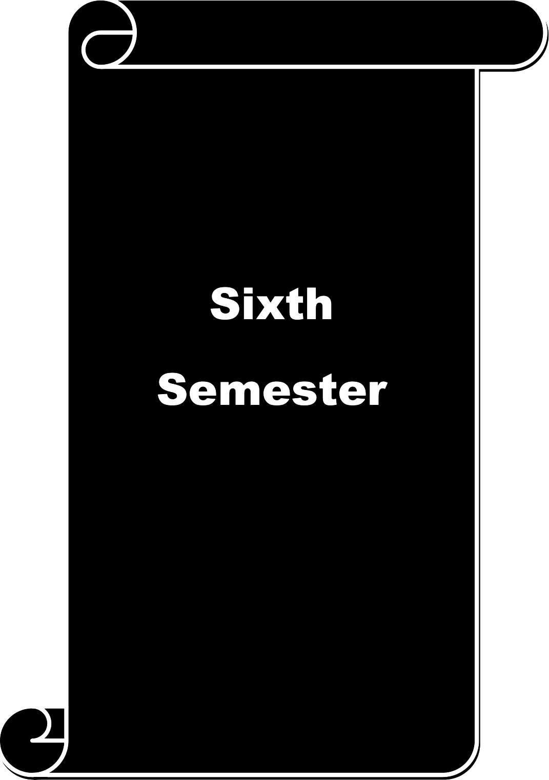

Course  code |  | 63A | SOCIAL LEGISLATION | L |  |  | T | P | C
Core XIII |  |  | SOCIAL LEGISLATION | 3 |  |  | - | - | 4
Pre-requisite |  |  | Basic knowledge on social welfare and social  legislation | Syllabus  Version |  |  |  | 2026-  2027
Course Objectives:
The main objectives of this course are to:

- To acquire knowledge about social reforms, and social legislation and critically understand their role in controlling the social problems.
- This course is to help learners understand the legal systems and procedures of people welfare in India.
Expected Course Outcomes:
On the successful completion of the course, student will be able to:
1 | It helps in understanding the processes in different legislations and develop skills  for the same. |  |  |  |  |  |  | K3
2 | Help students to understand the legal systems and procedures of people welfare in  India. |  |  |  |  |  |  | K4
3 | Gain insight into the problems faced by women and children and remedial  measures through legislation. |  |  |  |  |  |  | K3
4 | Understand democracy, social welfare and the system of governance  prevailing in India |  |  |  |  |  |  | K3
5 | Gain insight to the working conditions of children, SC, ST and other weaker  sections of the society with reference to the constitutional rights. |  |  |  |  |  |  | K3
K1 - Remember; K2 - Understand; K3 - Apply; K4 - Analyze; K5 - Evaluate; K6 — Create
Unit:1 |  | SOCIAL LEGISLATION AN INTRODUCTION |  |  |  | 15 hours
The concept of Social Legislation - Needs and Importance of Social legislation - Social Welfare &
Social Change - Concepts of Social Justice - Social assistance - Social Security, Directive Principles of State Policy.
Unit:2 |  | PERSONAL LAWS OF HINDU AND MUSLIM |  |  |  | l S hours
The Hindu & Muslim laws governing marriage, divorce, adoption & inheritance.
Unit:3 |  | SOCIAL LEGISLATION FOR WEAKER SECTION |  |  | 15 hours
Social legislation relating to the physically, mentally & socially handicapped persons,
SC/ST, legislations relating to the Welfare of the children & women.
Unit:4 |  | CORRECTIONAL SETTING AND SOCIAL  LEGISLATION |  |  | 14 hours
Social legislation for amelioration of social problems such and delinquency, prostitution, dowry,
beggary.
Unit:5 |  | SOCIAL LEGISLATION AND SOCIAL WORK |  |  | 14 hours
Legislation and social work, role of social worker in promoting in social justice.

Unit:6 |  | Contemporary Issues | 2 hours
 |  | Expert lectures, online seminars, webinars
 |  | Total Lecture hours | 75 hours
Text Book(s)
1 | Agarwal.R.K. - Indian Law, Central Law Agency, Allagabad.
2 | Gangrade K.D. —Social legislation in India, Impact Social Legislation on social change.
3 | Sone R.K. Walla D.R. - Law and layman Tara Povalla and Sons Bombay.
Reference Books
1 | Social Legislation - Its role in social welfare - Government of India, New Delhi,  Publication Division.
2 | Tandan .M.P. - Indian law Allagabad Association, .
Related Online Contents [MOOC, SWAYAM, NPTEL, Websites etc.]
1 | http://ignou.ac.in/up1oad/bswe-02-b1ock6-unit-31-smal1%20size.pdf
2 | http://legislative.gov.in/constitution-of-india
3 | http://egyankosh.ac.in/handle/123456789/17197
Course Designed By: Dr. Sam Lovely Son, Dr. Sasikalamary

Mapping with Programme Outcomes
Cos | PO1 | PO2 | PO3 | PO4 | PO5 | PO6 | PO7 | PO8 | PO9 | PO10
CO1 | M | M | L | M | S | S | S | S | S | M
CO3 | M | M | M | S | S | S | S | S | S | M
CO3 | M | M | M | M | S | S | S | M | S | S
CO4 | M | M | M | M | M | M | M | M | M | S
CO5 | M | M | M | M | M | S | S | S | S | S
*S-Strong; M-Medium; L-Low

Course  code |  | 63B | CLINICAL SOCIAL WORK |  | L | T |  |  | P | C
Core XIV |  |  |  |  | 3 | - |  |  | - | 4
Pre-requisite |  |  | Understanding the concept of health and functions of Sy  hospital |  | syllabus  Version |  | 2026-  2027
Course Objectives:
The main objectives of this course are to:
- Students get oriented about medical social work
- Students will improve their awareness on many chronic diseases and on mental health
- It will comprehend their knowledge on health care and various health programmes
Expected Course Outcomes:
On the successful completion of the course, student will be able to:
1 | Students will able understand the importance of medical social worker in hospitals |  |  |  |  |  |  | K2
2 | They can able find out the symptoms of many diseases and its causes |  |  |  |  |  |  | K5
3 | Students will gain knowledge on mental health and it related issues |  |  |  |  |  |  | K2
4 | It will equip them with the skills of medical social worker in handling persons with  disability |  |  |  |  |  |  | K3
5 | It will expand their experience on community health programmes |  |  |  |  |  |  | K3
K1 - Remember; K2 - Understand; K3 - Apply; K4 - Analyze; K5 - Evaluate; K6 — Create
Unit:1 |  | CONCEPT OF HEALTH AND HYGIENE |  |  | 15 hours
Health and Hygiene: meaning, definition, Determinants of health, health as a fundamenta 21 right
Personal and Environmental Hygiene; Communicable and Non-communicable diseases; prevention and control; Indicators of Health.
Unit:2 |  | MEDICAL SOCIAL WORK |  |  | 15 hours
Medical social work meaning and concept. Medical social work in relation to different
disciplines, multi-disciplinary approach and team work. Problems encountered by medical social worker in the field.
Unit:3 |  | MENTAL HEALTH |  | 15 hours
Mental health meaning definition and concept. Significant and characteristics of Mental health.
Features of mental health. Factors affecting Mental health. Types of mental disorders, causes and prevention.
Unit:4 |  | HEALTH CARE AND HEALTH PROGRAMMES |  | 14 hours
Health Care: Concepts, health care services, Primary Health Care, present level of health care;
Health Education: principles and means; National Health Programmes: ICDS, Expanded Programme of Immunization, STD control programme, National AIDS control programme.
Unit:5 |  | ROLE OF MEDICAL SOCIAL WORKER |  |  | 14 |  |  |  | hours
Organization and administration of medical social work department in hospitals. importance of,
Role of medical social worker in rehabilitating persons with disability, sex education and school health programmes. Significance of medical social worker in Community health
Unit:6 |  |  | Contemporary Issues | 2 hours
Expert lectures, online seminars webinars
Total Lecture hours |  |  |  | 75 hours

Text Book(s)
1 | Bajpai P K (Ed): Social Work Perspective On Health
2 | Bartlatt H M Social Work Practice In Health Field 27
3 | Goldstein D Expanding Horizons In Medical Social Work
Reference Books
1 | Prasad L Rehabilitation Of The Physically Hand
2 | Park.J.R Textbook Of Preventive And Social Medicine
Related Online Contents [MOOC, SWAYAM, NPTEL, Websites etc.]
1 | https://en.wikipedia.org/wiki/Hygiene
2 | https://dghs.gov.in/content/1347 3 HealthProgrammes.aspx?format=Print
3 | https://www.mswguide.org/careers/medical-social-work/
Course Designed By: Dr. Sam Lovely Son, Dr. T. Priyadharisini

Mapping with Programme Outcomes
Cos | PO1 | PO2 | PO3 | PO4 | PO5 | PO6 | PO7 | PO8 | PO9 | PO10
CO1 | M | L | L | M | M | M | M | S | M | M
CO3 | M | M | M | L | S | S | S | S | M | M
CO3 | L | L | M | M | M | M | M | M | S | M
CO4 | S | M | M | M | S | S | S | S | S | M
CO5 | M | M | M | M | S | S | S | S | S | S
*S-Strong; M-Medium; L-Low

Course  code |  |  | 66A | FIELD WORK /BLOCK PLACE EMNT | L | T | P | C
Core XV |  |  |  | FIELD WORK /BLOCK PLACE EMNT | - | - | 3 | 4
Pre-requisite |  |  |  | Having field work experience and profession  skill to organise a program | Syllabus  Version |  | 2026-  2027
Course Objectives:
The main objectives of this course are to:

- Students will apply their social work knowledge in the field work
- They will practice their professional skills and techniques
- They can successfully stan their carrier as social worker in an organization
Expected Course Outcomes:
On the successful completion of the course, student will be able to:
1 |  | Students will have chance to get an employment in the organisation where they  are doing their field work |  |  |  |  | K3
2 |  | Students will be able to exhibit their talents according to their specialization |  |  |  |  | K4
3 |  | Students can face any challenges in their profession |  |  |  |  | K5
4 |  | They will be able to give solution by using their comprehended knowledge in  social work |  |  |  |  | K5
5 |  | Students will be an effective social worker were ever they are placed |  |  |  |  | K6
K1 - Remember; K2 - Understand; K3 - Apply; K4 - Analyze; K5 - Evaluate; K6— Create
Students must place in an organisation for one month as block field work to complete their
professional course. Through this block field work they will once again practice their knowledge and skill which they acquire thought out their study period. Block field work training will finally shape their profession talents. Through this training period they will be motivated to excel in their carrier. Block place training is essential for social worker students to strengthen them before getting an employment in their respective areas
Text Book(s)
1 | Contemporary Field Social Work: Integrating Field and Classroom Experience By Mark  Doel, Steven shardlow, Paul Gordon Johnson
2 | Achieving Competency in Social Work Through Field Education By Marion Bogo
Refe | rence Books
I | Techniques and Guidelines for Social Work practice By Bradford W. Sheafor
2 | Field Work Training in Social Work By I.S.Subhedar
Rela | ted Online Contents [MOOC, SWAYAM, NPTEL, Websites etc.]
I | https://fieldeducator.simmons.edu/ai‘ticle/a-program-evaluation-of-block-and-concurrent-  practicum-formats/
2 | https://www.researcheate.net/publication/32391133 I What makes a good placement Findi  n s of a social woi k student-to-student i‘esearch stud y
Course Designed By: Dr. Sam Lovely Son, Mr. Francis Xavier

Mapping with Programme Outcomes
COs | PO1 | PO2 | PO3 | PO4 | PO5 | PO6 | PO7 | PO8 | PO9 | PO10
CO1 | M | M | M | M | S | S | M | M | M | S
CO3 | M | M | M | S | S | S | S | M | M | M
CO3 | L | M | M | S | S | S | S | M | M | M
CO4 | M | M | M | M | M | M | S | S | S | S
COS | M | S | S | S | S | S | S | M | M | M
*S-Strong; M-Medium; L-Low

Course  code |  | 6EA | HUMAN RESOURCE MANAGEMENT | L P |  |  | C
Elective II |  |  | HUMAN RESOURCE MANAGEMENT | 3 - - |  |  | 4
Pre-requisite |  |  | Human Resource management in social work  perspectives | Syllabus  Version |  | 2026-  2027
Course Objectives:
The main objectives of this course are to:
- Understands the importance of Labor and Industrial Relations.
- Acquires and practices a good Organizational Behavior.
- Learns to apply social work methods in the field of Human Resource Management.
Expected Course Outcomes:
On the successful completion of the course, student will be able to:
1 | The students to know the status of labour community in India. |  |  |  |  | K1
2 | Students should acquire the knowledge on Labour welfare and its measures. |  |  |  |  | K2
3 | Course facilitates the students to enhance and analyse the conflict and  management system among labour community. |  |  |  |  | K4
4 | Students will be able to define human Resource and strategies of Management. |  |  |  |  | K5
5 | Learns to approach Human Resources in Social work perception. |  |  |  |  | K3
K1 - Remember; K2 - Understand; K3 - Apply; K4 - Analyze; K5 - Evaluate; K6 — Create
Unit:1 |  | CONCEPT OF LABOUR IN INDIA |  | 15 hours
Concept of labour, Characteristics of Indian Labour and Types of labour. Concept and meaning of
Industry, Divisions and Departments.
Unit:2 |  | LABOUR WELFARE AND INDUSTRIAL RELATIONS |  | 15 hours
Labour Welfare —Concept and Classifications, Role of Labour welfare officer. Industrial relations —
concept, definitions, need and objectives. Factors influencing Industrial relations.
Unit:3 |  | TRADE UNION AND ORGANISATIONAL BEHAVIOUR |  |  | 15 hours
Concept, objectives and functions of Trade union, Role of trade union in labour welfare. Industrial
dispute —Strike, layoff, Lock-out, Retrenchment and Closure. Organisational Behaviour —definition, objectives and need.
Unit:4 |  | PERSONNEL MANAGEMENT AND HUMAN RESOURCE  MANAGEMENT |  |  | 14 hours
Personnel Management —meaning, definition and functions. Human Resource Management —Concept,
Definition, importance and scope. Difference between Personnel Management and Human Resource Management.
 |  | HUMAN RESOURCE MANAGEMENT AND  APPLICATION OF SOCIAL WORK METHODS |  |  | 14 hours
Concept of Human Resource Development, meaning and functions. Scope of Social work and
Application of Social work methods in the field of Human Resource Management.
 |  | Total Lecture hours |  |  | 75 hours

Text Book(s)
1 | Mamoria C B Dynamics of Industrial Relations in India —Bombay: Himalayas Publishing  house.
2 | Sharma A M Industrial relations conceptional and legal frame work —Bombay : Himalaya.
Related Online Contents [MOOC, SWAYAM, NPTEL, Websites etc.]
1 | www.mhrd.gov.in
2 | https://www.tandfonline.com/dot/abs/1tJ.1300/J022v05n01 05?journalCode=wzea20
3 | https://www.emera1d.com/insight/content/doi/10.1108/eb055279/fu1l/htm1?skipTracking=true
Course Designed By: Dr. Sam Lovely Son, Mr. Francis Xavier

Mapping with Programme Outcomes
Cos | PO1 | PO2 | PO3 | PO4 | PO5 | PO6 | PO7 | PO8 | PO9 | PO10
CO1 | M | S | S | S | M | M | L | M | M | M
CO3 | S | S | S | S | M | M | M | M | M | M
CO3 | M | S | S | S | S | S | S | S | M | M
CO4 | S | S | S | S | M | M | S | M | L | S
CO5 | S | S | S | S | M | M | M | M | L | S
*S-Strong; M-Medium; L-Low

Course code |  | 6EB | LABOUR WELFARE | L |  | T | P | C
Elective-II |  |  | LABOUR WELFARE | 3 |  | - | - | 4
Pre-requisite |  |  | Basic knowledge on labour and their needs | Syllabus  Version |  |  | 2026-  2027
Course Objectives:
The main objectives of this course are to:
- Acquire basic knowledge in labour welfare
- Develop an understanding of scope, principles and objectives of labour welfare.
- Become familiar with various labour laws and its impacts in industrial settings.
Expected Course Outcomes:
On the successful completion of the course, student will be able to:
1 | Students get acquainted with advanced level of knowledge in labour welfare |  |  |  |  |  | K2
2 | Students to meet out various challenges in the industrial settings |  |  |  |  |  | K3
3 | Course facilitates the students to enhance their employability skills and enables  them to take up the challenging job assignments. |  |  |  |  |  | K4
4 | Students will able to find out the real cause for the problem and plan interventions  in organization |  |  |  |  |  | K3
5 | Will nurture the Social Work Professionals to become effective industrial Social  Worker and contribute to the organization with commitment and integrity. |  |  |  |  |  | K5
K1 - Remember; K2 - Understand; K3 - Apply; K4 - Analyze; K5 - Evaluate; K6 — Create
Unit:1 |  | BASICS IN LABOUR WELFARE |  | 15 hours
Concept of labour - characteristics of Indian labour- labour in unorganized sector - recommendations of
national commission on labour on various issues, absenteeism and labour turnover - factors Influencing productivity.
Unit:2 |  | SCOPE OF LABOUR WELFARE |  | 15 hours
Concept and scope of labour welfare - classifications of labour welfare — labour welfare officer - role of
labour welfare officer - impact of automation, globalization &liberalization on labour welfare. Role of Trade Unions in Labour Welfare
Unit:3 |  | ADMINISTRATION OF LABOUR WELFARE |  |  | 15 hours
Labour welfare - principles of labour welfare - administration of labour welfare at central and state
level. The scheme of workers education - the objectives of workers education
Unit:4 |  | APPLICATIONS OF LABOUR WELFARE MEASURES |  |  | 15 hours
Significant labour welfare measures - housing - industrial housing policy and housing programmes -
family benefit schemes - children education - cooperative society - canteen - transport facilities and recreation facilities.
Unit:5 |  | INDUSTRIAL ACCIDENTS |  |  | 15 hours
Industrial accidents -. causes and prevention - industrial health & hygiene occupational diseases -
treatment and prevention - pollution control and environmental protection
Unit:6 |  | Contemporary Issues |  |  | Hours
Expert lectures, online seminar—s webinars
 |  | Total Lecture hours |  |  | 75 hours

Text Book(s)
1 | Bhagoliwal T.N Economics Of Labour And Social Welfare
2 | Charles. BAn Introduction To Industrial Sociology
3 | GiriV.VLabour Problems In Indian Industry
Reference Books
- Moorthy M. V Principles Of Labour Welfare Vishakapatnam G u ta Brothers.
- Saxene R CLabour Problems And Social Welfare Meeruat: The Oxford Publishing Co.
Related Online Contents [MOOC, SWAYAM, NPTEL, Websites etc.]
1 | https://www.vourarticlelibrarv.com/management/labour-welfare-its-scope-and-importance/26102
2 | https://shodhcan a.in Hibnet.ac. in/bitstream/10603/ 174927/18/ 12 chapter°/r206.pdf
4 | https://www.vourarticlelibrarv.com/industries/industrial-accidents-tvpes-and-causes-of-  accidents-explained-with-diagram/35400
Course Designed By: : Dr. Sam Lovely Son, Mr. Francis Xavier

Mapping with Programme Outcomes
COs | PO1 | PO2 | PO3 | PO4 | PO5 | PO6 | PO7 | PO8 | PO9 | PO10
CO1 | M | S | S | S | M | M | L | M | M | M
CO3 | S | S | S | S | M | M | M | M | M | M
CO3 | M | S | S | S | S | S | S | S | M | L
CO4 | S | S | S | S | M | M | S | M | L | S
CO5 | S | S | S | S | M | M | M | M | L | S
*S-Strong; M-Medium; L-Low

Course code |  | 6EC | INDUSTRIAL RELATIONS | L |  | T P |  |  | C
Elective II |  |  | INDUSTRIAL RELATIONS | 3 |  | - - |  |  | 4
Pre-requisite |  |  | Basic understanding about employee relations  and conflict resolution measures | Syllabus  Version |  |  | 2026-  2027
Course Objectives:
The main objectives of this course are to:

- Help students to learn basic concepts of Industrial relations
- Help students understand conflict arising in industries
- Gain understanding on the laws relating to industrial relations
Expected Course Outcomes:
On the successful completion of the course, student will be able to:
1 | Students will have good knowledge about bipartite and tripartite bodies in industrial  relations |  |  |  |  |  |  | K2
2 | Students will get a better knowledge about various committees in an industry |  |  |  |  |  |  | K2
3 | Students will have a better know how about various problems arising in an industry  and conflict resolution strategies |  |  |  |  |  |  | K4
4 | Students will have good knowledge about Legislation related to industrial relations |  |  |  |  |  |  | K3
5 | Students will have better knowledge on collective bargaining, WPM etc |  |  |  |  |  |  | K2
K1 - Remember; K2 - Understand; K3 - Apply; K4 - Analyze; K5 - Evaluate; K6— Create
Unit:1 |  | CONCEPTS OF INDUSTRIAL RELATIONS |  |  |  | 15 hours
Definition - concept - need, importance, scope, objectives of industrial relations - Factors influencing
industrial relations, bipartite and tripartite bodies in industrial relations - joint management council - works committee- Indian labour conference - standing labour committee-. Wage settlements
Unit:2 |  | CODE OF ETHICS AND DISCIPLINE |  |  |  | 15 hours
Ethical codes of industrial relations concept code of discipline in industry, causes and effects of
industrial conflicts —problem of short term employment and out sourcing— strikes, lock outs, lay off, retrenchment, closur—e need for industrial peace.
Unit:3 |  | LEGISLATIONS RELATED TO INDUSTRIAL RELATIONS |  |  | 15 hours
The Industrial Disputes Act 1941 concepts of standing order - content - procedure for certification. The
Industrial Employment (Standing Orders Act) 1946. Employee discipline- Domestic enquiry.
Unit:4 |  | TRADE UNIONS |  |  | 14 hours
Definition, concept, Structure and objectives of trade unions- Growth of Trade unionism in India -
positive role of trade unions - major trade unions in India - problems and weaknesses of trade unions- measures to strengthen the functioning of trade unions. Indian Trade Unions Act 1926.
Unit:5 |  | COLLECTIVE BARGAINING AND WPM |  |  | 14 hours
The Concept of collective bargaining - objectives- principles, process -subject matter for collective
bargaining -administration of collective agreements - difficulties observations of the National

Commission on Labour 1969) Workers participation in Management - Concept, objective, importance
- forms of participation - workers participation in management in India - limitations to workers participation.
Unit:6 |  | Contemporary Issues |  | 2 hours
Expert lectures, online seminars — webinars
 |  | Total Lecture hours |  | 75 hours
Text Book(s)
1 | Sharma A M |  | Industrial Relations Conceptional And Legal Frame Work
2 | SubbaRao P. |  | Essentials of Human resource and Industrial Relations
Ref | erence Books
1 | Subramainan K N |  | Labour Management Relations In Tamil Nadu
2 | Tripathi P.C |  | Personnel Management and Industrial elations
Rela | ted Online Contents [MOOC, SWAYAM, NPTEL, Websites etc.]
1 | https://www.economicsdiscussion.net/industries/industrial-relations/32249
2 | https://abhipedia.abhimanu.com/Artic1e/EPFO/MTUxMzY5/Trade-Union--Meaning--Objectives-and-  Benefits-Industrial-Relation-and-labour-law-EPFO
3 | https://www.economicsdiscussion.net/collective-bargaining/collective-bargaining-definition-types-  features-and-importance/31375
Course Designed By: : Dr. Sam Lovely Son, Mr. Mohan

Mapping with Programme Outcomes
Cos | PO1 | PO2 | PO3 | PO4 | PO5 | PO6 | PO7 | PO8 | PO9 | PO10
CO1 | M | M | M | M | L | L | M | M | M | M
CO3 | M | M | L | M | M | M | M | M | M | L
CO3 | S | M | M | M | M | M | M | M | M | M
CO4 | S | M | M | M | M | M | M | M | M | M
COS | S | S | S | M | M | S | S | S | S | M
*S-Strong; M-Medium; L-Low

Course  code |  | 6ED | SOCIAL WORK WITH FAMILY & CHILDREN | L |  | T | P | C
Elective III |  |  | SOCIAL WORK WITH FAMILY & CHILDREN | 3 |  | - | - | 4
Pre-requisite |  |  | Essential knowledge on Human Growth a d  Development ^{f'}  Basic knowledge on the Mankind and Society in Indian Purview | Syllabus  Version |  |  | 2026—  2027
Course Objectives:
- To impart knowledge on the concept of family, it's functions and significance to the
society.
- To exchange thoughts on the present/modern trends of family to generate awareness on the intense situations, such as child abuse, extreme poverty, malnutrition and juvenile delinquents and increase understanding on the present position of children in India to develop notions of good practice with children and families.
- Introduce the National & International welfare plans meant for children and the families to prepare the generalist for service delivery with children and families.
Expected Course Outcomes:
1 | Students can recollect their position and roles in their family. |  |  |  |  |  | K1
2 | Students shall be acquainted with advanced level of knowledge on the primary  institution of the society |  |  |  |  |  | K2
3 | Students as the generalist shall make their family better and be prepared for  service delivery with children and families. |  |  |  |  |  | K3
4 | Students will be able to identify the true colour and discover the roots of every  intense ground against the children and families. |  |  |  |  |  | K4
5 | Knowledge on the existing policies and programmes shall kindle the students to  further examine the results and impacts in the society |  |  |  |  |  | K5
6 | The course shall inspire young minds to become efficient and effective Social  Workers and increase learning platforms to make eminent civil service providers where, employability and respect is never short. |  |  |  |  |  | K6
K1 - Remember; K2 - Understand; K3 - Apply; K4 - Analyze; KS - Evaluate; K—6 Create
Unit:1 |  | CONCEPT OF FAMILY |  | 15 hours
The concept of family - family as a social unit - the functions of family - modern family - cultural
aspects and the present trends of family.
Unit:2 |  | PAST & THE MODERN FAMILY |  | 15 hours
Importance of family in the present context; Effects of Industrialisation, Westernisation,
Modernisation and Urbanisation, on the family.
Unit:3 |  | SIGNIFICANCE OF CHILD AND THEIR ISSUES |  |  | 15 hours
The place & significance of the child in the family, major problem of children in India, child hood and
its importance, the present position of children. Major problems of children in India, Child labour, Street Children Juvenile Delinquents, Female infanticide, Sexual Abuse of Children.
Unit:4 |  | UN DECLARATION FOR CHILDREN |  |  | 14 hours
The child rearing patterns; emerging philosophy of child development, UN declaration of the rights of

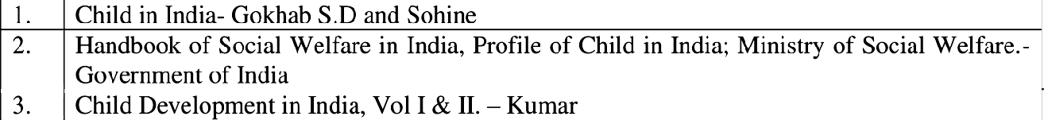
the child, National policy for children in India.
Unit:5 |  | NATIONAL & INTERNATIONAL SERVICES | 14 hours
Family Welfare Services, File Year Plans or Family Welfare Services ; CSWB; child development
services under the five year plan in India, National and International agencies in Family Welfare & Child Welfare.
Unit:6 |  | Contemporary Issues | 2 hours
 |  | Expert lectures, online seminar—s webinars
 |  | Total Lecture hours | 75 hours
Text Book(s)
1 | Human Growth & Development — Elizabeth Hurlock
2 | Sociology of the family - Anderson Michael
3 | Sociology Principles Of Sociology - C.N. SHANKAR RAO
Reference Books
- Child in India- Gokhab S.D and Sohine
- Handbook of Social Welfare in India, Profile of Child in India; Ministry of Social Welfare. - Government of India
- Child Development in India, Vol I & II. — Kumar
Related Online Contents [MOOC, SWAYAM, NPTEL, Websites etc.]
1 | https://www.unicef.org/child-rights-convention/convention-text
2 | https://www.slideshare.net/salmanhabeebek/international-agencies-of-child-welfare
3 | https://childmind.org/topics/concerns/behavior/
 | Course Designed By: : Dr. Sam Lovely Son,, Dr. John Wesley

Mapping with Programme Outcomes
Cos | PO1 | PO2 | PO3 | PO4 | PO5 | PO6 | PO7 | PO8 | PO9 | PO10
CO1 | L | L | M | M | M | M | M | M | M | S
CO3 | M | M | M | M | M | S | S | S | M | M
CO3 | S | M | M | S | S | S | S | S | M | M
CO4 | S | M | S | S | S | M | S | S | S | M
COS | M | M | S | S | S | S | S | S | S | S
*S-Strong; M-Medium; L-Low

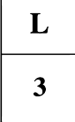
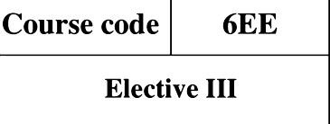
Course code 6EE COUNSELLING THEORY AND  Elective III PRACTICE |  |  |  |  |  |  | 4
Pre-requisite Basic knowledge in counseling and its yllabus 2026- significance ersion 2027
Course Objectives:
The main objectives of this course are to:
- Impart the knowledge on counseling its process techniques and skills
- Equipping with assessment techniques of counselling
- Enabling their practical knowledge of counselling
Expected Course Outcomes:
On the successful completion of the course, student will be able to:
1 | Understanding the need for counseling in life |  |  |  |  | K2
2 | Equipping themselves to be a good counselor |  |  |  |  | K4
3 | Developing confident in giving counseling to different clients |  |  |  |  | K4
4 | Promoting the society or the individual to have a quality of life |  |  |  |  | K5
5 | Drafting new module in the area of counseling as an effective intervention |  |  |  |  | K6
K1 - Remember; K2 - Understand; K3 - Apply; K4 - Analyze; K5 - Evaluate; K—6 Create
Unit:1 |  | CONCEPT OF COUNSELLING |  | 15 hours
Introduction to counselling Meaning and Definition of Counselling. Characteristics of a good
counsellor- The common features of counsellors. The identity of counselling. Guidance: Meaning of Guidance, Types of Guidance and its Functional aspects. Basic principles and assumptions underlying guidance.
Unit:2 |  | BASIC SKILLS OF COUNSELLING |  | 15 hours
Basic skills of counseling- Attending, listening, reflective skills and probing skills. Counseling as
a process- out come goals of counseling, stages of counseling process. Counseling theoriespsychodynamics,Sigmund Freud, Alfred Adler. Humanistic counseling- person centered counseling [Carl Rogers] Transactional Analysis, Cognitive theory and behaviour counseling.
Unit:3 |  | DIFFERENT APPROACHES | 15 hours
Different approaches to counseling client centered, behavioural cognitive, solution oriented
Unit:4 |  | EGNMODELOFCOUNSELLING | l4hours
The Egan model of counseling - the skilled approach
Stage I problem exploration and clarification
Part I attending and listening
Attending, orientation oneself to be present Micro skills - active listening - verbal and non-verbal messages and behavior
Part II helpers response and clients self exploration
Helper's skills: accurate empathy (primary level) respect, genuineness, and concreteness. Client's skill - self-exploration
Stage II: Integrative understanding dynamic self understanding
Part I: Focusing, summarizing, and probing for missing experiences behavior, feelings

Part II: Helper's skill
All the skills of stage 1, self-disclosure, immediacy, confrontation clients skills non-defensive listening, and dynamic self-understanding.
Stage III: facilitating action; developing a new perspective, preferred scenario.
Part I: Helping the client see alternatives- helping the client choose and formulate action plans - helping the client implement and evaluate.
Part II: helper's skills
All the skills of action programmers (problem solving decision make in, behavior modification, home work, training in interpersonal skills) support from the helper clients skills - cooperation, risk taking, acting
Selective and integrative counseling- multi model counseling, counselor-counselee relationship. Counselor's needs in counseling, developing self awareness —personal qualities of counselor , counselor as a model
Unit:5 |  | GROUPCOUNSELLING | 14 hours
Group counseling — definition advantages of group counseling, process of group counseling
ethical practices in counseling, counseling in school setting, palliative care counseling and rehabilitation counseling.
Unit:6 |  | Contemporary Issues | 2 hours
Expert lectures, online seminar—s webinars
 |  | Total Lecture hours | 75 hours
Text Book(s)
I | N.D. Gururani,2005 Guidance & Counselling: Educational, Vocational & Career Planning,  Akansha Publishing House, New Delhi.
2 | Kottler, J.A. andBrown, R.W., 2000 Introduction to Therapeutic Counselling, Brooks/Cole, U.S.
3 | Woofe, R & Dryden,W.1996 Handbook of Counselling Psychology, Sage, New Delhi.
Re | ference Books
1 | Gelso, Charles J. &Fretz, Bruce R., 1995 Counselling Psychology, Prism Book Pvt. Ltd.  Bangalore.
2 | Dave, Indu, 1991 The Basic Essentials of Counselling, Sterling Publishers,
Re | lated Online Contents [MOOC, SWAYAM, NPTEL, Websites etc.]
I | https://www.s1ideshare.net/tmxyz/guidance-counsel1ing-29066361
2 | https://www.tandfonline.com/dot/pdf/10.l080/03057877180000tJ81
3 | https://www.counse11ing-directory.org.uk/counsel1ing.htm1
Course Designed By: : Dr. Sam Lovely Son, Dr. T. Priyadharisini

Mapping with Programme Outcomes
Cos | PO1 | PO2 | PO3 | PO4 | PO5 | PO6 | PO7 | PO8 | PO9 | PO10
CO1 | M | M | M | L | L | M | M | M | L | M
CO3 | L | M | M | L | M | M | M | M | M | M
CO3 | M | M | M | M | M | M | N | M | M | M
CO4 | S | S | S | M | M | S | S | M | M | S
CO5 | S | S | S | S | S | S | S | M | M | S
S-Strong; M-Medium; L-Low

Course code |  | 6EF | YOUTH WELFARE |  |  | L | T |  |  | P | C
Elective III |  |  |  |  |  | 3 | - |  |  | - | 4
Pre-requisite |  |  | Basic understanding about youth and their Sy  needs |  |  | syllabus  Version |  | 2026-  2027
Course Objectives:
The main objectives of this course are to:

- Helps students to understand youth and their culture
- Students will know about the influential factors in the life of youth
- It will improve their knowledge on national youth welfare programme
Expected Course Outcomes:
On the successful completion of the course, student will be able to:
1 | Students can thorough on youth welfare programmes |  |  |  |  |  |  |  | K2
2 | Students develop their confidence level to perform as youth welfare officer at  national level |  |  |  |  |  |  |  | K3
3 | It will facilitate them to organise many innovative training programme for youth |  |  |  |  |  |  |  | K3
4 | It will make to develop critical approach in the field of youth welfare |  |  |  |  |  |  |  | K4
5 | Professional knowledge will support them to develop an intervention for youth  development. |  |  |  |  |  |  |  | K6
K1 - Remember; K2 - Understand; K3 - Apply; K4 - Analyze; I'iS - Evaluate; K—6 Create
Unit:1 |  | YOUTH |  |  |  | l S hours
Definition types of youth. Youth in India — Youth welfare. Need and Importance .Social work for
the empowerment of Youth . Role of Social Workers in Youth welfare
Unit:2 |  | YOUTH CULTURE |  |  |  | 15 hours
The values and life styles of youth. Youth and Maodernisation - The period of youth in the life
cycle — Emotional problems of the Youth — Parent youth confliets — youth unrest.
Unit:3 |  | INFLUENTIAL FACTORS IN THE LIFE OF YOUTH |  |  | 15 hours
Youth in the context of Education, Religion and politics — The influence of poverty and
unemployment of youth. The involvement of youth in social services Role of youth in National Development and social change.
Unit:4 |  | PROBLEMS OF YOUTH |  |  |  |  | 15 |  |  | hours
Problems of urban and rural youth. Alcoholism and drug dependency among youth — youth and
crim—e Exploitation of youth for communalism and terrorism— special problems of female youth
— Youth and mass media — Role of youth against the social evils
Unit:5 |  | NATIONAL YOUTH POLICY |  |  |  |  | 15 |  |  | hours
National youth policy — National sports policy — youth welfare organization — National cadet corps
National service schem—e youth hostels and youth clubs youth movement—s leadership training for youth— promotion of national integration— Counselling service—s training youth in community development programmes — youth festivals youth camps and youth exchange programmes.
Unit:6 |  | Contemporary Issues |  | 2 hours
Expert lectures, online seminar—s webinars
 |  | Total Lecture hours |  |  | 75 hours

Text Book(s)
 | Ahuja Ram. 1992. Social problems in India. New Delhi: Rawat publications
2 | Rajendra. J, 1992, Modernisation of youth in India, New Delhi: Rawat Publications Pvt. Ltd
Reference Books
 | Saraswathi. S, 1998, Youth in India, New Delhi: ICSSR .
2 | Singh DR, 1987, Rural Youth, Allahabad: Choogh Publications.
Related Online Contents [MOOC, SWAYAM, NPTEL, Websites etc.]
1 | https://www.s1ideshare.net/ma1amaha1aha/youth-welfare
2 | https://youth.gov/youth-briefs/foster-care-youth-brief/challenges
3 | https://www.manifestias.com/2020/01/13/national-programme-for-youth-and-ado1escent-  development-npyad/
Course Designed By: : Dr. Sam Lovely Son, Dr.Premamalini

Mapping with Programme Outcomes
Cos | PO1 | PO2 | PO3 | PO4 | PO5 | PO6 | PO7 | PO8 | PO9 | PO10
CO1 | L | M | M | M | L | M | M | M | M | M
CO3 | M | M | M | M | M | M | MS | S | S | S
CO3 | M | M | M | M | L | M | M | M | M | M
CO4 | S | S | M | S | S | M | M | M | M | S
CO5 | S | S | S | M | M | S | S | S | S | M
*S-Strong; M-Medium; L-Low

Course  code |  | 6ZD | NGO MANAGEMENT | L |  | T | P | C
Skill Based  Subject-4 |  |  | NGO MANAGEMENT
Pre-requisite |  |  | Basic knowledge on NGO, Types and registration  process and programs and policies framing for the welfare and upliftment of the Society. | Syllabus  Version |  |  | 2026-  2027
Course Objectives:
The main objectives of this course are to:
- Acquire basic knowledge about NGO and its functions
- Develop an understanding about the project planning, formulation and implementation.
4. Gaining knowledge about fund raising techniques and project proposal writing
Expected Course Outcomes:
On the successful completion of the course, student will be able to:
1 | Students get acquainted with advanced level of knowledge in NGO Management. |  |  |  |  |  | K2
2 | Students to meet out various challenges in the field of Voluntary organisations.. |  |  |  |  |  | K3
3 | Course facilitates the students to enhance their employability skills and enables  them to take up the challenging job assignments. |  |  |  |  |  | K4
4 | Students will able to find out the real cause for the problem and plan interventions |  |  |  |  |  | K3
5 | Will nurture the Social Work Professionals to become effective Social Worker and  contribute to the welfare of the society with commitment and integrity. |  |  |  |  |  | K5
K1 - Remember; K2 - Understand; K3 - Apply; K4 - Analyze; K5 - Evaluate; K6 — Create
Unit:1 |  | NGO - HISTORY,TYPES AND NEEDS |  | 15 hours
Non-government organisation: Definition, Meaning, Objectives, Principles, Historical Development
of NGOs in India. Need for NGOs. Types of Non-government organisation, Role of NGO's in the development of a country.
Unit:2 |  | REGISTERATION, BY LAWS PREPARATION AND  MONITORING MECHANISM OF NGO. |  | 15 hours
Registration and Establishment of NGOs: Societies Act, Trust Act, Company's Act (Sec. 25), Bylaws
Preparation and Legal Status of NGO. Monitoring Mechanism adopted by Governments — FCR Act. Administration, Policy Making: Membership Classification, Aims and Objectives of the Executive Committee, Office Bearers and Governing Counsel, and Rights, Power and Duties.
Unit:3 |  | PROJECT MANAGEMENT |  |  | 15 hours
Project identification: Feasibility/Base Line studies —Project Formulation —Planning and Policy
making —Strategic Formation —Preparation of project proposals —Project implementation.
Unit:4 |  | FUND RAISING AND RESOURCE MOBILIZATION |  |  | 14 hours
Budgeting: Meaning, Steps, important items in Budget —Resource Mobilization —Central and State
Government Assistance and Other Assistance —Fund Raising: Meaning, techniques —Income Generation Programmes (IGP), —Financial Management —Financial Collaboration between Funding Organization and Non-Profit Organizations.

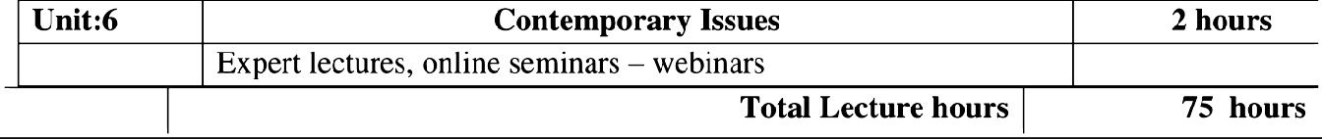
 |  | PROJECT - EVALUATION, MONITORING AND  APPRAISAL |  | 14 hours
Project evaluation and monitoring: Aims, Objectives, Purposes Creating management Information
system —Project appraisal: Meaning and techniques —Logical Frame Analysis (LFA) Participatory Rural Appraisal (PRA).

1 | Kumar.A. |  | Social change through NGO'S, Anmol Publishers.
2 | Rodrigues |  | Hand Book for Management of Voluntary organisations, Madras,A1fa.
3 | Kandasamy .M.  NewDelhi, |  | Governance and Financial Management in Non-profit organization,
Reference Books

Related Online Contents [MOOC, SWAYAM, NPTEL, Websites etc.]
1 | https://managementheIp.org/projectinanagement/
2 | https://managementheIp.org/projectinanagement/
3 | https://en.wikipedia.ore/wiki/Project management#: -:text=Project%2tJmanagement%2tJis' o20t  he% 2tJprocess, goals' o20within' o20the% 2tJgiven' o2tJconstraints
Course Designed By: : Dr. Sam Lovely Son, Mr. Francis Xavier

Mapping with Programme Outcomes
COs | PO1 | PO2 | PO3 | PO4 | PO5 | PO6 | PO7 | PO8 | PO9 | PO10
CO1 | M | M | M | L | M | M | S | S | M | S
CO3 | M | M | M | L | M | M | S | S | M | S
CO3 | S | S | S | L | M | S | S | S | M | S
CO4 | M | L | L | M | M | M | M | M | M | S
CO5 | M | M | M | M | M | M | S | M | M | S
*S-Strong; M-Medium; L-Low

