BHARATHIAR UNIVERSITY: COIMBATORE 641 046
B. Sc. Geography Curriculum (University Affiliated colleges)

(For the students admitted during the academic year 2022 – 2023 onwards)

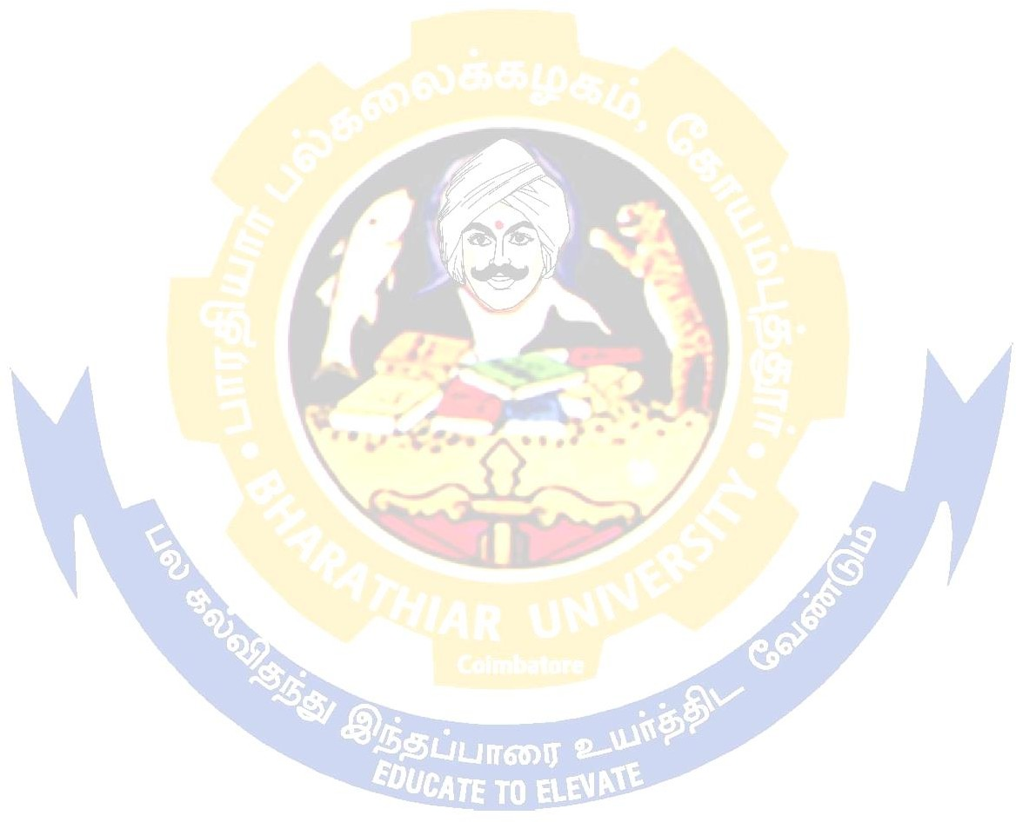
Scheme of Examination

Course Code | Title of the Course | Credits | Hours |  | Maximum Marks
 |  |  | Theory | Practical | CIA | ESE | Total
FIRST SEMESTER
1IT | Language – I | 4 | 6 | - | 50 | 50 | 100
12E | English – I | 4 | 6 | - | 50 | 50 | 100
13A | Core I – Fundamentals of Geomorphology - I | 4 | 5 | - | 50 | 50 | 100
13B | Core II – Geography of India | 4 | 5 | - | 50 | 50 | 100
1AC | Allied: Paper I – Statistics for Geography -I | 4 | 6 | - | 50 | 50 | 100
1FA | Environmental Studies # | 2 | 2 | - | - | 50 | 50
Total |  | 22 | 30 |  | 250 | 300 | 550
SECOND SEMESTER
21T | Language – II | 4 | 6 | - | 50 | 50 | 100
22E | English – II | 2 | 4 | - | 50 | 50 | 100
 | Language Proficiency for Employability: Effective English | 2 | 2 | - | 25 | 25 | 50
23A | Core III – Fundamentals of Geomorphology - II | 4 | 5 | - | 50 | 50 | 100
23P | Core IV – - Practical - Basics of Map Making | 4 | - | 5 | 50 | 50 | 100
2AC | Allied: Paper II - Statistics for Geography -II | 4 | 6 | - | 50 | 50 | 100
2FB | Value Education – Human Rights # | 2 | 2 | - | - | 50 | 50
 | Swatch Bharat Summer Internship* | - | - | - | - | - | -
Total |  | 22 | 25 | 5 | 275 | 325 | 600
THIRD SEMESTER
31T | Language - III | 4 | 6 |  | 50 | 50 | 100
32E | English - III | 4 | 6 | - | 50 | 50 | 100
33A | Core V - Climatology | 4 | 4 | - | 50 | 50 | 100
33B | Core VI – Population & Settlement | 4 | 4 | - | 50 | 50 | 100
3AC | Allied: III – Elements of Cartography | 4 | 5 | - | 50 | 50 | 100
3ZA | Skill Based Subject – Basics in  Computers (Minimum 2 hrs compulsory lab for a week) | 3 | 3 | - | 30 | 45 | 75
3FB/  3FC/  3FD | Tamil @ / Advanced Tamil # (OR) Non – Major Elective – I (Yoga for Human Excellence) #  / Women’s Rights # | 2 | 2 | - | - | 50 | 50
 | NAAN MUTHALVAN-  Digital Skills for employability | 2 | 2 | - | 25 | 25 | 50
Total |  | 27 | 32 |  | 305 | 370 | 675

FOURTH SEMESTER
`41T | Language - IV | 4 | 6 | - | 50 | 50 | 100
42E | English - IV | 4 | 6 | - | 50 | 50 | 100
43A | Core VII – Oceanography | 4 | 4 | - | 50 | 50 | 100
43P | Core VIII – Practical – Map  Interpretation and Representation of Climatic Data | 3 | - | 3 | 50 | 50 | 100
43Q | Allied: IV – Practical - Cartography | 3 | - | 3 | 50 | 50 | 100
4ZB | Skill Based Subject – Basics of GIS & GPS (Minimum 2 hrs  compulsory lab for a week) | 3 | 3 | - | 30 | 45 | 75
4FB/  4FE | Tamil @ / Advanced Tamil #  (OR) Non – Major Elective – II (General Awareness #) | 2 | 2 | - | - | 50 | 50
 | NAAN MUTHALVAN-Digital Skills for employability – Office Fundamentals | 2 | 3 | - | 25 | 25 | 50
Total |  | 25 | 24 | 6 | 305 | 370 | 675
FIFTH SEMESTER
53A | Core IX – Geography of Natural Regions of the World | 4 | 6 | - | 50 | 50 | 100
53B | Core X – Geography of Tamil Nadu | 3 | 6 | - | 30 | 45 | 75
53C | Core XI – Geography of Resources - I | 4 | 6 | - | 50 | 50 | 100
53D | Core XII – Remote Sensing and its Applications in Geography | 4 | 5 | - | 50 | 50 | 100
5EA | Elective – I, Urban Geography | 4 | 4 | - | 50 | 50 | 100
5EB | Skill Based- Subject – Disaster Studies | 3 | 3 | - | 30 | 45 | 75
 | NAAN MUTHALVAN-  Marketing and Design Tools | 2 | 2 | - | 25 | 25 | 50
Total |  | 24 | 32 |  | 285 | 315 | 600
SIXTH SEMESTER
63A | Core XIII – Geography of Resources - II | 4 | 6 | - | 50 | 50 | 100
63B | Core XIV – Environmental Studies and Management | 3 | 6 | - | 30 | 45 | 75
63P | Core XV – Practical - Surveying & Interpretation  of Aerial Photos and Satellite Images (Minimum 2 hrs compulsory lab for a week) | 4 | - | 5 | 50 | 50 | 100
6EA | Elective –II, Political Geography | 4 | 5 | - | 50 | 50 | 100
6ED | Elective – III, Regional Geography of South East Asia | 4 | 5 | - | 50 | 50 | 100
6ZD | Skill Based Subject – Geography of Tourism | 3 | 3 | - | 30 | 45 | 75
67A | Extension Activities @ | 2 | - | - |  | 50 | 50
 | Other Item Swatch Bharat Internship Scheme - II | 2 | - | - | - | - | -
Employability Readiness- Naan
Mudhalvan Course
Total |  | 24 | 25 | 5 | 260 | 340 | 600
Grand total |  | 144 | 168 | 16 | 1680 | 2020 | 3700
@ No University Examinations. Only Continuous Internal Assessment (CIA) # No Continuous Internal Assessment (CIA), Only University Examinations.
nt (CIA), Only University Examinations.

