BHARATHIAR UNIVERSITY: COIMBATORE 641 046
B. Sc. Chemistry – Revised Scheme of Examinations (CBCS Pattern)
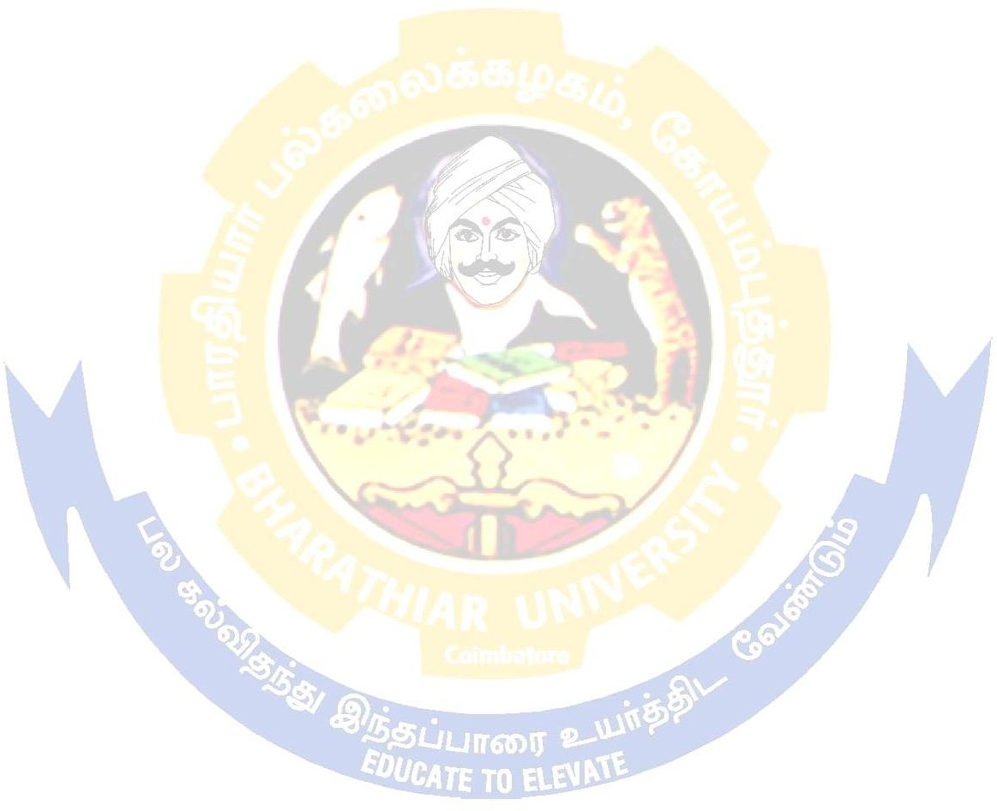
(For the students admitted during the academic year 2021 – 22 onwards)
Part | Title of the Course | Hours/ Week | Examination |  |  |  | Credits
 |  |  | Duration in Hours | Maximum Marks
 |  |  |  | CIA | CEE | Total
 | Semester I
I | Language - I | 6 | 3 | 50 | 50 | 100 | 4
II | English - I | 6 | 3 | 50 | 50 | 100 | 4
III | Core Paper I – General Chemistry - I | 7 | 3 | 50 | 50 | 100 | 4
III | Core Practical I (Inorganic Qualitative Analysis) | 3 | 3 | - | - | - | -
III | Allied A: Paper I# (or) | 6 | 3 | 50 | 50 | 100 | 4
 | Allied A: Paper I@ | 4 | 3 | 30 | 45 | 75 | 3
III | Allied A: Practical@ | 2 | - | - | - | - | -
IV | Environmental Studies* | 2 | 3 | - | 50 | 50 | 2
 | Total | 30 |  | 180 | 245 | 425 | 17
 | Semester II
I | Language – II | 6 | 3 | 50 | 50 | 100 | 4
II | English – II | 6 | 3 | 50 | 50 | 100 | 4
III | Core Paper II – General Chemistry - II | 7 | 3 | 50 | 50 | 100 | 4
III | Core Practical I (Inorganic Qualitative Analysis) | 3 | 3 | 50 | 50 | 100 | 4
III | Allied A: Paper II# (or) | 6 | 3 | 50 | 50 | 100 | 4
 | Allied A: Paper II@ | 4 | 3 | 30 | 45 | 75 | 3
III | Allied A: Practical@ | 2 | 3 | 25 | 25 | 50 | 2
IV | Value Education – Human Rights* | 2 | 3 | - | 50 | 50 | 2
 | Total | 30 |  | 255 | 320 | 575 | 23
 | Semester III
I | Language – III | 6 | 3 | 50 | 50 | 100 | 4
II | English – III | 6 | 3 | 50 | 50 | 100 | 4
III | Core Paper III – Inorganic Chemistry - I | 3 | 3 | 50 | 50 | 100 | 4
III | Core Paper IV – Physical Chemistry - I | 3 | 3 | 50 | 50 | 100 | 4
III | Allied B: Paper I# (or) | 6 | 3 | 50 | 50 | 100 | 4
 | Allied B: Paper I@ | 4 | 3 | 30 | 45 | 75 | 3
III | Core Practical II (Volumetric and Organic Analysis) | 3 | - | - | - | - | -
III | Allied B: Practical@ | 2 | - | - | - | - | -
IV | Skill based Subject 1: Chemistry of Natural and Synthetic Fibers | 2 | 3 | 30 | 45 | 75 | 3
IV | Tamil** / Advanced Tamil* (OR) Non-  major elective - I (Yoga for Human Excellence)* / Women’s Rights* | 1 | 3 | - | 50 | 50 | 2
 | Total | 30 |  | 260 | 340 | 600 | 24

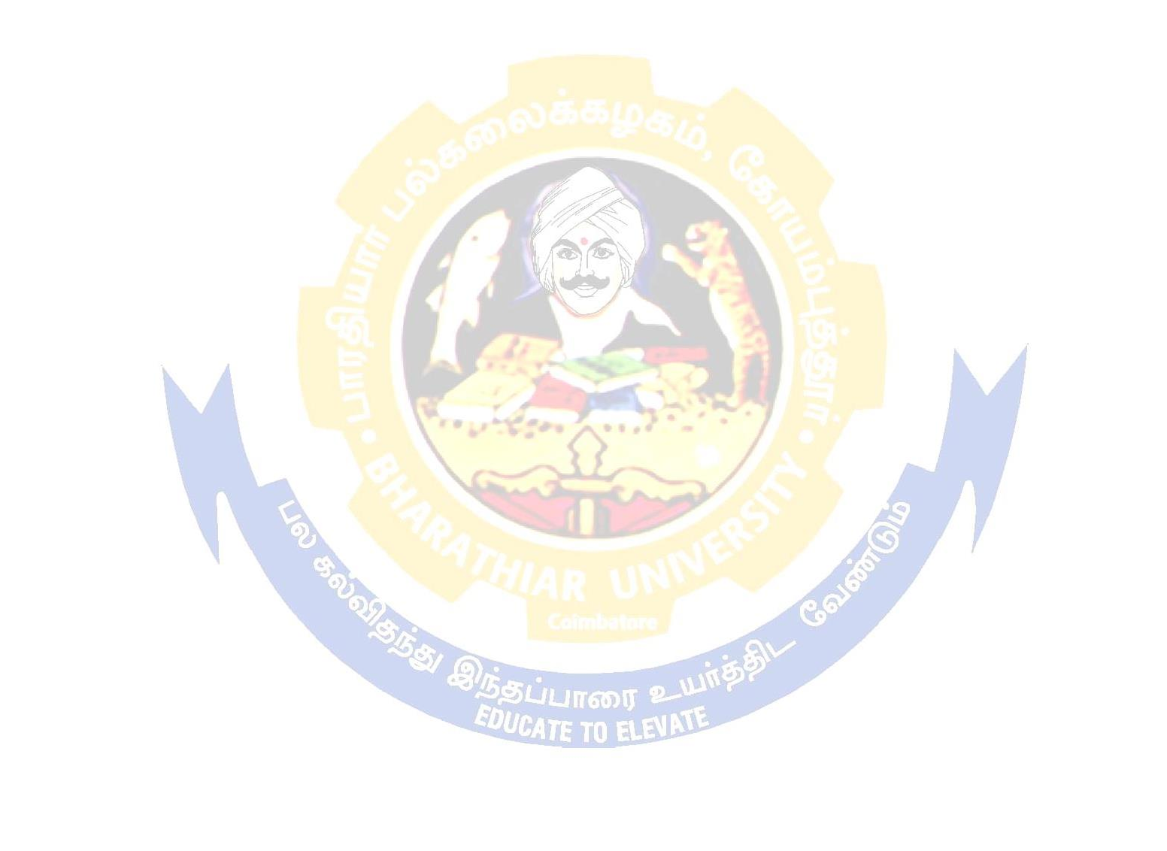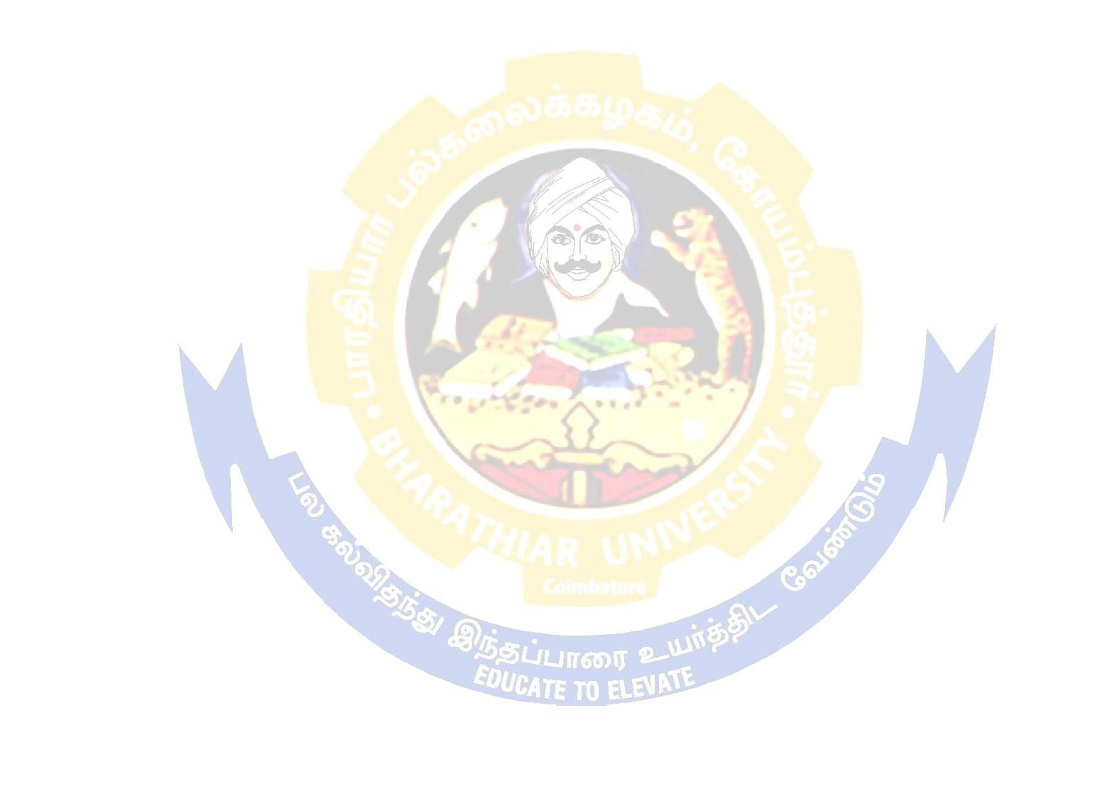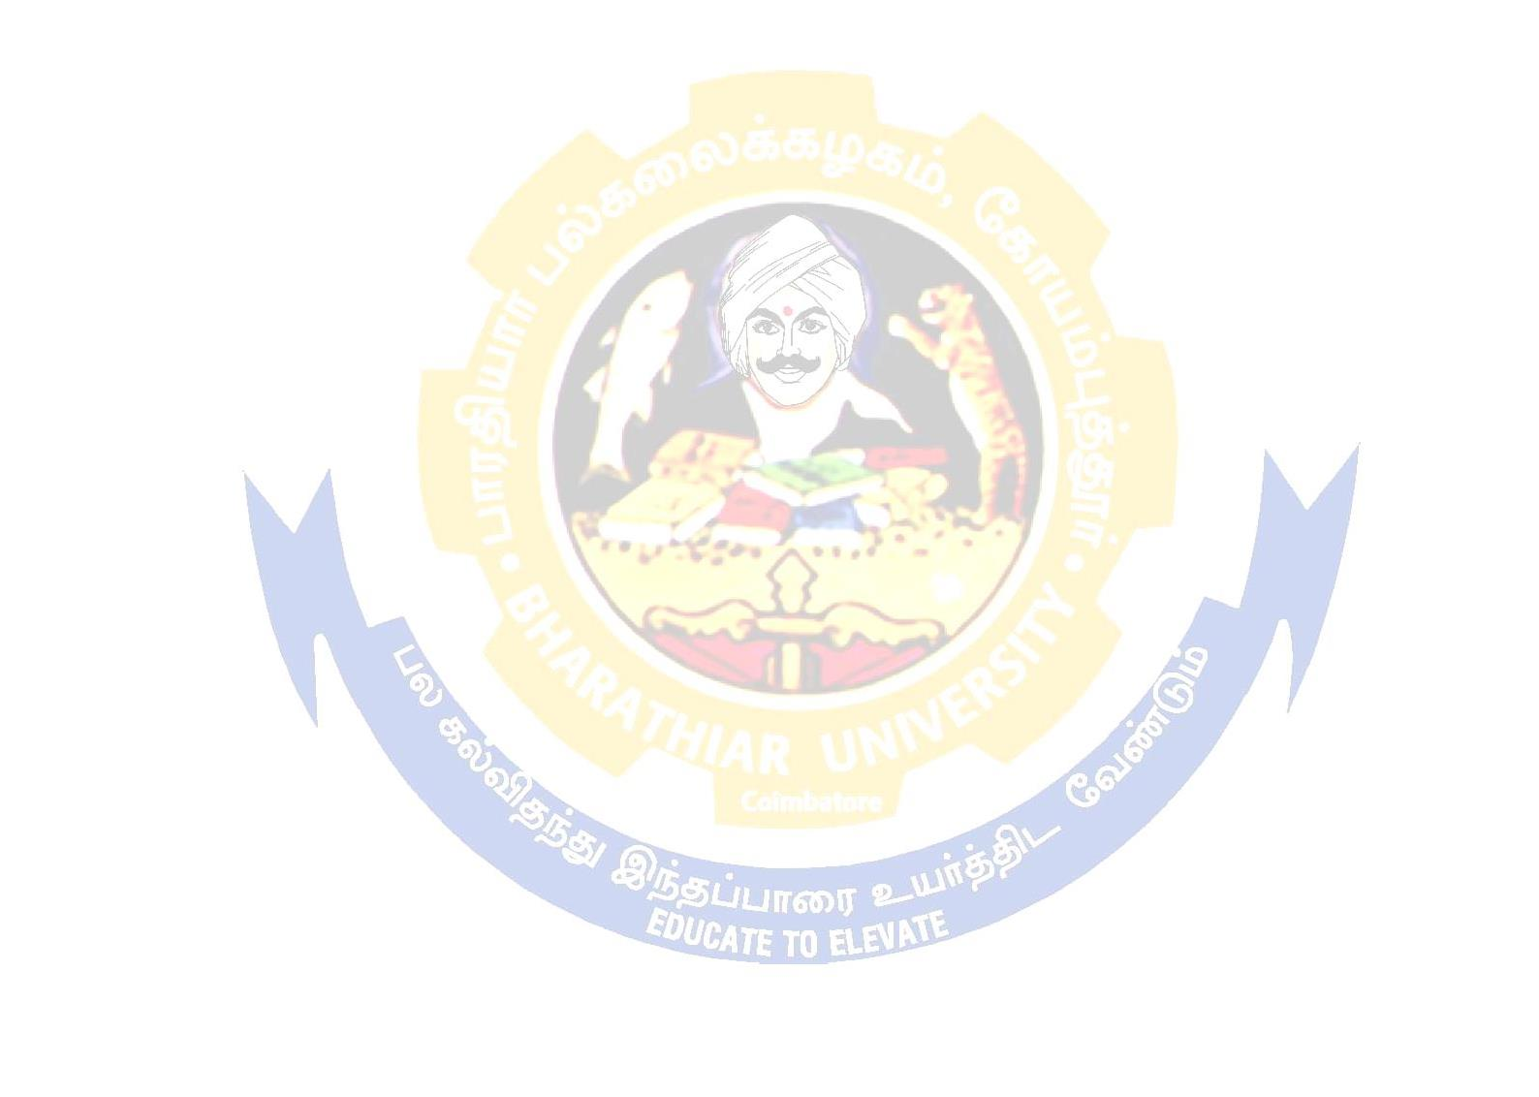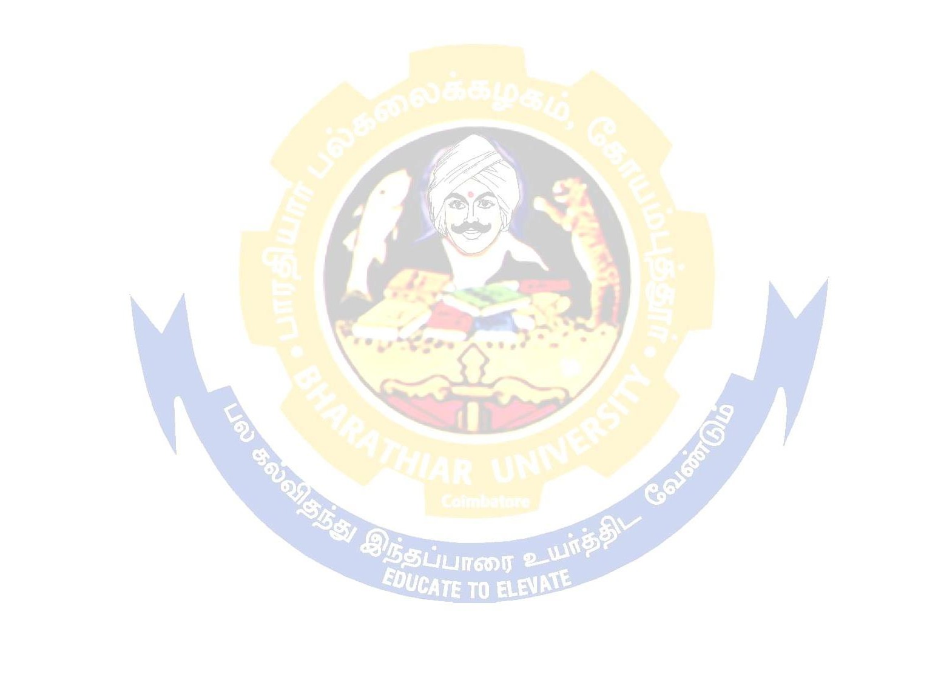
 |  | Semester IV
 | I | Language – IV | 6 | 3 | 50 | 50 | 100 | 4
 | II | English – IV | 6 | 3 | 50 | 50 | 100 | 4
 | III | Core Paper V – Organic Chemistry - I | 4 | 3 | 50 | 50 | 100 | 4
 | III | Core Practical II (Volumetric and Organic Analysis) | 3 | 6 | 30 | 45 | 75 | 3
 | III | Allied B: Paper II# | 6 | 3 | 50 | 50 | 100 | 4
 |  | Allied B: Paper II@ | 4 | 3 | 30 | 45 | 75 | 3
 | III | Allied B: Practical@ | 2 | 3 | 25 | 25 | 50 | 2
 | IV | Skill based Subject 2: Technology of Dyeing of Natural Fibers | 2 | 3 | 25 | 25 | 50 | 2
 |  | Naan Mudhalvan Skill Course - Digital Skills for Employability –  Office Fundamentals http://kb.naanmudhalvan.in/Special: Filepath/Microsoft_Course_Details.xlsx | 2 | - | 25 | 25 | 50** | 2
 | IV | Tamil** / Advanced Tamil* (OR) Non-major elective - II (General Awareness)* | 1 | 3 | - | 50 | 50 | 2
 |  | Total | 30 |  | 285 | 365 | 650 | 26
 |  | Semester V
 | III | Core PaperVI (Inorganic Chemistry II) | 5 | 3 | 50 | 50 | 100 | 4
 | III | Core Paper VII (Spectroscopy) | 5 | 3 | 50 | 50 | 100 | 4
 | III | Core Paper VIII (Electrochemistry) | 5 | 3 | 50 | 50 | 100 | 4
 | III | Core Paper IX (Analytical Chemistry) | 4 | 3 | 50 | 50 | 100 | 4
 | III | Core Practical III (Gravimetric And Physical) | 5 | - | - | - | - | -
 | III | Elective I | 4 | 3 | 50 | 50 | 100 | 4
 | IV | Skill based Subject 3: Water &  Effluent Treatment And Pollution Control | 2 | 3 | 30 | 45 | 75 | 3
 |  | Naan Mudhalvan Skill Course – Advanced technology for Employability in Life Science |  |  | 25 | 75 | 100 | 2
 |  | Total | 30 |  | 305 | 370 | 675 | 25
 |  | Semester VI
 | III | Core Paper X (Organic Chemistry II) | 6 | 3 | 50 | 50 | 100 | 4
 | III | Core Paper XI (Physical Chemistry II) | 6 | 3 | 50 | 50 | 100 | 4
 | III | Core Practical III (Gravimetric And Physical) | 5 | 6 | 50 | 50 | 100 | 4
 | III | Elective II | 4 | 3 | 30 | 45 | 75 | 3
 | III | Elective III | 4 | 3 | 30 | 45 | 75 | 3
 | III | Core Practical for Elective Subjects | 3 | 3 | 50 | 50 | 100 | 4
 | IV | Skill Based Subject 4: (Textile Chemistry Practical) | 2 | 3 | 30 | 45 | 75 | 3
 |  | Extension Activities @ | - | - | 50 | - | 50 | 2
 |  | Naan Mudhalvan Skill Course- Employability Readiness – IBM Skills build* | - | - | - | - | - | -
 |  | Total | 30 |  | 340 | 335 | 675 | 27
 |  | Grand Total | 180 |  | 1625 | 1975 | 3600 | 142

Note
# For subjects without practical.
@ For subjects with practical.
* No Continuous Internal Assessment (CIA). Only University Examinations.
** No University Examinations. Only Continuous Internal Assessment (CIA).

** Naan Mudhalvan – Skill courses- external 25 marks will be assessed by Industry and internal 25 marks will be offered by respective course teacher.
Semester IV Skill based Subject 2: Technology of Dyeing of Natural Fibers University examination will be
conducted for 45 marks (As per the existing pattern of examination ) and it will be converted for 25 marks .

Allied Subjects(Colleges can choose any two subjects)
1. Mathematics, 2. Physics, 3. Botany, 4. Zoology, 5. Biochemistry
List of Elective papers
(Colleges can choose any one of the paper as electives)
Elective – I | A | Polymer Chemistry
 | B | Agro Industrial Chemistry
 | C | Pharmaceutical Chemistry
Elective – II | A | Leather Chemistry
 | B | Chemistry of Plant Based Products
 | C | Dye Chemistry
Elective – III | A | Analytical Chemistry II Lab Techniques
 | B | Environmental Chemistry
 | C | Textile Chemistry

Students are encouraged to register through the website www.naanmudhalvan.tn.gov.in and takeup thecourses to enhance their skills .

