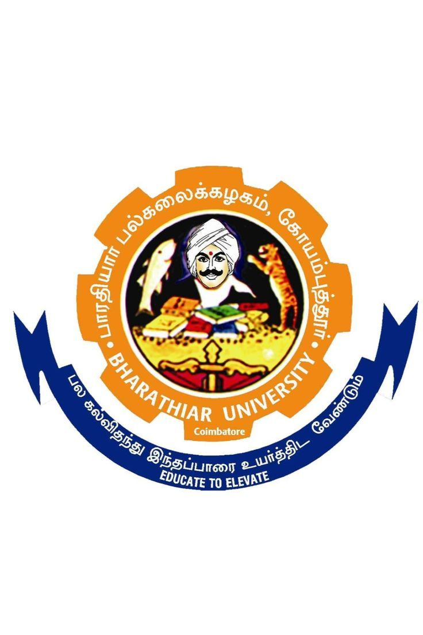

BHARATHIAR UNIVERISTY CENTRE FOR UNIVERSITY AND INDUSRY COLLABRATION

**BHARATHIAR UNIVERSITY**

**(A State University, Accredited with “A++” Grade by NAAC, Ranked 21st among Indian Universities by MHRD-NIRF)**

**Coimbatore -641 046, Tamilnadu, India**

CERTIFICATE COURSE ON “YOUTH VOLUNTEERISM AND SOCIAL SERVICE”

**Bharathiar University, Coimbatore–641046**

**Centre for University and Industry Collaboration (BU-CUIC)**

**Industry Collaborative Programme**

Certificate Course on **“Youth Volunteerism and Social Service”**

**SCHEME OF EXAMINATIONS**

(For the students admitted from the academic year **2025-26** onwards)

|  |  |  |  |  |  |  |  |  |  |
| --- | --- | --- | --- | --- | --- | --- | --- | --- | --- |
| **S. No.** | **SUBJECT** | | **Credits** | **Hours per Week** | | | **Marks for** | | **Total Marks** |
| **Lecture** | **Tutorial** | **Practical** | **CIA** | **ESE** |
| **Course Duration – 3 Months** | | | | | | | | | |
| **Lecture** | | | | | | | | | |
| 1 | Basics of Volunteerism and Social Service | | 4 | 2 | 2 | - | 25 | 75 | 100 |
| **Practical, Internship & Project** | | | | | | | | | |
| 2 | **Practical:** Volunteerism and Social Service | | 6 | - | - | 6 | 40 | 60 | 100 |
| 3 | Internship | | 4 | - | - | 4 | 40 | 60 | 100 |
| 4 | Project & Viva voce | | 6 | - | - | 6 | 25 | 75 | 100 |
| **Total** | | | **20** | **2** | **2** | **16** |  |  | **400** |
| **CIA** |  | Continuous Internal Assessment | | | | | | | |
| **ESE** |  | End Semester Examination | | | | | | | |
| **\*** |  | **General Component:** 6 Credits | | | | | | | |
| **^** |  | **Skill Component:** 16 Credits | | | | | | | |

**--**

|  |  |  |  |  |  |  |  |  |  |  |  |  |
| --- | --- | --- | --- | --- | --- | --- | --- | --- | --- | --- | --- | --- |
| **Course code** | | | **1** | **Basics of Volunteerism and Social Service** | | **L** | | | **T** | | **P** | **C** |
| 2 | | | 2 | | - | 4 |
| **Pre-requisite** | | | Basics in in Volunteerism/ Social Work/ Basic Health / Basic Education/ Environmental Issues/ Climate Change / Poverty Alleviation. | | **Syllabus**  **Version** | | | | | **2024-25** | | |
| **Course Objectives:** | | | | | | | | | | | | |
| The main objectives of this course are to:   1. Make students understand Volunteerism and Social Service. 2. Make students understand Social Work. 3. Provide a strong foundation on the principle’s Social Work. 4. Make student understand Basic Health. 5. Make student understand Basic Education. 6. Make student understand Environmental Issues and Climate Change. 7. Make student understand Poverty Alleviation Programmes. 8. Inculcate the knowledge application of Volunteerism and Social Servicein different fields. | | | | | | | | | | | | |
|  | | | | | | | | | | | | |
| **Expected Course Outcomes:** | | | | | | | | | | | | |
| On the successful completion of the course, student will be able to: | | | | | | | | | | | | |
| 1 | Understand the Volunteerism Attitude and Behaviour. | | | | | | K1, K2 | | | | | |
| 2 | Understand the Social Work. | | | | | | K1, K2 | | | | | |
| 3 | Learn the fundamentals Volunteerism and Social Service. | | | | | | K1, K2 | | | | | |
| 4 | Understand the Basic Health Systems | | | | | | K1, K2 | | | | | |
| 5 | Understand the Basic Education | | | | | | K1, K2 | | | | | |
| 6 | Understand the basics of Natural Disaster and Climate Change | | | | | | K1, K2 | | | | | |
| 7 | Learn the fundamentals of Social Entrepreneurship | | | | | | K1, K2 | | | | | |
| 8 | Learn the application of Volunteerism and Social Servicein different fields. | | | | | | K1, K2 | | | | | |
| **K1** - Remember; **K2** - Understand; **K3** – Perform; **K4** - Analyse | | | | | | | | | | | | |
|  | | | | | | | | | | | | |
| **Unit:1** | | **Concept of Volunteerism and Social Work** | | | | | **15 Lectures** | | | | | |
| Volunteerism – Definition – Scope- role – Ethics – Time – Skills – Deliverables – Review – Monitoring – Rewards – Volunteerism for Attitude – Behaviour – Leadership – Competency – Social Order – Economic Order – Quality of Life and Well-being for people and their communities – SDG and Volunteerism - Social Work - Concepts and Definitions of Social Work – General Principles of Social Work – Theoretical Framework of the Social Work in the Context of Volunteerism - Approaches and Methods of Social Work - Social Structure – Definition and Meaning – Role of Social Workers – Social Action – Definition, Concept – Scope of Social Action - Community Development Approaches – Principals of Community Development - Scope for Social Work Practices - Programmes for Rural, Urban and Tribal Development – Development Plan for Inclusive Growth - Social Evils in India – Social Problems – Social Disadvantages - Correctional Institutions and Social Work – Social Inclusion Strategies – Violence Conflict Resolution Choices. | | | | | | | | | | | | |
| **Unit:2** | | **Volunteerism and Social Work: Basic Health** | | | | | **14 Lectures** | | | | | |
| Health Standards – Human Health System – Pandemic & Out Break – Communicable and Non-Communicable Diseases – AIDS & Cancer – Gerontology Hygiene – Hygiene Standards – Public and Personal Hygiene - Sanitation – Standards of Sanitation – Household Sanitation – Public Sanitation – ODF Status - Volunteerism in Safe Water Supply – Standards of Drinking Water – Various Water Sources – Protection and Sustainability of Water Sources – Water Quality Improvements – Water Quality Monitoring – Water Recharge – Water Harvesting Technologies & Methods. | | | | | | | | | | | | |
| **Unit:3** | | **Volunteerism and Social Work in Basic Education** | | | | | **14 Lectures** | | | | | |
| Education – Basics of Education – Educational System – Special Education – Adult Education – Continuing Education - Behavioural & Attitudinal Change – Knowledge Management – Skilling, Skill Upgradation – Vocational Education – Human Resource Optimization – Labour and Employment. | | | | | | | | | | | | |
| **Unit:4** | | **Volunteerism and Social Work in Environmental Issues and Climate Change** | | | | | **15 Lecture** | | | | | |
| Environmental Issues – Local & Global Thoughts - Standards of Pollution Control – Control Measures for Soil Pollution, Air Pollution and Water Pollution - Climate Change Mitigation – Action for Climate Change – Reuse, Reduce & Recycle (RRR) – Volunteerism in Natural Resource Promotion – Social Forestry - Natural Disasters – Man Made Disasters - Disaster Risk Mitigation – Volunteerism in Natural Resources Augmentation – Common Asset Management. | | | | | | | | | | | | |
| **Unit:5** | | **Volunteerism and Social Work in Poverty Alleviation** | | | | | **14 Lectures** | | | | | |
| Poverty Alleviation Programmes – Five Year Plans - Socio Economic Development – SHG Movement – Panchayat Level Federations – Farmers Producers Organizations - Skill Development and Training Programmes – DDUGKY – TNSDC – NABARD – NABSKILLS-PMKVY – Livelihood Programmes – TNSRLM – DIC – TAHDCO - Rural Economy Revival – Social Entrepreneurship – Visioning and Planning for Community – Institutional Platform for Volunteerism. | | | | | | | | | | | | |
|  | | | | | | | | | | | | |
| **Total Lectures** | | | | | | | | **72 Lectures** | | | | |
| **Mapping with Programme Outcomes** | | | | | | | | | | | | |
| |  |  |  |  |  |  | | --- | --- | --- | --- | --- | --- | | **COs** | **PO1** | **PO2** | **PO3** | **PO4** | **PO5** | | **CO1** | S | S | S | M | L | | **CO2** | S | S | S | M | L | | **CO3** | S | S | S | M | L | | **CO4** | S | S | S | M | L | | | | | | | | | | | | | |
| **\*S – Strong; M-Medium; L- Low** | | | | | | | | | | | | |

|  |  |  |  |  |  |  |  |  |  |  |
| --- | --- | --- | --- | --- | --- | --- | --- | --- | --- | --- |
| **Course code** | | **2** | **Practical: Volunteerism and Social Service** | | **L** | | **T** | | **P** | **C** |
| - | | - | | 6 | 6 |
| **Pre-requisite** | | NGOs/ Vos/ PHC& GH/ Panchayat Office and Block Office / Anganvadi / Panchayat School / Skill Training Centre | | **Syllabus**  **Version** | | | | **2024-25** | | |
| **Rural and Panchayat Development Agencies:** | | | | | | | | | | |
| 1. Visit to Two NGOs/Vos/NSS Unit/YRC Units 2. Visit to Primary Health Centre (PHC) & Government Hospital (GH) 3. Visit to Panchayat Office and Block Office 4. Visit to Anganvadi, Panchayat Union School, Skill Training Centre 5. Visit to Panchayat Level Federation (PLF) and Farmers Produce Organization 6. Profiling of Natural Disaster, Traditional Knowledge of Climate Change, Natural Resources | | | | | | | | | | |
| The Candidate must visit all the listed above places and submit the report of the activities of the Rural and Panchayat Development Agencies. | | | | | | | | | | |
|  | | | | | | | | | | |
| **Expected Course Outcomes:** | | | | | | | | | | |
| On the successful completion of the course, student will be able to: | | | | | | | | | | |
| 1 | Document their activities related Volunteerism | | | | | K1, K2 | | | | |
| 2 | Record the Roles and Activities of PHC/GH and Explore Scope of Volunteerism. | | | | | K1, K2 | | | | |
| 3 | Evaluate their Works in Water Supply and Sanitation. | | | | | K1, K2 | | | | |
| 4 | Understand the scope of their work in Education, Hygiene and Volunteerism. | | | | | K1, K2 | | | | |
| 5 | Document the Efforts in providing Social Inclusion, Social Up-liftment, Collectiveness, Service, Business Plan, Credit Plan and Comment on Scope of Volunteerism. | | | | | K1, K2 | | | | |
| 6 | Comment on Volunteerism – in Your Panchayat and Measures taken to control the same by the Departments and Local Bodies. | | | | | K1, K2 | | | | |
| **K1** - Remember; **K2** - Understand; **K3** – Perform; **K4** - Analyse | | | | | | | | | | |

|  |  |  |  |  |  |  |  |  |  |  |
| --- | --- | --- | --- | --- | --- | --- | --- | --- | --- | --- |
| **Course code** | | **3** | **Internship: Volunteerism and Social Service** | | **L** | | **T** | | **P** | **C** |
| 2 | | 2 | | - | 4 |
| **Pre-requisite** | | NGOs/ Vos/ PHC& GH/ Panchayat Office and Block Office / Anganvadi / Panchayat School / Skill Training Centre. | | **Syllabus**  **Version** | | | | **2022-23** | | |
| **Course Objectives:** | | | | | | | | | | |
|  | | | | | | | | | | |
| **S. No.** | **The main objectives of this course are to:** | | | | | | | | | |
| 1 | Make students understand Documentation Work. | | | | | | | | | |
| 2 | Make students understand Document Role and Activities. | | | | | | | | | |
| 3 | Provide strong foundation on the principle’s work evaluation | | | | | | | | | |
| 4 | Inculcate the knowledge application of Volunteerism and Social Work. | | | | | | | | | |
|  |  | | | | | | | | | |
| **Expected Course Outcomes:** | | | | | | | | | | |
| **On the successful completion of the course, student will be able to:** | | | | | | | | | | |
| 1 | Understand the Documentation Activities. | | | | | K1, K2 | | | | |
| 2 | Understand the basics of Volunteerism. | | | | | K1, K2 | | | | |
| 3 | Learn the fundamentals of Social Work Principles. | | | | | K1, K2 | | | | |
| 4 | Learn the application of molecular techniques in different fields | | | | | K1, K2 | | | | |
| **K1** - Remember; **K2** - Understand; **K3** – Perform; **K4** - Analyse | | | | | | | | | | |
|  | | | | | | | | | | |
| **S. No** | **Internship Titles/Headings** | | | | | | | | | |
|  | NGOs / VOs / PHC& GH/ Panchayat Office and Block Office / Anganvadi / Panchayat School / Skill Training Centre.  **\* Visit any one of the listed Rural and Panchayat Development Agencies for 10 days (50hrs) and to submit the internship undergone Certificate with report (The Report may be minimum 5pages with Photos).** | | | | | | | | | |

|  |  |  |  |  |  |  |  |  |  |
| --- | --- | --- | --- | --- | --- | --- | --- | --- | --- |
| **Course code** | | | **4** | **Project and Viva Voce** | **L** | | **T** | **P** | **C** |
| 2 | | 2 | - | 4 |
| **Pre-requisite** | | | **Volunteerism and Social Service Skills** | | **Syllabus**  **Version** | | | **2024-25** | |
| **Course Objectives:** | | | | | | | | | |
| **S. No.** | | **The main objectives of this course are to:** | | | | | | | |
| 1 | | Make students understand Training in Education. | | | | | | | |
| 2 | | Make Students understand Rural Local Bodies. | | | | | | | |
| 3 | | Provide a strong effort in Providing Social Inclusion. | | | | | | | |
| 4 | | Inculcate the knowledge of Rural Development Programmes. | | | | | | | |
|  | | | | | | | | | |
| **Expected Course Outcomes:** | | | | | | | | | |
| **S. No.** | **On the successful completion of the course, student will be able to:** | | | | |  | | | |
| 1 | Understand the Documentation Activities. | | | | | K1, K2 | | | |
| 2 | Understand the basics of Volunteerism. | | | | | K1, K2 | | | |
| 3 | Learn the fundamentals of Social Work Principles. | | | | | K1, K2 | | | |
| 4 | Learn the application of molecular techniques in different fields | | | | | K1, K2 | | | |
| **K1** - Remember; **K2** - Understand; **K3** – Perform; **K4** - Analyse | | | | | | | | | |
|  | | | | | | | | | |
| **Titles / Heading** | | | | | | | | | |
| 1. Visit to Two NGOs/Vos/NSS Unit/YRC Units 2. Visit to Primary Health Centre (PHC) & Government Hospital (GH) 3. Visit to Panchayat Office and Block Office 4. Visit to Anganvadi, Panchayat Union School, Skill Training Centre 5. Visit to Panchayat Level Federation (PLF) and Farmers Produce Organization. 6. Profiling of Natural Disaster, Traditional Knowledge of Climate Change, Natural Resources.   **\* Candidates are instructed to use the format given by the District Resource Centre for the Panchayats for the Project Report Writing.** | | | | | | | | | |

# Mark Allotment

The certificate programme theory, practical, project and internship/Field work have the following components:

**1. Theory**

Maximum Marks – 100 (credits – 4, 6)

**Internal Marks: 25**

**Tests**: 15 Marks, **Assignment:** 05 Marks, and **Others:** 5 Marks

**External Marks:** 75

**Minimum Pass in internal and external examination:** 40 Mark

**2. Practical**

I) For 6/4 Credits Maximum Marks = 100

**Internal Marks 50**

Tests – 30 Marks

Observation – 05 Marks

Record – 05 Marks

---------------

Total = 40 Marks

---------------

**External Marks: 60**

**Minimum Pass in internal and external examination:** 40 Mark

# 3. Internship/Field work (credits – 6/4)

**Internal Marks: 40**

Observation - 30 Marks

Review (2*05) - 10Marks

**External Marks: 60 (Record & Viva)**

**Minimum Pass in internal and external examination:** 40 Mark

**4. Project:**

**Internal Marks: 25**

Observation - 15 Marks

Review (2*05) - 10 Marks

**External Marks: 75 (Record & Viva)**

Evaluation : 50

Viva-voce : 25

**Minimum Pass in internal and external examination:** 40 Mark